2019 Filing Guide for System, Local and Flexible Resource Adequacy (RA) Compliance Filings
Issued: October 3, 2018

1. Purpose and Overview of Resource Adequacy Guides and Templates 2
2. New for 2019 RA Compliance Year 2
3. Major Components of the RA Templates 4
4. The Filing Process 5
5. Using the Templates – 2019 System and Local RA Compliance 8
6. Net Qualifying Capacity 9
7. Flexible Capacity Framework 11
7.1 Flexible Need and Allocation 11
7.2 Flexible Capacity Requirements Study 12
7.3 Effective Flexible Capacity (EFC) Counting Conventions and EFC List 12
7.4 RA Showings and Validation 13
7.5 Sale and Purchase of Flexible Capacity 14
7.6 Use-Limited Flexible Resources 15
8. Cost Allocation Mechanism and Combined Heat and Power Contracts Accounting Process 16
9. Local and Flexible RA Reallocation Process for 2019 Compliance Year 19
10. Confidentiality and RA Filings 19
11. Load Forecast Adjustments 20
12. Maximum Cumulative Capacity and Resource Categories 22
13. Demand Response Resources and the Demand Response Tab 23
14. Export Commitments Made with RA Resources 24
15. Outages 25
16. Import Capacity Allocation Process for 2019 25
17. Zonal RA: Constraint on Flows Across Path 26 28
18. Certification of LSE Resource Adequacy Compliance Filing 30
19. Submission of RA Filings – Secure FTP 31
20. Correction of Errors: Minor or Substantial 32
21. RA Penalty Structure 33
22. Local Waiver Process 33
Appendix A: Submission of RA Compliance Filings 34
Appendix B: CAISO Import Allocation Process for 2019 37
Appendix C: Frequently Asked Questions and Clarifications to the Filing Instructions 40
Appendix D: Directions for Use of Secure FTP 42

Purpose and Overview of Resource Adequacy Guides and Templates
This 2019 Resource Adequacy (RA) Compliance Guide (Guide) is meant to inform Load Serving Entities (LSEs) in demonstrating compliance with the CPUC’s RA program. Along with the RA System and Local/Flexible Reporting Templates (Templates), LSEs are to use this Guide as reference material. To the extent that this Guide is incomplete or does not address a particular issue that the LSE may discover, the LSE is strongly encouraged to contact Energy Division staff (RAFiling@cpuc.ca.gov) immediately and request direction. Although this Guide is organized for quick reference, the LSE is strongly encouraged to read the entire Guide and become familiar with its contents. More specific line item instructions are provided in the “Instructions” tabs of the Templates.

New for 2019 RA Compliance Year
For the 2019 RA Compliance Year, the CPUC is issuing this Guide to specify how to fill out the Templates. LSEs are encouraged to read this Guide and the instructions included in the Templates carefully and to contact Energy Division with any questions at: RAFiling@cpuc.ca.gov.
D.18-06-030 made several changes to the RA program rules and implementation. Those changes for 2019 RA compliance year, among others, are summarized below:
- Dates were revised to reflect 2019 dates, and some other minor rewording was made to clarify directions. The schedule of filing deadlines included in Section 2 of this Guide is based on current rules regarding when RA filings are due; please visit our online RA Filing calendar for a current calendar.

- The California Independent System Operator Corporation’s (CAISO) annual availability assessment hour analysis will be submitted into the resource adequacy proceeding for consideration as to whether the Commission should adjust its resource adequacy measurement hours.

- The resource adequacy measurement hours are modified to HE17-HE21 (4:00 p.m. – 9:00 p.m.) for each month of the year beginning in 2019.

- Combined storage and demand response projects are eligible to participate in the Resource Adequacy program.

- All LSEs must participate in the year-ahead resource adequacy process in order to serve load in the subsequent compliance year.

In addition, Energy Division has made several clarifications regarding filing requirements in the 2019 RA Guide. These clarifications appear throughout the document and are reproduced in bullet form below.
- LSEs must file all load forecasts with both the CEC and the CPUC. If an LSE does not anticipate changes to its Month Ahead forecasts, the LSE should inform CPUC and CEC that it will not submit a revised forecast.

- Energy Division will no longer enter credit allocations (e.g. CAM and RMR) and incremental Local and Flexible requirements into LSEs’ filing templates. Each LSE is responsible for entering the correct credits and incremental requirements into its own filing templates.

- Energy Division will attempt to perform initial compliance checks based on CAISO supply plans downloaded from CIRA at or around midnight on the day following Energy Division’s monthly RA filing deadline. If this is not possible, Energy Division will perform initial compliance checks based on supply plans identified in the first complete run of the RA validation in CIRA after midnight on the day following Energy Division’s monthly RA filing deadline. Correction notices and deficiency notices will be based on information contained in the CAISO supply plans, regardless of when Energy Division performs the compliance check.

- Energy Division may accept the following formats for certification of RA filings:

  - (1) a PDF version of the filing template’s Certification tab containing the name, title, and signature of the certifying officer in the appropriate cells, or

  - (2) the certifying officer’s “electronic signature” placed in the appropriate cell of the filing template’s Certification tab. The electronic signature may be either (i) an image file of the certifying officer’s signature or (ii) the certifying officer’s digital signature with a timestamp.

- The Certification tab of an LSE’s filing template should always contain the name and title of the certifying officer (in the appropriate cells), regardless of whether the LSE submits a signed copy of the tab as a PDF document. This will enable Energy Division to determine quickly whether the certifying officer has changed.

- The fields “Capacity Effective Start Date” and “Capacity Effective End Date” in the Phys_Res_Imports_RA_Res and II_Construc tabs of the filing templates refer to the start and end dates of capacity contracts, respectively. (For a resource owned by the LSE, these fields refer to the first and last dates on which the LSE anticipates showing the resource for RA capacity, respectively. These may be the commercial online date and anticipated retirement date of the resource.) LSEs should enter contract start and end dates in these fields, regardless of whether the contract extends beyond the terms of the given compliance month. For example, if a particular resource is under contract from January 15, 2018 to December 31, 2020, then in its January 2019 Month Ahead RA compliance filing, the LSE should enter “1/15/2018” in “Capacity Effective Start Date” and “12/31/2020” in “Capacity Effective End Date.”

Timeline for Year Ahead Load Forecasts for 2019 Compliance Year:
LSEs file Historical load info | Mar 16, 2018
LSEs file 2019 Year-Ahead Load Forecast | Apr 20, 2018
LSEs receive 2019 Year-Ahead RA obligations | Aug 10, 2018
Final date to file revised forecasts for 2019 | Aug 17, 2018
LSEs receive revised 2019 RA obligations | Sep 20 , 2018

Load Forecast and Month-Ahead Filing Dates for 2019 RA Compliance (Includes the Due date for the Local RA True up Filing Pursuant to D.14.06-050)
* Pursuant to Rule 1.15 of the CPUC Rules of Practices and Procedure, if the due date falls on a Saturday, Sunday, or holiday, it is extended to the following business day.
RA Filing Month | Load Forecast Month | Due Date
Final 2019 Year-Ahead |  | Oct 31, 2018
January | February | Nov 17, 2018 *
February | March- June | Dec 18, 2018
March | April | Jan 15, 2019
April | May | Feb 15, 2019
May | June-December | Mar 17, 2019 *
June | July | Apr 17, 2019
July (with Local & Flex true up) | August | May 17, 2019
August (with Local & Flex true up) | September- December | Jun 17, 2019
September (with Local & Flex true up) | October | Jul 18, 2019
October (with Local & Flex true up) | November | Aug 17, 2019 *
November (with Local & Flex true up) | December-March | Sep 17, 2019
December (with Local & Flex true up) | January 2020 Compliance Year | Oct 17, 2019

Major Components of the RA Templates
The Templates are comprised of a number of individual tabs, including the following:
- ID and Local Area tab listing resources available for use in the RA Filings. Information is taken from the CAISO NQC list.
- LSE-specific Allocations of Demand Response, CAM, RMR, Path 26, and load forecasts are inserted into the LSE Allocations tab so as to minimize manual error and paperwork. The allocations in this tab also include monthly flexible RA procurement requirements.
- The System RA Template includes both the Year Ahead and Month Ahead Summary Sheets that sum resources and compute LSE compliance. The Month Ahead summary sheet also includes a check for Local RA adjustments and a check for flexible RA capacity requirements by category.
- The Physical Resource and Import tab of the System template includes a flexible capacity column and a flexible capacity category drop down list in which LSEs are to report flexible MW capacity procured by category. Similarly, LSEs must specify MCC buckets on the resource tabs using the drop down list in the relevant column.
- The Local and Flexible RA template includes a reporting tab for year-ahead flexibility RA requirements and a summary table in the Summary tab of the workbook.
- The Demand Response tab is used to report all DR capacity that is either allocated (utility-run DR) or not allocated (e.g. DRAM). The first few rows of the DR tab automatically pull DR allocations from the LSE Allocations tab, and LSEs manually enter any non-allocated DR capacity in the rows beneath the allocations. Total DR capacity (allocated and not allocated) then flows through into the Summary tabs, where a 15% PRM is added for compliance.

The Filing Process
Decision (D.)05-10-042 established a Year Ahead and Month Ahead System RAR for LSEs under the jurisdiction of the CPUC. D.06-06-064 expanded the RA program to include a Year Ahead Local RAR, and D.10-12-038 adopted a Local RA True-up Process for compliance year 2012 and onward. D.13-06-024 and D.14-06-050 adopted an interim Flexible RA Framework and Flexible RA requirements for 2015-2017. Below is a breakdown of the Year Ahead and Month Ahead RA requirements.
- Due October 31, 2018: LSEs are required to make a 2019 Year-Ahead System, Local and Flexible RAR compliance showing that demonstrates Year Ahead compliance with the following obligations:
    - For YA System compliance, LSEs must demonstrate they have procured 90% of the total forecasted load plus planning reserves for the five summer months of May through September of the applicable compliance year.
    - For YA Local compliance, LSEs must demonstrate they have procured 100% of the Local RAR for all 12 months of the applicable compliance year. LSEs must show all units they have under contract that are Local RA units and are included in the CAISO NQC list, although units in excess of Local RA obligations may be listed on the Additional Local Resources tab.
    - For YA Flexible compliance, LSEs must demonstrate they have procured 90% of each month’s allocated flexible RAR.
  - 75 days prior to the compliance month (exact due dates specified in the RA calendar above), LSEs are required to file an adjusted load forecast for the compliance month that incorporates any changes due to load migration that have occurred since the YA forecasting process. If needed, LSEs may further revise these Month Ahead adjusted forecasts until 25 days before the RA filing deadline for the compliance month (70 days prior the compliance month), pursuant to CEC approval. All forecasts must be filed with both the CEC and the CPUC. If an LSE does not anticipate changes to its Month Ahead forecasts, the LSE should inform CPUC and CEC that it will not submit a revised forecast.
      - Pursuant to D.10-12-038 and revised by D.14-06-050 LSEs must make only one revised August load forecast (to inform the local RA reallocation process) in March of each year. In addition to the August revised forecast, LSEs must provide revised forecasts for July through December in order to inform the incremental flexible RA reallocation (“true-up”) process.
      - Pursuant to the quarterly CAM allocation process adopted in D.14-06-050, LSEs must include, with their revised monthly load forecast adjustments, updated values for all months in the upcoming CAM quarter. Since these quarterly allocations occur four times a year, they should be included in the following monthly load forecast submissions to the CEC: March, June, September and December (this information is included in the calendar above).
  - 45 days prior to the compliance month (due dates specified in the RA calendar above) LSEs are required to file the following information with the CPUC:
    - Month Ahead Monthly Flexible System, and Local RAR showings that demonstrate 100% compliance with an LSE’s Flexible, System, and Local RAR.
    - From July through December, the monthly filings must include Incremental Flexible and Local RAR showings that demonstrate 100% compliance with the incremental (“true-up”) Flexible and Local RAR that LSEs receive based on their revised forecasts filed in March. The Templates contain tables in which LSEs enter their incremental Flexible and Local RAR for the appropriate months (i.e. there is not a separate filing template for incremental Flexible and Local RAR).

4.1 Templates
The Guide and the accompanying Templates (System RA template and Local-Flexible RA template) provide the means for LSEs to demonstrate compliance with the System, Local and Flexible RAR:
- For 2019 Year Ahead System RAR – LSEs are required to make a showing for May through September using the 2019 System RA Template. The Year Ahead Summary sheet is automated to perform the Year Ahead RA requirement checks.
- For 2019 Year Ahead Flexible and Local RAR – LSEs are required to use the Local and Flexible RA Template to demonstrate compliance with the Local and Flexible RAR for all 12 months of 2019. Local RA resources procured in excess of Local RA obligations may be listed on the Additional Local Resource tab.
- For 2019 Monthly RAR - LSEs are required to make a showing using the 2019 System RA template. The Month Ahead Summary sheet is automated to perform the Month Ahead RA requirement checks, including incremental Local and Flexible capacity in the appropriate months.
- For 2019 Monthly, Quarterly, and Semi-Annual Forecast Updates - LSEs are required to use the CEC 2019 MA load forecast template to revise their forecasts (1) for each month, (2) for each quarter to inform reallocations for CAM and other credits, and (3) for July through December (due in March) in support of the annual true-up of Local and Flexible RAR. Please consult the schedule in Section 2 of this guide for more information.
4.2 Notification of LSE RA Requirements and Allocations
Each LSE will be notified by the CEC and CPUC Energy Division of its System, Local, and Flexible RAR, as well as its DR and CAM allocations. This notification process consists of four parts.
- For Year Ahead System RAR – LSEs were notified on August 10, 2018 via Secure FTP of the following: peak load forecasts for all 12 months, Local RARs, Flexible RARs, DR Allocations, and 12 monthly CAM Allocations for use in the Year Ahead System RA Filing. The CAM allocations are based on the CAM accounting process adopted in D.14-06-050. For non-IOU LSEs, CAM allocations are allocated as they have been in the past. For IOUs, these allocations are a negative value in an amount equal to what the non-IOUs were credited. LSEs are to consider these RA obligations and allocations preliminary. LSEs will receive Final 2019 RA obligations and allocations on September 20, 2018, after LSEs have filed adjusted annual load forecasts. Barring changes to RMR contracting, LSEs are to consider those allocations final. Beginning with the 2016 compliance year, LSEs receive 12 monthly CAM allocation values in their year-ahead allocations for use in the Year Ahead RA filings. In the 2019 compliance year, LSEs will also receive 12 monthly LCR preferred resources values in their year ahead allocation as a credit to reduce their Year Ahead system RA requirement. On a separate timeline, each LSE will receive notification of their Import Allocations and Path 26 Allocations for use in their System RAR filing. See Sections 12 and 13 for more details regarding Path 26 and Import Allocations.
- For Year Ahead Local RAR – LSEs were notified of their 2019 Local RA requirements. For non-IOU LSEs, these Local RARs are net of CAM, RMR, and LCR preferred resources amounts for use in the Year Ahead Local RA Filing. Local RA obligations are not net of DR. DR is automatically taken off in the year-ahead Local and Flexible RA template. LSEs are to consider these RA obligations preliminary, as LSEs will receive Final 2019 RA obligations on September 20, 2018, after LSEs have filed adjusted forecasts. As adopted in D. 15-06-063, each LSE’s local capacity requirement is capped at that LSE’s system requirement in the monthly resource adequacy process.
- For Year Ahead Flexible RAR– LSEs were notified of flexible RA requirements. For non-IOU LSEs, these Flexible RARs are net of CAM and RMR amounts for use in the Year Ahead Flexible RA Filing. For IOUs, these Flexible RARs are not net of CAM resources, since IOUs will be able to show the CAM resources in filings. Instead the IOU’s Flexible RARs are adjusted upwards in an amount equal to what the non-IOU LSEs are adjusted downwards.
- For Monthly System RAR – LSEs will be issued their System RAR for all months of 2019 alongside the annual obligations. LSEs are required to comply with the Monthly Load Forecast Adjustment process throughout 2019, as in past years. LSEs are to continue using the Import Allocations and Path 26 Allocations they receive in August 2018 for all 2019 Month Ahead RA Filings. CPUC Energy Division will notify LSEs via Secure FTP of any change to Condition 2 RMR allocations, CAM allocations, CPM credit, and LCR preferred resources allocation as they occur throughout compliance year 2019 for use in subsequent Monthly RA Filings.
- For Local and Flexible RA Reallocation Requirements - LSEs will receive notification of adjustments to their Local and Flexible RA obligations concurrent with their CAM and RMR allocation letters via Secure FTP. The Local and Flexible RA adjustments will apply to the July through December compliance months and will be sent in April, along with the Quarter 3 CAM/RMR allocation letters. Pursuant to D.14-06-050, there is only one local and flexible true-up cycle for 2015 and beyond.

Using the Templates – 2019 System and Local RA Compliance
Energy Division staff made some minor changes to the Templates for the 2019 RA compliance year, which were either based on changes adopted explicitly by Commission decision or were implemented in accordance with adopted CPUC policy. LSEs are encouraged to pay close attention during RA workshops and to contact Energy Division staff for direction, as needed.
LSEs use the templates to report contracts they have signed with qualifying generators (including DR resources) in order to verify compliance with RA obligations. LSEs can view their RA obligations on the Summary tab and begin listing contracts to meet their RA obligations on the appropriate resource tabs. For unit specific RA resources, either internal to CAISO or imported into CAISO, the LSE is to use the Phys_Res_Imports_RA_Res tab.
LSEs should begin by entering a contract identifier in the first column, then selecting a Scheduling ID in the second column. The Local and Zonal Area designation will be automatically propagated. From there, the LSE should enter the applicable System, Local and Flexible MW amounts in the appropriate columns, along with the associated MCC bucket and Flex category (if applicable), so that the LSE can demonstrate compliance with the System, Local and Flexible RA obligations.
For Year Ahead Flexible RA and Local RA showings, use the “Local and Flexible RA Template.” The Local Res tab is for reporting year ahead local resources committed to meet Local RA obligations. The Committed Flexible Res tab is for reporting flexible resources that are committed to meeting flexible capacity obligations. The summary tab includes summary tables for both Local and Flexible YA compliance. The monthly Local RA obligation is capped at the System requirement.
In both the Year Ahead and Month Ahead templates, MW capacity values in the resource tabs will be summed and flow into the Summary tabs, where they will be compared against the applicable yearly and monthly requirements. LSEs are to use the appropriate summary tabs (Year Ahead or Month Ahead) to verify their compliance before filing. Energy Division staff will then review compliance and notify LSEs of any errors.
Pursuant to D.10-06-036, LSEs are able to list additional Local RA resources that they have contracted for but which are not committed for RA. For the Year Ahead showing, it is mandatory to list all Local resources that LSEs control, meaning that LSEs are not able to avoid informing CPUC and CAISO of Local resources under contract. However, it is no longer mandatory that all Local resources that LSEs control be committed for RA and subject to the RA Must Offer Obligation. Thus, LSEs can list resources under contract for possible backstop designations but not commit them to availability penalties in the event of forced outage.
The Year Ahead Local and Flexible RA template has a tab for Additional Local Resources controlled by LSEs but not committed as RA resources. The contracted capacity from these resources will not flow into the Summary tabs and therefore will not be counted against local requirements. Local resources in the LSEs’ monthly system RA showing may differ from the Local resources that had been shown in the annual YA local RA showing, as long as the new resources in the monthly showing are in the same local area as the resources they replace and have at least the same August NQC value. LSEs must highlight the local resources in the monthly system RA filings that differ from the annual Year Ahead Local filing. If a resource physically located in a local area is shown in the RA filing, it will be counted as local RA capacity.
The fields “Capacity Effective Start Date” and “Capacity Effective End Date” in the Phys_Res_Imports_RA_Res and Construc tabs refer to the start and end dates of capacity contracts, respectively. (For a resource owned by the LSE, these fields refer to the first and last dates on which the LSE anticipates showing the resource for RA capacity, respectively. These may be the commercial online date and anticipated retirement date of the resource.) LSEs should enter contract start and end dates in these fields, regardless of whether the contract extends beyond the terms of the given compliance month. For example, if a particular resource is under contract from January 15, 2018 to December 31, 2020, then in its January 2019 Month Ahead RA compliance filing, the LSE should enter “1/15/2018” in “Capacity Effective Start Date” and “12/31/2020” in “Capacity Effective End Date.”
LSEs should enter the appropriate CPM credit if CAISO issues a CPM designation and the CPUC allocates CPM credit to LSEs. This can be done in the LSE Allocation tab.

Net Qualifying Capacity (NQC)
D. 05-10-042 requires all LSEs to fulfill their System RAR based on adopted NQC. D.10-06-036 adopted a Qualifying Capacity Manual that describes the methodologies used to calculate NQC values for all resources. D.16-06-045 subsequently made some modifications to the QC calculations and definitions The manual is available on the RA compliance website at http://www.cpuc.ca.gov/General.aspx?id=6311.
D.-16-06-045 adopted the following change related to QC methodologies:
- All biomass, biogas, and cogeneration facilities, regardless of QF status, that are able to submit a schedule into the day-ahead market, but are not dispatchable, may receive a QC value based on the higher of their bid or self-scheduled amounts in the day-ahead market. To the extent that an individual resource is dispatchable, it may continue to apply for a QC value based on its Pmax.
Thus, all cogeneration, biomass, and biogas facilities that are utility prescheduled will receive a QC value calculated using bid and schedule history instead of settlement data.
D.14-06-050 adopted a QC (and EFC) methodology pertaining to Energy Storage and Supply-Side Demand Response Resources for compliance years 2015-2017. The adopted methodologies can be found in Appendix B of D.14-06-050. D.17-06-027 adopted an Effective Load Carrying Capacity approach to determining the capacity value of wind and solar resources.
The Final 2019 CAISO NQC List will be available and posted under “Current Net Qualifying Capacity (NQC)” on the CAISO website at: http://www.caiso.com/planning/Pages/ReliabilityRequirements/Default.aspx, as well as on the CPUC website at http://www.cpuc.ca.gov/General.aspx?id=6311.
Every resource on the NQC list has a resource name (“Generator Name”) and associated resource identification number (“Resource ID”). Each unit also has a Path 26 and Local Area designation. Resources not located in Local Areas are labeled as “CAISO System” and can only count toward the System RAR. To help automate the filing process, the filing Templates contain an ID and Local Area tab that contains recent NQC data. When an LSE selects a resource ID in the resource tabs, relevant local and zonal information will automatically populate based on information in the ID and Local Area tab.
LSEs may add new resources that come online in 2019, or that change their Scheduling Resource ID during 2019, to the bottom of the list on the ID and Local Area until the new units are reflected in an updated NQC list. Certain import resources (e.g. interties) are also not included on the NQC list and therefore are not reflected in the ID and Local Area tab. An LSE may add these intertie resources and their associated capacity to the ID and Local Area tab (labeled as “CAISO System”) for inclusion in their filings, provided the LSE has either (1) received an associated import allocation from CAISO along the applicable path or (2) has obtained an allocation along the applicable path from another market participant who originally received the allocation from CAISO. It is the responsibility of the LSE to ensure that information is entered correctly.
Resources under construction are listed on a separate tab of the NQC List. These resources are available for an LSE to include in the Other tab of its Year Ahead RA Filing, provided that the current projected date of commercial operation (COD) for the resource is on or before the first date of the compliance month in which the LSE wishes to count the resource towards its RA obligation. Information on the 2019 NQC List will not be changed except for data maintenance, correction of errors, and addition of new resources that come online during the course of 2019. Any revisions made by the CAISO after it is published will be evaluated by the CPUC before being added to the list posted on the CPUC website. Revisions can raise a given unit’s NQC or add units to the NQC list, but CAISO revisions cannot lower the resource’s NQC or remove units for purposes of RA. In instances where more than one Local Regulatory Authority seeks to determine NQC values for a given Scheduling ID, the CPUC will post NQC values consistent with CPUC adopted QC calculation methodologies, and CPUC jurisdictional LSEs are required to use the values posted on the CPUC website for subsequent compliance filings.
NQC and Local RA Compliance
D.06-06-064 adopted a program of Local RAR for LSEs that are under the jurisdiction of the CPUC, while D.18-06-030 adopted Local RA totals for 2019 compliance year. These decisions require all LSEs to procure physical resources to meet the Local RARs. These units must be located in the ten LCR areas identified in the CAISO NQC list. For purposes of RA compliance, the ten LCR areas have been aggregated into five Local Areas (LA Basin, Big Creek/Ventura, San Diego-IV, Other PG&E Local Areas, and the Greater Bay Area). The Other PG&E Local Areas include the Local Areas of Fresno, Humboldt, Kern, North Coast/North Bay, Sierra, and Stockton. The LSE is responsible for verification of the Local Area Designation of the unit, as well as the NQC value and the Scheduling Resource ID. To report a contract with a unit located within a Local Area on the relevant Template, LSEs select the correct Scheduling ID from a drop-down list in Column C of the Reporting Template, and upon selection, the Local Area designation is automatically populated based on information contained in the ID and Local Area tab.
In the case of DR resources, the template will utilize the August DR values (located in the LSE allocation tab) for each Local Area for each of the 12 months of the year.
During the 2019 compliance year, LSEs are to make RA showings demonstrating compliance with the Local RA obligations as adjusted by the Local RA True-up methodology adopted in D.10-12-038 and modified by D.14-06-050. A Local RA column appears in the Physical Resource tab and the Demand Response tab to allow LSEs to demonstrate monthly Local RA compliance on the same template as System RA compliance.
The Physical Resource tab has a column called “Local RA MW” (Column E) in which the LSE is to enter the amount in MW that is meant to satisfy Local RA obligations from that unit. This MW value must be the same MW value that the LSE listed in its Year Ahead Local RA filing for the appropriate month, unless the LSE sold some portion of that capacity to another LSE between the Year Ahead and Month Ahead filings. In that case, the MW value in the Month Ahead filing should equal the capacity that the LSE still holds under contract from that resources.
Note also that the resource may have an NQC value that differs by month. In that event, the LSE would list the applicable month’s NQC in the System MW column but the August NQC value in the Local RA MW column. (The August NQC value is used for Local RA for any month.) In cases where the LSE has contracted for only a portion of the resource, that resource’s NQC values should be adjusted accordingly. For example, if a resource had a January NQC of 10 MW and an August NQC of 50 MW, an LSE that contracted for 5 System MW in January would show 25 Local MW for January.

Flexible Capacity Framework

7.1 Flexible Need and Allocation
D.13-06-024 recognized a need for flexible capacity in the RA fleet. “Flexible capacity need” is defined as the quantity of economically dispatched resources needed by the California ISO to manage grid reliability during the greatest three-hour continuous ramp in each month. Resources will be considered as “flexible capacity” if they can sustain or increase output, or reduce ramping needs, during the hours of “flexible need.” The Decision adopted the following formula to calculate the system’s flexibility requirement:

Flexibility NeedMTHy= Max [(3RRHRx) MTHy] + Max (MSSC, 3.5%*E(PLMTHy)) + ε

Where,
Max [(3RRHRx) MTHy] = Largest three-hour continuous ramp starting in hour x for month y
E(PL) = Expected peak load
MTHy= Month y
MSSC = Most Severe Single Contingency
ε = annually adjustable error term to account for uncertainties such as load following. This term is zero for 2019. ED staff will use peak load- ratio share to allocate flexibility among LSEs. In the future, ED intends to explore other methods of allocation based on causation through the RA proceeding, potentially in conjunction with staff’s analysis of reliability needs.
An LSE’s Flexible procurement obligation is calculated as follows, consistent with how System and Local RA requirements are allocated:

LSE monthly flexible capacity procurement obligation = [(LSE monthly coincident peak load)/ (ISO monthly coincident peak load)] * Cumulative monthly flexible capacity requirement

7.2 Flexible Capacity Requirements Study
By April 15 of each year (or as soon as practical), the ISO will complete and file a flexible capacity requirement (“FCR”) study in the CPUC RA proceeding, -together with the Local Capacity Requirements (“LCR”) study - which lists flexible capacity needs for each month of the following year. Parties to the RA proceeding will vet the studies and submit comments to the CPUC. The annual RA decision will then adopt final study results, which consist of total monthly Flexible obligations and Local capacity obligations for CPUC jurisdictional LSEs.

Effective Flexible Capacity (EFC) Counting Conventions and EFC List
In order to qualify as a flexible resource, the resource must meet the following criteria:
- A resource must qualify as an RA resource and have a qualifying capacity (“QC”) value in order to have an EFC value.
- A resource must be able to ramp and sustain energy output for a minimum of three hours.
Specific counting conventions apply in determining the EFC of a resource relative to its NQC. The EFC reflects the flexibility of a resource that can be counted towards an LSE’s flexible RA obligations.

Counting conventions for EFC applicable in 2019 are listed below:

Dispatchable thermal resources
- If start-up time of resource is greater than 90 minutes, then EFC is limited to the MW range between Pmin and NQC as limited by ramp rate:
EFC= minimum of (NQC-Pmin) or (180 min * RRavg)
Where: RRavg = average between Pmin and NQC.
- If start-up time of resource is less than or equal to 90 minutes, then EFC is limited to the MW range between zero and NQC, as limited by start-up time and ramp rate:
EFC = minimum of (NQC) or (Pmin + (180 min – SUT) * RRavg)
Where: SUT = Longest (cold) RDT start-up time in minutes, cold start-up time is the highest value in the startup time segments for the resource, and RRavg = average ramp rate between Pmin and NQC.
Hydro resources
A hydro resource will qualify as flexible if it has the physical storage capacity to provide energy for up to Pmax for six hours. A hydro resource will be permitted to designate an EFC value annually for each month of a counting year. The proposed EFC shall not exceed the NQC or the Pmax of the hydro resource.

Combined Heat and Power Facilities
A Combined Heat and Power (“CHP”) resource will be permitted to designate an EFC value annually for each month of a counting year to reflect its unique operating requirements related to industrial host obligations or CHP contract limitations. EFC of a CHP resource is capped at the lesser of the NQC or Pmax minus Pmin.

Energy Storage and Supply Side Demand Response
Please see Appendix B of D.14-06-050. D.15-06-063 modified Appendix B to eliminate the prohibition on non-zero transition times, and to allow up to 45 minutes transition times that will not count towards either the one-and-a-half hour charge or discharge.

The CPUC and CAISO will develop and post a list of the effective flexible capacity value for each participating dispatchable resource (“EFC list”). EFC is calculated using the relevant counting conventions, as described above. Additionally, to accommodate the CHP settlement that allows existing CHP resources to convert to dispatchable resources (referred to in the settlement as “Utility Prescheduled Facilities”), CHP resources that change their operations as specified in the CHP settlement will be able to request an EFC value from the CAISO without having a history of economic bids.

Mirroring the current NQC list process, CAISO is expected to issue a draft EFC list in August. Generators may request modifications or additions to these lists and by sending these requests to the CPUC and CAISO. Generators may refer to the CPUC for further details. The CAISO and CPUC will issue the final EFC list for CPUC jurisdictional LSEs by September.

RA Showings and Validation
General timelines, guidelines, and procedures for RA showings and validation are provided in Section 2 and 4 of this guide. The additional information in this subsection applies specifically to Flexible capacity.

Each megawatt of capacity from an RA resource can have up to two “attributes” associated with it: flexible capacity and generic (non-flexible) capacity. A megawatt of capacity only counts as flexible capacity if it has a flexible attribute. Flexible attributes are bundled with generic attributes, however, which means that a flexible megawatt is also a generic megawatt, and the flexible and generic attributes of that megawatt cannot be sold separately. Therefore, if an LSE purchases a flexible megawatt from an RA resource, that megawatt automatically counts as a generic system megawatt, and the LSE may include both the flexible megawatt and the system megawatt in its monthly RA filing. If the RA resource is located in a local reliability area, then the flexible megawatt automatically counts as both a system megawatt and a local megawatt.

The EFC of a resource indicates the total countable megawatts from that resource that have flexible attributes, and the NQC of a resource indicates the total countable megawatts from that resource that have generic attributes. The EFC and NQC are distinct numbers and may not be used interchangeably. Subtracting the EFC value from the NQC value reveals the capacity from the resource that is only generic (as opposed to both flexible and generic). If a resource has any such remaining generic capacity, this capacity is generally related to the resource’s Pmin and start up time. See the QC Modeling Manual for further information regarding EFC and NQC calculation for various resources.

For example, assume that for August of a given year, an LSE contracts the entire NQC of a resource in a local area that has an NQC of 200 MW, a Pmin of 50 MW, and an EFC of 150 MW. In this scenario, the LSE can make the following August RA showing:

System RA | Local RA | Flexible RA
200 MW | 200 MW | 150 MW

Alternatively, if the LSE only contracts for the 50 MW of generic (non-flexible) capacity associated with the Pmin of the resource, then the LSE could make the following August RA showing:

System RA | Local RA | Flexible RA
50 MW | 50 MW | 0 MW

The flexible capacity from a resource that an LSE reports on its applicable RA filing will bear obligations under the flexible must-offer obligation specified in the CAISO Tariff, and the generic (system and/or local) capacity from the same resource that an LSE reports will bear obligations under the resource adequacy must-offer obligations specified in the CAISO Tariff.

Sale and Purchase of Flexible Capacity
The sale of flexible capacity will entail an enhanced must-offer obligation and a potentially higher cost to a resource owner due to potential increases in wear and tear on a facility from cycling. Therefore, a resource owner will have discretion in the sale of generic and flexible capacity. A resource must submit economic bids into the CAISO’s day ahead and real time markets for the committed flexible portion of the facility’s operating range. A megawatt may be sold only once as either flexible or inflexible. A resource owner may sell the flexible and inflexible capacity in separate transactions and to different purchasers. A resource owner may elect to sell any portion of qualified flexible capacity as inflexible. A resource owner with a resource consisting of both “generic” capacity (below Pmin) and “flexible” capacity may elect to sell (or not sell) the generic capacity prior to selling the flexible portion of the capacity. For example, if an LSE contracts with a resource that has an NQC of 200 MW and a Pmin of 50 MW, the resource owner could sell quantities with the same freedom as they can purchase, similar to the example described above.

An LSE’s generic and flexible obligations will be examined separately. Each generic RA MW committed by an LSE in its RA showing as generic RA counts toward that LSE’s generic RA obligation, and each flexible RA MW of a resource committed by an LSE in its RA showing as flexible RA counts toward its flexible RA obligation. CPUC expects LSEs to employ procurement and showing practices that maximize efficiency and minimize excess procurement.

Use-Limited Flexible Resources
D.13-06-024 directed Energy Division staff and parties to develop rules regarding use-limited resources. Staff organized a workshop on October 15, 2013, which among other things included a discussion on use-limited resources.
Use-limited resources can be classified as (1) resources that can run in all or most hours but are limited in the total starts or hours they can run or (2) resources that cannot offer in certain hours (excluding outages). This includes, but is not limited to, thermal units limited by starts or emissions, demand response, hydro resources, storage, and variable energy resources (“VERs”). Flexible use-limited resources must be operationally capable of ramping or sustaining output for three continuous hours.
Interim Approach
Due to developments in the Reliability Services Initiative, as well as in the Commission’s OIR regarding multi-year RA requirements, the CPUC instituted an interim approach for flexible capacity procurement through December 31, 2019. This interim approach requires LSEs to procure flexible resources in accordance with flexible categories based on varying must-offer obligations and energy limitations. There is a three- category approach with fixed monthly percentage limits.

LSEs shall procure and show their flexible resources according to the characteristics defined in Table 1 below.

Table 1 Categories of Must-Offer
 | Category 1 | Category 2 | Category 3
Must-offer obligation | 17 Hours | 5 Hours | 5 Hours
 | 5 AM- 10 PM Daily  For the whole year | 3 PM to 8 PM for  May – September | 3 PM to 8 PM for  May – September
 | 5 AM- 10 PM Daily  For the whole year | 2 PM- 7 PM for  January- April and  October-December | 2 PM- 7 PM for January- April and  October-December
 | Daily | Daily | Non-holiday weekdays
Energy limitation | At least 6 Hours | At least 3 Hours | At least 3 Hours
Starts | The minimum of two starts per day or the number of starts feasible with minimum up and down time | At least one start per day | Minimum 5 starts a month
Percentage of LSE portfolio of flexible resources | At least 62 % for  May – September | Up to 38% for categories 2 and 3 combined | Up to 5%
 | At least 46 % for January- April and October-December | Up to 54% for categories 2 and 3 combined | Up to 5%

If CAISO observes a collective deficiency in these categories, it might backstop to meet the requirements. In case of such a shortfall, backstop costs will be allocated to LSEs based on their respective load ratio shares. The categories will be assessed annually, and the percentages for flexible categories may change accordingly. CAISO is expected to issue monthly advisory targets to the CPUC for flexible categories in the FCR study.

Long Term Approach
The Commission will design a long-term approach based on experience following implementation of this proposal, which may include a revision of percentage or timing limitations on all flexible categories.3

Cost Allocation Mechanism and Combined Heat and Power Contracts Accounting Process
D.06-07-029 adopted the Cost Allocation Mechanism (CAM). CAM allows the IOUs to allocate the capacity costs and benefits of certain new generation resources to all benefiting customers within their service areas. System reliability need identified in the long-term procurement planning (LTPP) proceedings is specific to the service area of each IOU. Each IOU is tasked with maintaining reliable operation within their service area, although they do not serve all retail customers in their service area.
Similar to the CAM process, the D.10-12-035 QF/CHP settlement established a cost treatment for distributing the benefits and costs associated with meeting the CHP and greenhouse gas goals. The adopted cost treatment is almost identical to what was adopted in the LTPP decision for CAM resources. Under the QF/CHP settlement framework, the costs and the RA benefits are also allocated to all benefiting customers.
The IOU responsible for procurement of the CAM or CHP resources may act as the Scheduling Coordinator (SC) and may show all CAM, CHP, and DRAM resources on its RA filings to count towards its RARs. As the SCs, the IOUs must manage the resources for scheduled outages. The IOUs have the authority to recover scheduled outage replacement costs through a balancing account mechanism. For scheduled outages that are approved after the compliance filing due date, the SC of the resource will be responsible for outage replacement as specified in the CAISO’s replacement rule.
IOUs are required to manage their CAM and CHP scheduled outage replacement costs consistent with least-cost-best fit evaluation. The recoverable cost of replacement capacity for CAM and CHP resources shall be as follows:
- For replacement with IOU portfolio resources (resources already under contract or owned by the IOU), the weighted average RA capacity price by zone and month from the most recent Energy Division Resource Adequacy report shall be used to determine the recoverable costs. These prices can be found on page 30 of the 2017 RA report in Figure 8.
- For replacement with capacity procured in the market, the actual capacity price paid shall be used to determine the recoverable costs.
- For replacement capacity that is unavailable in the market and for which CAISO exercises backstop authority using its capacity procurement mechanism (CPM), the CPM price shall be used to determine the recoverable costs.
For non-IOU LSEs, the CPUC will provide a CAM, CHP and DRAM credit that will count towards their System RA requirements. The CPUC will also provide the IOUs with a CAM, CHP and DRAM debit. The CAM, CHP and DRAM debit will be a negative value (meaning an addition to the IOU’s RA obligation) equal to the amount of CAM, CHP and DRAM credits provided to non-utility LSEs serving load in each TAC area.
For example, assume that an IOU has a 90% load ratio share in its TAC and has procured a CAM resource with an NQC of 100 MW. The IOU would show the 100 MW CAM resource (or a replacement if the resource is on a planned outage) in its RA showing, non-IOU LSEs serving load in the TAC area would receive a collective 10 MW RA CAM credit, and the IOU would receive 10 MW CAM debit (negative value). In this case, the IOU would receive a higher RA requirement equal to its calculated requirement plus the credit the other LSEs are receiving. The CAM resource, or replacement, would be shown in the IOU’s RA filing as a physical resource which would count for a 100 MW towards its RA requirement (which was increased by 10 MW).
The process of allocating the Local RA benefit associated with the CAM and CHP resources is similar to the System RA process. For each non-IOU LSE, the RA requirement for each local area will first be reduced by the RA value of all the CAM and CHP resources in the local area. LSEs will then be assigned their Local RA requirements net of these CAM and CHP local benefits. For IOUs, the Local RARs will be allocated WITHOUT considering the RA benefit of CAM and CHP resources. Instead, the IOUs will receive an upward adjustment to their local RA requirements equal to the amount of local CAM and CHP benefits subtracted off requirements of the non-utility LSEs serving load in each TAC. The IOUs will then show the whole local value of the CAM and CHP resources – or that of replacement units – on their RA showings to meet their Local RA requirements.
For Flexible RA benefits, the same process outlined above for allocation of Local RA benefits will apply. Flexible capacity benefits will be allocated consistent with the flexible categories adopted in D.14-06-050. All three IOUs are required to submit a list of their CAM, CHP, DRAM, and LCR preferred resources – including the contracted system and flexible capacity benefits of each resource – to Energy Division prior to the allocation timeline laid out for Local RA in Sections 2 through 4 of this guide.
Pursuant to the allocation timeline adopted in D.14-06-050, Energy Division will allocate the Capacity benefits of CAM, CHP & RMR resource as follows:
- For System RA benefits, Energy Division staff will allocate system credits/debits quarterly. The first quarterly allocation will be sent in January 2019.
- For Local and Flexible benefits, Energy Division will conduct one incremental Local RAR and Flexible RAR reallocation annually. This incremental reallocation will be sent in April 2019 and will adjust Local RAR and Flexible RAR for the July compliance month through the end of the compliance year.
In order to implement the quarterly CAM allocation process, LSEs must provide an adjusted load forecast that includes the months covered by the allocation. See Sections 2 through 4 above for further details. The IOUs must also submit the CAM and CHP scheduled outage replacement costs to Energy Division quarterly in the CAM template sent by Energy Division prior to each allocation. Following the quarterly CAM reallocations, ED will post a list of CAM resources that were included in the quarterly CAM allocation.
Pursuant to D.15-06-063, Energy Division shall provide LSEs with twelve distinct forecast values, one per month, for the full year ahead CAM-related capacity allocation forecasts. For the 2019 compliance year, LSEs will also receive twelve monthly LCR preferred resources values in the Year Ahead allocation. Each LSEs’ local RA requirement will be net of CAM, RMR, and LCR preferred resources. In the quarterly CAM allocation process, LSEs will also receive updated LCR preferred resources credits for use in their Month Ahead RA filings. In the local and flexible true-up process, LSEs will also receive incremental local allocation net of CAM, RMR, and LCR preferred resources.

Local and Flexible RA Reallocation Process for 2019 Compliance Year
D.10-12-038 adopted a local RA reallocation process for the 2012 compliance year and beyond. D.14-06-050 modified that process to include only one incremental reallocation cycle and extended the reallocation process to flexible capacity.
The Local and Flexible RA reallocation process requires the use of two existing templates: the Load Migration Forecast template and the System RA compliance template.
The Local and Flexible RA reallocation process (“true-up”) occurs in the second quarter (April) of the year and applies to filings in the third and fourth quarters (July- December) of the year. LSEs file adjusted load migration forecasts in March, along with their May MA RA filing, and receive incremental Local RA adjustments in April. For the Flexible true up, the adjusted load migration forecast filed in March needs to include peak forecasts for June through December so that the monthly flexible capacity requirements can be trued up accurately for each month from July-December. (The June forecast is used for June’s Month Ahead RA compliance.) See Section 11 below for more information regarding load forecast adjustments.
LSEs will have approximately five days to make any corrections to their true-up load forecasts following submission in March. Energy Division staff will notify LSEs of incremental adjustments to Local and Flexible RAR for July through December and send these to LSEs 45 days before the July MA filing compliance due date, along with the letter containing July CAM-RMR allocations. The adjusted Local Flexible RAR will then be used for July through December Month Ahead RA filings.
LSEs will receive the letters containing their incremental Local and Flexible RA obligations through the Secure FTP. LSEs must insert the incremental Local RA adjustments into Table 5 of the LSE Allocations tab of the RA Compliance Template. Table 5 in the Summary Month Ahead tab will then calculate the adjusted month ahead RAR. Similarly, LSEs must insert the incremental Flexible RAR into Table 7 of the LSE Allocations tab of the RA Compliance Template. Table 7 in the Summary Month Ahead tab will then calculate the adjusted Month Ahead RAR.
Pursuant to the Local RA reallocation process adopted in D.10-12-038, incremental Local RAR may be aggregated by TAC area. To implement this provision, LSEs may combine any portion of the incremental Local RAR allocation for a given Local Area with the incremental Local RAR allocation for another Local Area within the same Transmission Access Charge (TAC) Area. The LSE must do this manually in Table 5 of the LSE Allocations tab in its Month Ahead RA filing template. Note that this aggregation only applies to incremental Local RAR, not to Local RAR set in the Year Ahead RA process.

For example, if an LSE receives a two MW incremental Local RA adjustment in the LA Basin and a three MW incremental Local RA adjustment in Big Creek-Ventura, the LSE could enter zero MW for the LA Basin and five MW for Big Creek-Ventura in Table 5 of the LSE Allocations tab. The LSE could then procure five additional MW of capacity in Big Creek-Ventura to meet its incremental requirement. The LSE could also enter different MW values for LA Basin and Big Creek-Ventura in Table 5 in the LSE Allocations tab, so long as the total incremental MW value entered for these two local areas summed to five MW (the total incremental allocation for the two areas). The template will draw the allocations entered by LSEs into the Summary Tab and calculate any needed or extra local capacity for the month ahead RA showing.

10. Confidentiality and RA Filings
CPUC starts with a presumption that information should be publicly disclosed and that any party seeking confidentiality bears a strong burden of proof. However, in some instances (such as "market sensitive" information relating to electric procurement that passes a materiality standard), confidential treatment of data may not only be allowed, but may be required in order to carry out our statutory and constitutional duties.
Parties or persons submitting RA Filings for which they claim a right to confidential treatment shall attach a declaration, under penalty of perjury, certifying that they only claim confidentiality for data included in the D.06-06-066 Matrices. Pursuant to D.08-04-023, an LSE need not seek confidential treatment every time it makes a compliance filing of a repetitive nature. Rather, on making subsequent compliance filings, the LSE may cite the earlier declaration for confidentiality. Thus, the LSE is required to send a signed electronic version of the declaration in PDF format via the Secure FTP application accompanying the 2019 Year Ahead Filing templates and cover letter and to include a reference to this declaration by date and summary of content in the cover letter accompanying each future Month Ahead RA Filing. LSEs also may use the initial declaration submitted with the 2019 Year Ahead Filing to request protection for the annual and Month Ahead load forecast information submitted to the CEC. Again, the LSE must refer to the initial declaration filed with the 2019 Year Ahead filings in the cover letter to the Load Forecast submittals.
RA Filing or Data Requests Related to RA Filings
Assume an LSE makes an RA Filing and seeks confidential treatment for data of the type addressed in the Matrices to D.06-06-066. In this situation, the following procedure applies:
A declaration under penalty of perjury will accompany the filing, establishing the five factors required by D.06-06-066, Ordering Paragraph 2, but no motion is initially required. These five factors include the following:
- That the material constitutes a particular type of data listed in the Matrix;
- The category or categories in the Matrix to which the data correspond;
- That the submitting party is complying with the limitations on confidentiality specified in the Matrix for that type of data;
- That the information is not already public; and
- That the data cannot be aggregated, redacted, summarized, masked or otherwise protected in a way that allows partial disclosure.
If another person asks to see the confidential data, the filer and the requesting person shall meet and confer to resolve the dispute informally, consistent with the intent of new Rule 11.3 of Commission Decision D.06-06-066. If they cannot resolve the dispute, the filer and the requesting person shall present the dispute to the assigned ALJ. The confidentiality claim and dispute will be resolved consistent with the Commission’s procedures for addressing confidentiality claims and requests for information in the context of Public Record Act requests.

Load Forecast Adjustments
D.05-10-042 (at 91) stated, “[w]e require that month-ahead compliance filings include adjustments for positive and negative load growth due to migration. Apart from load changes due to load migration, load forecasts should not be updated from LSE’s Year-Ahead filing.” LSEs submit historical load data and Year Ahead load forecasts in March and April of the year before the RA compliance year. CEC staff complete analysis on the LSEs’ submitted information and, together with overall statewide forecasts that CEC staff produce annually, LSEs are sent updated Year Ahead RA obligations based on load forecast information in July of each year. Before the 2012 compliance year, LSEs were unable to revise or change their forecasts between April and the October RA filing deadline. This proved to be a significant period of time, and some LSEs requested the ability to revise their Year Ahead information closer to the RA Filing. D.11-06-022 created a process for LSEs to adjust their Year Ahead forecasts up until August 19 (the exact date for the 2019 compliance year is listed in Section 2 above). This ensures that RA obligations LSEs procure to meet are as accurate as possible.
On August 10, 2018, the CPUC will send each LSE the preliminary month-specific RA obligation for January-December 2019. Because the Year Ahead forecasts will make assumptions about direct access and Community Choice Aggregator (CCA) loads, LSEs revise the Year Ahead forecasts in their subsequent Month Ahead filings to account for actual direct access and CCA customer migration to date, as well as expected additional load migration prior to the compliance month. On August 17, 2018, LSEs are required to submit revised forecasts to account for load migration that occurs between April and August. As noted above, this is to improve accuracy of the RA obligations that LSEs are required to procure towards prior to the Year Ahead filing in October. All LSEs will receive Final RA obligations and allocations on or about September 20, 2017; all LSEs will receive adjustments even if each LSE’s Year Ahead load forecasts did not change.
After the Year Ahead RA compliance filings, an LSE with migrating direct access and CCA customers is responsible for adjusting its monthly load forecast and monthly System RA obligation and to reflect those changes in its Month Ahead RA Template. In making adjustments to forecasts, IOUs should account both for customers who are known to have returned to bundled service and for those that have notified the IOU that they intend to return to bundled service prior to the filing Month. ESPs should account for contracted load and a reasonable expectation of the rate of contract renewals of non-firm load or load with expiring contracts. CCAs should adjust their forecast to account for changes in load, including new load resulting from all planned expansion activities impacting the 2019 RA compliance year. If the CEC determines that the assumptions made are not plausible, the CEC may make a plausibility adjustment to account for a more plausible rate of customer retention. The CPUC requires LSEs to procure to meet RAR based on the load forecasts that are submitted to the CEC and adjusted by the CEC. The CEC will communicate these monthly adjusted forecasts to the CPUC for compliance validation purposes.
The CEC has provided a separate template to facilitate the forecast revision process and to verify that migrating load is correctly incorporated. LSEs which have gained or lost customers since their Year Ahead forecast will enter the amount of monthly peak load associated with the change in customers, and the template will make the appropriate adjustments, including for coincidence. LSEs are to submit complete load forecast adjustments each month to both the CEC and CPUC. This required submission shall include the certification sheet signed by an officer of the company, as well as the electronic template and all supporting data. Pursuant to D.04-10-035 and D.05-10-042, the CPUC retains control over the review, assessment, and adjustment process of the load forecast. In light of the large load migration that is occurring, it is more important than ever for the CPUC to receive this information. Guidelines for submission of load information are provided by the CEC. The Load forecast template for 2019 can be found on the CPUC compliance website: http://www.cpuc.ca.gov/General.aspx?id=6311.
As noted earlier in this guide, LSEs must provide various load forecast updates in addition to Month Ahead load forecast throughout the year. To implement the incremental Local and Flexible true-up process outlined in D.10-12-038 and D.14-06-050, LSEs must submit load migration estimates for June through December with their June MA load migration filing. To implement the quarterly CAM allocation process, LSEs must also provide adjusted load forecasts for the months covered by an upcoming quarterly CAM allocation. The schedules for submitting these additional load forecasts coincide with Month Ahead load forecast filings according to the schedule in Section 2.
LSEs must use the “best estimate” approach to develop all load forecasts, which requires LSEs to make a forecast of both anticipated customer retention and new customers coming to the LSE. As the “best estimate” approach requires LSEs to forecast load migration in advance of final Direct Access Service Request (DASR)/Community Choice Aggregator Service Request (CCASR) approval, the CEC will expect LSEs to be as accurate and complete as possible and may adjust or correct load migration filings before reallocating Local RA obligations. LSEs are to account for the impacts of Load Migration in their Month Ahead RA filings by entering the Net Change in Load plus Trans. Losses & UFE for each service territory into Table 4 of the LSE Allocations tab for the appropriate month. Summary Table 1 in the Summary Month Ahead tab will sum the Year Ahead forecast for each service territory and the Net Change in Load for each service territory for that month to determine the LSE’s RA obligation. The data to include in Table 4 are the same data that appear in Column 7 (Q-S) of the LSE’s most recent load forecast adjustments submitted to the CEC and CPUC.
Pursuant to D.10-06-036 (OP 6e), LSEs may, at the discretion of CEC staff, file changes to their load forecasts up to 25 days before the due date of any 2019 Month Ahead compliance filings. LSEs are not to submit revisions after the filing due dates laid out in Section 2 of this guide, unless approved by CEC staff, and any revisions made after the filing date without CEC approval or any revisions made less than 25 days before the RA compliance filing will be disregarded by CEC and CPUC staff for RA compliance purposes.

Maximum Cumulative Capacity and Resource Categories
Maximum Cumulative Capacity categories (the so called “MCC buckets”) were designed in 2005 to limit LSEs’ reliance on resources to meet RA that are contractually limited in their hours of availability. Since 2005, standard energy contracts no longer count towards RA, and LSEs are shifting more and more to meeting RA obligations with resources that are not contractually limited. Because the 2005 MCC buckets did not address various concerns related to physical availability of a facility as a result of emissions limits or intermittency of production, Energy Division proposed to redesign the buckets in the 2013 RA proceeding. D.12-06-025 revised the percentages applicable to the buckets to reference more updated load shapes, from 2009-2011, and also added a bucket for Demand Response resources. The hour limits for all the existing buckets remain the same, and the hour limit for the DR bucket was chosen in light of the fact that all DR programs are available a minimum of 24 hours in a month. Energy Division intended to allow all current DR programs to continue to count for RA, even within the new DR bucket construct. For the 2019 RA compliance year, there is no MCC percentage limit on the DR bucket.
The chart below outlines the different buckets applicable for the 2019 compliance year. As in past years, the MCC restrictions will apply and are based on the total RA obligation, not the Year Ahead 90% RA obligation.

Summary of Resource Categories
Category | Resources may be categorized into one of the five categories shown below, according to their planned availability as expressed in hours available to run or operate per month (hours/month):
DR | Demand Response resources available for “Greater than or equal to” 24 hours per month.
1 | Greater than or equal to the ULR [Use Limited Resource] monthly hours.These are for May through September, respectively: 30, 40, 40, 60, and 40.
2 | “Greater than or equal to” 160 hours per month.
3 | “Greater than or equal to” 384 hours per month.
4 | All Hours (planned availability is unrestricted)

Demand Response Resources and the Demand Response Tab
As in the past, in the 2019 compliance year, LSEs will receive an allocation of Demand Response (DR) credit for programs that are administered by the utilities. These allocations should appear on the LSE Allocations tab of the compliance spreadsheet and str directly debited from the LSE’s RA obligation. LSEs must ensure that these allocations match the allocations they receive in the Year Ahead process in both their Year Ahead and Month Ahead RA filings.

Pursuant to D.12-06-025, a new MCC bucket has been created for DR resources, and the percentages used for MCC buckets has been updated to reflect a more current load shape. The DR tab is where LSEs must list all the DR allocations they receive, for each Local Area, as well as any programs that they themselves run or which are not allocated (e.g. DRAM). DR allocation information is drawn automatically from the LSE allocation tab into the DR tab, combined with any non-allocated DR capacity from the DR tab, and then pushed from the DR tab to the Summary tabs for use in compliance checks. The Summary tabs count allocated DR and non-allocated DR alike as resources against an LSE’s relevant requirements.
The DR allocations – and other DR capacity values entered manually into the DR tab – do not include the 15% planning reserve margin. The 15% planning reserve margin is added to the DR capacity in the Summary tabs to reflect that DR programs directly reduce the load that the system is required to support, and thus that load does not need planning reserves. Most LSEs other than the utilities have not developed DR programs themselves. Although the DR tab of the compliance template has been available for this purpose, no non-IOU LSE has used it to date.
As described below, several other rules have been adopted in recent DR decisions so as to conform treatment of DR programs with treatment of other RA resources.
The NQC for DR resources will be grossed up to add back the effects of distribution and transmission line losses. The formula adopted in D.10-06-036 as adjusted by D.15-06-063:
DR RA Value= 1.15*DR Load Impact * T&D line loss factors

 | PG&E | SCE | SDG&E
Peak, transmission and distribution losses | 1.097 | 1.076 | 1.096
Line loss factors are updated based on the most recently adopted LTPP T&D line loss assumptions.
Pursuant to D.11-06-022, the rules adopted in D.05-01-042 have been superseded and are no longer effective. All DR resources are required to be available a minimum of four hours per day and three days in a row to be available as RA credit. This is to harmonize rules for DR RA resources with non-DR conventional RA resources.
In D.14-03-026, DR programs were bifurcated into Supply Resources and Load Modifying Resources. No changes have yet been made in how Supply Resource DR and Load Modifying Resource DR are treated by the CPUC in the RA context. However, in its California Energy Demand Forecasts, the CEC has treated the IOUs’ Permanent Load Shifting programs and Time-of-Use rates as load modifiers (i.e., reducing the load forecast). Beginning with the CEC’s 2014-2024 California Energy Demand Forecast, the CEC treats IOU Critical Peak Pricing and Peak-Time Rebate programs as load modifiers, as well.
D.14-06-050 established a QC and EFC methodology for supply side DR resources. The QC methodology continues to rely on the load impacts protocols but also includes a testing requirement and compliance with the CAISO’s must-offer obligations. D.15-06-063 exempted DR resources contracted through the Demand Response Auction Mechanism (DRAM) Pilot from the load impacts for compliance year 2016, and D.16-06-045 continued this exemption through 2019. QC values for the DR resources procured though the DRAM pilot will be based on the program’s design (contracted MW amount).

Export Commitments Made with RA Resources
Some LSEs have export commitments that they seek to fulfill with RA Resources. The Reporting template formalizes a method for the LSE to accomplish this while maintaining the level of proper RA resources to meet the LSE’s RA obligation within CAISO. This is done via the Phys_Res_Imports_RA_Res tab. LSEs are to list the amount of Export Commitment into which they have entered with a negative value of MW capacity in the proper Maximum Cumulative Capacity resource category. All other information is also entered, such as contract start date, contract end date, and contract identifier.
The LSE must also add the export commitment to the ID and Local Area tab as if it was a new generator. On the ID and Local Area tab, the LSE must create a Scheduling ID that includes an abbreviation of the name of counterparty. The LSE must also enter a Zonal Designation for the export commitment on this tab. For Export Commitments that exit the CAISO via an intertie in SP26, the export commitment has a Zonal Designation of SP26, and for commitments that exit the CAISO via an intertie in NP26, the export commitment would be designated as NP26. Since a negative number is listed and a zonal designation is given for the resource, the template is able to debit the export commitment from resources in that zone to ensure that the amount of the LSE’s RA obligation is still met with an appropriate amount of resources within that zone.

Outages
Scheduled Outages:
Beginning with the 2013 compliance year, the CPUC no longer has a scheduled outage replacement rule. CPUC’s scheduled outage replacement rule was replaced by the CAISO’s replacement requirement for scheduled generation outages. http://www.caiso.com/planning/Pages/ReliabilityRequirements/Default.aspx
Forced Outages:
Forced outage of any RA resource occurring during a month does not change the RA compliance established for that LSE for that month. If the forced outage continues into succeeding months, the resource may still be counted towards the LSE's RA compliance.

Import Capacity Allocation Process for 2019
Please refer to Section 40 of the CAISO Tariff for the express language on this topic and to Appendix B of this guide for a quick reference regarding the timelines and tasks that are codified in Section 40 of the CAISO Tariff.
In summary, import capacity will be assigned to entities that serve load in the CAISO Control Area in 2019 per the following steps:
- Posting of Maximum Import Capability on Interties: For 2019, the CAISO will establish for each branch group the total import capacity values into the CAISO Control Area and publish these values on its website by July 2, 2018 The information can be found on the CAISO website at: http://www.caiso.com/Documents/ISOMaximumResourceAdequacyImportCapabilityforYear2019.pdf
- Determination of Available Import Capability by Accounting for Existing Contracts and Transmission Ownership Rights Held by Out-of-Balancing Authority Area LSEs: For each branch group, the CAISO will determine the Available Import Capability into the CAISO by taking the Total Import values from Step 1 and deducting the import capacity associated with (i) Existing Transmission Contracts and (ii) Encumbrances and Transmission Ownership Rights.
- Determination of Existing Contract Import Capability by Accounting for Existing Contracts and Transmission Ownership Rights Held by CAISO Balancing Authority Area LSEs: The import capability associated with ETCs and TORs in Step 2 will be reserved for the holders of such commitments and will not be reduced subsequent to the following process.
- Assignment of Pre-RA Import Commitments: The LSEs submitted their existing commitments from resources outside CAISO Control Area entered into before March 10, 2006 and with a term lasting into the year 2019 as part of the 2019 Compliance Year Import Allocation Process. The CAISO will use this information to determine Import Capability reserved for Pre-RA Commitments. Previously, LSEs selected particular branch groups based on the primary branch group that energy or capacity from each particular import resource commitment had historically been scheduled. For resources that did not have deliveries into 2019 or were not included in the Compliance Year 2019 Import Allocation process, the CAISO will assign capacity based on which branch group the energy or capacity was anticipated to be scheduled. This is the Pre-RA Import Capability.
To the extent a particular branch group is over requested due to Pre-RA commitments not included in the Compliance Year 2019 Import Allocation process or changes to system conditions that affect total import capability into the CAISO, the requested Pre-RA Import Capability will be allocated based on the Import Capacity Load Share ratio of each LSE that submitted such resource commitments. However, to the extent this initial allocation has not fully assigned the total import capacity of a particular branch group to the requested resource commitments, the remaining capacity will be allocated until fully exhausted based on the Import Capacity Load Share ratio of each LSE whose quantity of submitted resource commitment have not been fully satisfied. Import Capacity Load Share is each LSE’s proportionate share of the forecasted 2019 coincident peak load for the CAISO Control Area relative to the total coincident peak load of all LSEs that have not had their request for import capacity for a resource commitment on a particular branch group fully satisfied. The proportionate share of the forecasted 2019 peak load for the CAISO Control Area for each LSE is the “Coincident Load Share” as determined by the CEC.
- Assignment of Remaining Import Capability Limited by Load Share Quantity: The Total Import Capability remaining after Step 4 will be assigned only to LSEs serving Load within the CAISO Balancing Authority Area that have not received Existing Contract Import Capability and Pre-RA Import Commitment Capability under Steps 3 and 4, that exceed the LSE’s Load Share Quantity. Only the MW quantity of any Pre-RA Import Commitment Capability assigned to Existing Contract Import Capability under Step 4 that exceeds the Existing Contract Import Capability on the particular Intertie will be counted for purposes of this Step 5. This Total Import Capability will be assigned until fully exhausted to those LSEs eligible to receive an assignment under this Step based on each LSE’s Import Capability Load Share Ratio up to, but not in excess of, its Load Share Quantity. The quantity of Total Import Capability assigned to the LSE under this Step is the LSE’s Remaining Import Capability. This Step 5 does not assign Remaining Import Capability on a specific Intertie.
- Posting of Assigned and Unassigned Capability: By July 9, 2018 the CAISO will publish on their website (http://www.caiso.com/planning/Pages/ReliabilityRequirements/Default.aspx) the following information:
  - Total Import Capability;
  - Quantity in MW of ETCs and TORs assigned to each branch group, distinguishing between ETCs held by LSEs within the CAISO and those held by LSEs outside the CAISO;
  - The aggregate quantity in MW, the holders, of Pre-RA Import Commitments assigned to each branch group;
  - Remaining aggregate import capacity, the identity of the branch groups with available capacity, and the MW quantity remaining on each such branch group.
- Notification of LSE Assignment Information: By July 9, 2018 the CAISO will notify the Scheduling Coordinators of each LSE of the following information:
  - LSE’s Import Capability Load Share;
  - LSE’s Load Share Quantity
  - Amount and branch group on which the LSE’s Contract Import and Pre-RA Import Capability has been assigned;
  - LSE’s Remaining Import Capability
- Transfer of Import Capability: LSEs will be allowed to trade some or all of their remaining import capability to any other LSE or market participant. The CAISO will accept trades among LSEs and market participants only to the extent such trades are reported to the CAISO as outlined in a CAISO Market Notice. LSEs must report their trades to the CAISO by July 18, 2018 and include the following:
  - Name of counterparty
  - MW quantity
  - Term of transfer
  - Price per MW
- Request to assign Remaining Import Capability: By July 19, 2018, Scheduling Coordinators for LSEs and other market participants shall report to the CAISO requests to allocate post-trading Remainder Import Capacity on a MW per available branch group basis. The CAISO will honor the requests to the extent a branch group has not been over-requested. If a branch group is over requested, the requests for Remainder Import Capacity on that branch group will be allocated based on the ratio of each LSE’s Import Capacity Load Share, as used in Step 4. A market participant without an Import Capacity Load Share will be assigned the Import Capacity Load Share equal to the average Import Capacity Load Share of those LSEs from which it received Remainder Import Capacity.
- CAISO Notification of Initial Remaining Import Capability Assignments and Unassigned Capability: ISO Notification of Initial Remaining Import Capability Assignments and Unassigned Capability by July 26, 2018 the CAISO will notify each Scheduling Coordinator for LSEs of their accepted allocations and publish on its website remaining aggregate import capacity, the identity of the branch groups with available capacity, and the MW quantity remaining on each branch group.
- Secondary Scheduling Coordinator Request to Assign Remaining Import Capability by Intertie: To the extent import capacity remains unallocated pursuant to Step 10, all LSEs will notify the CAISO by August 1, 2018 of their request to allocate any Remainder Import Capacity on a MW per available branch group basis. The CAISO will honor the requests to the extent a branch group has not been over requested. If a branch group is over requested, the requests on that branch group will be allocated based on the ratio of each LSE or market participant’s Import Capacity Load Share, as used in steps 3 and 6.
- Posting of Assigned and Unassigned aggregate Import Capability: By August 8, 2018 the CAISO will notify each Scheduling Coordinator for a LSE of the LSE’s accepted allocation under this Step 12 and publish on its website the quantity and branch group identity of Remaining Import Capability that has not been assigned pursuant to the steps above.
- Requests for Unassigned Available Import Capability: To the extent total Available Import Capability remains unassigned pursuant to Step 12, Scheduling Coordinators for LSEs shall notify the CAISO pursuant to limitations discussed below, of a request to assign the Remaining Import Capability on a branch group. The CAISO will accept two (2) requests per calendar week from any Scheduling Coordinator on behalf of a single LSE or market participant. The CAISO will honor requests on a first come first served basis and without regards to the LSE’s Load Share Quantity. Requests will be honored and assigned for the balance of the Compliance Year, however requests honored by the CAISO and notified to the LSE after the 20th day of the month cannot be included in the Monthly RA Filing submitted at the end of that month, but may be used for subsequent RA Filings.
This multi-step allocation of import capacity does not guarantee or result in any actual transmission service being allocated and is only used for determining the maximum import capacity that can be credited towards satisfying an LSE’s planning reserve margin, or appropriate Resource Adequacy Obligation. Upon the request of the CAISO, Scheduling Coordinators must provide the CAISO with information on existing import contracts and any trades or sales of their load share allocation. The CAISO will inform the CPUC or other Local Regulatory Authority of any Resource Adequacy Plan submitted by a Scheduling Coordinator for an LSE under their respective jurisdiction that exceeds its allocation of import capacity.

Zonal RA: Constraint on Flows Across Path 26
The Path 26 Counting Constraint was adopted in D.07-06-029 and will continue into the 2019 compliance year. Path 26 lies between the Midway and Vincent substations, and LSEs are still required to balance their loads and resources to provide the CAISO with enough resources north of Path 26 and south of Path 26 to meet load while at the same time observing the transfer limits in both directions.
The reporting and offer requirements of resources listed in the Preliminary Path 26 submittals is the same as with a standard RA resource. There is a binding obligation that a resource listed in the Preliminary Path 26 submittals must also be used to satisfy an LSE’s RAR and thus be offered to the CAISO under an RA must-offer obligation in the subsequent System RA Filing and in all applicable Monthly RA Filings.
Each LSE is required to forecast load and to specify customer count separately by TAC Area (PG&E, SCE, and SDG&E) in a template submitted to the CEC in April. The CEC then verifies the submitted information, benchmarks the information against the CEC forecast and adjusts each LSE’s forecast for plausibility. Energy Division includes this information in the LSE Allocations tab in the Year Ahead System and Month Ahead reporting templates. The LSE then (1) enters its Path 26 allocations in the appropriate cells on the LSE Allocations tab of its relevant filing, (2) verifies that each resource it lists to provide RA capacity is has the correct Zonal Designation in the appropriate Resource Worksheet, and (3) ensures that the sum of the LSE’s commitments both north of Path 26 and south of Path 26 does not require transfers across Path 26 in either direction that exceed its Path 26 Allocation.
The Year Ahead System and Month Ahead templates implement and present this Path 26 transfer constraint by splitting the System RA obligation into Zonal RA obligations and measuring resources procured against the Zonal RA obligations. Table 4 on the Summary tabs of the templates pull Path 26 allocations and LSE load for each TAC Area are from the LSE Allocations tab and compare these against total capacity from physical resources, imports, units under construction, and demand response resources according to zone. Specifically, Table 4 subtracts the capacity of resources listed to meet an RA obligation in a given zone (plus an additional 15% for demand response) from the Zonal RA obligation to arrive at a necessary flow across Path 26 to meet the Zonal RA obligation. The table then compares this necessary flow against the LSE’s Path 26 allocation in the relevant direction to determine compliance.
Imports delivered across a particular import branch and then traveling across Path 26 must be accommodated by both an import allocation and a Path 26 allocation. Additionally, contracts that do not specify either a particular generating unit or a specific zone of delivery will not be included as resources in the zone to serve load and are unavailable to offset necessary flows across Path 26. The templates assume that resources delivered to the CAISO are in either SP26 or NP26, meaning that the templates assume that capacity is always transferred over Path 26 to meet Zonal RA obligations.

Pursuant to D.14-06-050, two changes were made to the Path 26 netting process: (1) IOUs are required to submit all existing contracts for CAM and CHP resources located outside of the IOU’s service area into the Path 26 netting process, and (2) the Path 26 capacity adjustments resulting from the netting process will be based upon the LSE’s netting participation-ratio share (not the LSE’s load-ratio).

The IOU responsible for the procurement of a given CHP resource must submit the resource/contract information to the CAISO as an existing contract in step three of the Path 26 netting process adopted in D.07-06-029 and detailed below. These submitted CHP contracts will be net against each other, and the overlapping amounts will supplement the “available” transfer capacity of Path 26, since in reality no actual flows will occur. The additional available Path 26 capacity created by netting CHP contracts will be allocated to all LSEs based on the LSEs’ netting participation-ratio share. The IOU responsible for procuring the CHP resource will receive the netting Path 26 benefit associated with CHP resource and may therefore use that benefit to show the resource on the RA plans for compliance. Other LSEs paying for the costs of the CHP resource would be allocated the RA system benefit of the resource consistent with the zone and TAC in which they serve load.
Schedule for 2019 Path 26 Allocation process
Step 1 – July 12th, 2018. The CAISO will determine the amount of Path 26 transfer capacity available for RA counting purposes after accounting for Existing Transmission Contracts (ETCs) and loop flow. The CAISO will notify the LSEs via their Scheduling Coordinators.
Step 2 – July 12th, 2018. The CAISO will allocate a baseline “Path 26 transfer capability” to each LSE, and notify them via their Scheduling Coordinator. The baseline allocation is the higher of (1) their Load Share Ratio of load in the zone into which capacity is being transferred, or (2) the sum of the LSE’s existing commitments including ETCs, TORs, and RA Commitments executed prior to March 22nd, 2007. Any LSE with a baseline allocation in excess of Load Ratio Share due to existing commitments will receive Path 26 transfer capability to cover those commitments, which will be taken out of other LSE’s baseline allocations.
Step 3 - July 23rd, 2018. Once the baseline quantities are determined, LSEs will have an opportunity, but not an obligation, to submit RA resource contract commitments (Preliminary Path 26 Submittals) that exist as of July 31st, 2007, including Grandfathered RA Commitments, that need to use Path 26 to deliver to the LSE’s loads (Existing RA Commitments). IOUs are required to submit CHP contract information for resources procured outside the IOUs north or south zone to be included in the netting. The CAISO will use these Preliminary Path 26 Submittals to “net” the north-to-south and south-to-north Path 26 RA counting impacts associated with the Existing RA Commitments. An LSE’s Preliminary Path 26 Submittal cannot exceed its baseline Path 26 RA counting capacity. Once submitted, the Preliminary Path 26 Submittals will create a binding obligation on the LSE to include the Existing RA Commitments in its Year Ahead and month-ahead RA compliance filings and make them subject to the CAISO Tariff regarding RA Resources.
Step 4 – July 26th, 2018. The CAISO will allocate the additional Path 26 RA counting capacity that was made available due to netting of existing commitments. This additional counting capacity will be allocated to LSEs based on the netting participation-ratio share and will be additive to the LSEs’ baseline allocations.
Step 5 –July 26th, 2018. The CAISO will notify LSEs of the final results of the Path 26 RA counting capacity process. This final notification can add to the baseline allocation in Step 2 but cannot decrease it.

Certification of LSE Resource Adequacy Compliance Filing
As confirmed in D.06-07-031, all RA filings shall be made under the following certification. A certification sheet signed by an officer of the organization must accompany each template. Electronic signatures are acceptable; see Section 19 below for additional details.
The required certification is as follows:
Consistent with Rules 1 and 2.4 of the CPUC Rules of Practice and Procedure, this Resource Adequacy compliance filing has been verified by an officer of the corporation who shall expressly certify, under penalty of perjury, the following:
- I have responsibility for the activities reflected in this filing;
- I have reviewed, or have caused to be reviewed, this compliance filing;
- Based on my knowledge, information, or belief, this filing does not contain any untrue statement of a material fact or omit to state a material fact necessary to make the statements true; and
- Based on my knowledge, information, or belief, this [filing] contains all of the information required to be provided by Commission orders, rules, and regulations.

Submission of RA Filings – Secure FTP
RA filings are now made in Excel 2010 format. Please do not save the templates in 2003 format, as that will disable several formulas and compliance checks built into the templates. Appendices A and D of this guide provide further instructions to LSEs regarding electronic submission of RA filings. LSEs are encouraged to contact Energy Division immediately with any questions or issues relating to the Secure FTP application. LSEs may need to reregister periodically, as the Secure FTP system may purge users after a period of inactivity. Additionally, in the case of unforeseen system failures, Energy Division will notify LSEs with alternate arrangements.
In light of the electronic nature of the submissions, LSEs are required to use the following naming convention when submitting compliance filings to the CPUC, CEC, and CAISO as follows:
[1-10 character name of LSE][first three letters of month or LOC for Year Ahead Local][YA for Year Ahead, or MA for Month Ahead][last 2 digits of the year][.xlsx]
For example, ACMELSE’s Year Ahead template for August 2015 would be named as follows: ACMELSEAugYA15.xls. Filenames are not case sensitive.
LSEs must use the Secure FTP client available at the URL below to transmit the following three files:
- Completed workbooks covering the applicable compliance months; Month Ahead System RA Filings cover the next compliance month, while Year Ahead System RA Filings cover the summer months of May through September and the Local RA Filing covers all months of 2019.
- A pdf of the signed certification sheet or an electronic signature in the certification page of the template (see further instructions below).
- Confidentiality Declaration covering the filing or reference in the cover letter and Summary Sheet to the date and content of the original confidentiality declaration meant to cover the filing.

Secure FTP URL: https://cpucftp.cpuc.ca.gov/
Energy Division may accept the following formats for certification of RA filings:

- a PDF version of the filing template’s Certification tab containing the name, title, and signature of the certifying officer in the appropriate cells, or

- the certifying officer’s “electronic signature” placed in the appropriate cell of the filing template’s Certification tab. The electronic signature may be either (i) an image file of the certifying officer’s signature or (ii) the certifying officer’s digital signature with a timestamp.

The Certification tab of an LSE’s Excel filing template should always contain the name and title of the certifying officer (in the appropriate cells), regardless of whether the LSE submits a signed copy of the tab as a PDF document. This will enable Energy Division to determine quickly whether the certifying officer has changed.
LSEs must submit files directly to the Energy Division via the Secure FTP application, and must submit the filings to the CEC and CAISO using the email addresses below. In the event that an LSE fails – or is unwilling – to submit the filings via email to the CEC and CAISO, Energy Division will forward all files to the CEC and CAISO at COB on the filing due date.

CPUC Energy Division  email: RAFiling@cpuc.ca.gov | California Energy Commission  email: RAFiling@energy.ca.gov | CAISO  email: reliabilityrequirements@caiso.com

The RA Filings are due according to the schedule listed in Section 2 of this Guide. Please do not print out and mail any of this information, as paper copies are not useful to Energy Division. Electronic copies of all documents and delivery receipts will be retained by Energy Division for record keeping.
LSEs will receive a letter via electronic mail that confirms approval of the filing from Energy Division. For this reason, the LSE must provide an email address to which the Energy Division will email the approval letter.
Energy Division staff has included a set number of rows for each worksheet of the template. If more rows are needed, the LSE should add rows to the Excel spreadsheet. All formulas are locked to prevent accidental overwriting, but LSEs may unlock the formulas to add rows or to make necessary changes. It is the responsibility of the LSE to ensure that all information is integrated into the formulas correctly. The Summary worksheets of the template are completely automated.

Correction of Errors: Minor or Substantial
There are two classes of corrections, minor or substantial:
- Minor errors are typos and numerical errors that do not affect compliance or require the LSE to procure additional capacity. Minor errors must be corrected through the filing of accurate replacement sheets. Energy Division will communicate correction notices to the LSE via e-mail.
- Substantive errors (deficiencies) require the LSE to procure and demonstrate additional capacity. Substantive errors must be corrected through a complete refiling, including a new certification sheet and cover letter. The LSE must clearly explain the corrections and list extra procurement. The LSE may be subject to enforcement action for substantive errors. Energy Division will communicate deficiency notices to the LSE via e-mail.
The CPUC has discretion over classifying errors and ordering corrections. LSEs must use Secure FTP for all submissions of information and for all error correction.
Energy Division will attempt to perform initial compliance checks based on supply plans downloaded from CIRA at or around midnight on the day following Energy Division’s monthly RA filing deadline. If this is not possible, Energy Division will perform initial compliance checks based on supply plans included in the first complete run of the RA validation in CIRA after midnight on the day following Energy Division’s monthly RA filing deadline. Correction notices and deficiency notices will be based on information contained in these supply plans, regardless of when Energy Division performs the compliance check.

RA Penalty Structure
D.11-06-022 modified the penalty structure of the RA program, changing both the penalties applicable under Resolution E-4195 and other program penalties. Specifically, D.11-06-022 eliminated the penalty for small procurement deficiencies and instead created a Specified Violation for any procurement deficiency remedied within five business days. For those deficiencies not cured within five business days, the other penalties adopted in D.10-06-036 continue to apply. D.14-06-050 extended the Local RA penalty structure to flexible RA deficiencies. The current penalty structure is as follows:
 | Deficiency in either System or Local RA Filing (Modifying Appendix A in Resolution E-4195)
 | System RA Penalty | Local & Flexible RA Penalty
Deficiency cured within five business days from the date of notification by the Energy Division | $5,000 per incident if the deficiency is 10MW or smaller, $10,000 for a deficiency larger than 10 MW. For the second and each subsequent deficiency in any calendar year, penalties will be $10,000 per incident if the deficiency is 10 MW or smaller, $20,000 for a deficiency larger than 10 MW. | $5,000 per incident if the deficiency is 10MW or smaller, $10,000 for a deficiency larger than 10 MW. For the second and each subsequent deficiency in any calendar year, penalties will be $10,000 per incident if the deficiency is 10 MW or smaller, $20,000 for a deficiency larger than 10 MW
Replaced after five-business days from the date of notification or not replaced | $6.66/kW-month | $3.33/kW-month

Local Waiver Process

LSEs that are unable to bilaterally contract for local capacity needed to meet their assigned obligation may request a waiver. D.06-06-064 and D.07-06-029 established a waiver process whereby an LSE can request relief from the procurement obligation with a demonstration that it has made every commercially reasonable effort to contract for Local RAR resources. A waiver request must demonstrate that the LSE actively sought products and either received bids with prices in excess of their proposed administratively determined local attribute price or received no bids. The waiver applies to Commission-imposed penalties only. A deficient LSE would still be responsible for any applicable backstop procurement costs, even if it received a waiver from CPUC penalties.

The waiver process is as follows. An LSE requesting a waiver must make such request at the time it files its Local RAR compliance showing. The waiver request must include both of the following:

(1) a demonstration that the LSE reasonably and in good faith
solicited bids for its RAR capacity needs along with accompanying
information about the terms and conditions of the Request for Offer
or other form of solicitation, and

(2) a demonstration that despite having actively pursued all
commercially reasonable efforts to acquire the resources needed to
meet the LSE’s local procurement obligation, it either

(a) received no bids, or

(b) received no bids for an unbundled RA capacity contract of under $40 per kW-year or for a bundled capacity and energy product of under $73 per kW-year, or

(c) received bids below these thresholds but such bids included what the LSE believes are unreasonable terms and/or conditions, in which case the waiver request must demonstrate why such terms and/or conditions are unreasonable.

These requirements are necessary, but are not necessarily a sufficient, condition for CPUC to grant waiver. The Commission will also consider other information brought to its attention regarding the reasonableness of the waiver request.

Staff will consider a waiver request along with any other pertinent information in making recommendations to the Commission regarding whether to institute formal enforcement proceedings against a deficient LSE. Energy Division will advise the LSE whether the Commission has accepted the waiver or whether the Commission intends to pursue the matter further. Energy Division will provide a report to the Executive Director detailing the number of waiver requests received and t granted, and a copy of this report will be furnished to the Commissioners and the ALJ.

Appendix A: Submission of RA Compliance Filings
1. Applicability
D.08-06-031 allows Energy Division staff to determine that RA Filings may be submitted via means other than an Advice Letter. These guidelines seek to give direction to LSEs as to how to make RA Filings under the new rules.
1.1 Code of Ethics
Rule 1 (“Code of Ethics”) of the Commission’s Rules of Practice and Procedure (California Code of Regulations, Title 20, Division 1, Chapter 1) shall apply to all RA Filings.
1.2 Computation of Time
As used in these rules, “day” means a calendar day, and “business day” means a calendar day except for Saturdays, Sundays, and weekdays when the Commission’s offices are closed, due either to a State holiday or to an unscheduled closure (e.g., an emergency or natural disaster). The Commission’s Internet site (www.cpuc.ca.gov, under “About CPUC”) will maintain a list of State holidays for the current calendar year and a list for the following calendar year as soon as that list is available.
When these rules set a time limit for performance of an act, the time is computed by excluding the first day (i.e., the day of the act or event from which the designated time begins to run) and including the last day. If the last day does not fall on a business day, the time limit is extended to include the first business day thereafter.
2. RA Filing format
The RA Filings (Cover Letter with Summary Sheet and all RA Templates) shall include a Cover Letter, which shall state the person to contact for questions, and the date when the LSE expects the RA Filing to be received by the CPUC. The Cover Letter shall summarize the contents as follows:
- Note the correct compliance period covered by this Filing
- Show contact person, telephone number, and e-mail address for additional information regarding the RA Filing and the person to whom the approval letter is to be sent.
If an RA Filing does not include a complete submission as described above, the Energy Division may reject the RA Filing and require a new submission by the LSE.
4. Submitting RA Filings and Related Documents
The RA filing (RA Templates and Confidentiality declaration if needed) shall be submitted to the CPUC Energy Division, CEC, and CAISO. The method of filing is summarized in Section 19 of the RA Guide, along with the exact email addresses to be used at the CPUC, CEC, and CAISO.
5. Service to Other Parties
RA filings are compliance filings and not subject to protest. Therefore, service beyond the parties listed in Section 19 of the RA Guide (CPUC, CEC, and CAISO) is not required.
6. Correction of Errors made in RA Filings
Minor typographical or numerical inaccuracies that do not affect compliance and do not require the procurement of additional capacity can be made by submitting a corrected template to replace the original, with the changes described in the cover letter. The LSE must type REVISED at the top of all Resource Worksheets (not Summary Pages) and highlight any changed cells in the Resource Worksheets (not Summary Pages). Since the Summary Pages are protected and unable to be edited, the LSE is not required to highlight any information on them. Errors that do affect compliance and require the LSE to procure additional capacity must be submitted via a complete refiling of the templates with a new cover letter, new Certification Sheet, and must be received by Energy Division within the time frame indicated in the correction notice. The Cover Letter must state the reason for the refiling, and indicate any additional procurement performed. Energy Division Staff reserves the discretion to classify errors as one of the two classes, and to order corrections. Corrections made to RA Filings that affect compliance may also be referred to the Commission’s enforcement staff.
- Minor Typographical and Numerical Errors:
Simple typographical or numerical errors that do not affect compliance or do not invalidate resources sufficient to drop the LSE below RAR can be corrected by the LSE by submitting a corrected template to replace the original in its entirety; specific revisions must be noted in a cover letter. In the case of a supply plan mismatch or a scheduled outage that invalidates a portion of the LSE’s capacity, if the supplier has submitted replacement capacity via a supply plan as of the RA Filing due date, the LSE may submit corrections to list the correct source of capacity via correction sheets. Submission of revised templates and cover letters is done via the same method as the original filing and to the same addresses. LSEs must type REVISED at the top of any page that contains corrections (except for Summary pages) and must highlight cells that have been altered. Corrections must arrive in Energy Division within five business days after notification by the CPUC.
- Substantive Errors that May Affect Compliance
Errors that are substantive and affect compliance, when removal of the capacity in question would leave the LSE without sufficient capacity committed to the CAISO (even in the event that the LSE otherwise controls the capacity but did not make it available to the CAISO via a RA Filing) to meet RAR. Substantive errors must be corrected via a complete refilling of the RA Filing (with cover letter that explains the errors and a new certification sheet). Additional procurement (even if the LSE already controls the capacity but not has made it available to CAISO via an RA filing) must be demonstrated via a corrected template and the LSE is to ensure that a revised supply plan documenting that additional procurement is filed with the CAISO by the supplier.
Procurement deficiencies occur when LSEs do not make sufficient RA capacity available to the CAISO via an RA Filing or supply plan confirmation by the RA Filing due date. If additional RA capacity is made available to the CAISO on behalf of the LSE by suppliers, that amount will be debited against any deficiency even if the LSE does not list it in their RA Filing. Corrections and additional procurement must be clearly explained in the Cover Sheet and noted in the certification sheet. Corrections to an original RA Filing must include the date of submission of the original RA Filing.
Refiled RA Filings are evaluated similarly to original RA Filings and are subject to the same filing provisions. Examples of errors that may affect compliance include omitting resource availability, filing a resource under an incorrect tab (recording an import as a Physical Resource), and any typographical or numerical error that would change an LSE’s compliance status. Energy Division must receive corrections or refilings within five business days of LSE receipt of the correction notice.

Appendix B: CAISO Import Allocation Process for 2019

CAISO Business Practice Manual Exhibit A-3: Import Capability Posting and Submittal Dates

Item | Posting Date | Submittal Date | Frequency
Market Notice requesting Import Commitment Data and contact person |  | 1st week in June | Annual
LSE to submit Data requested |  | 2 weeks after previous Market Notice | Annual
Step 1: Posting of Maximum Import Capability on Interties | 1st of July or next business day if 1st falls on a weekend |  | Annual
Step 6: Posting of Assigned and Unassigned Capability | 9th of July or next business day if 9th falls on a weekend
Step 7: Notification of LSE Assignment Information | 9th of July or next business day if 9th falls on a weekend |  | Annual
Step 8: Transfer of Import Capability |  | 18th of July, or next business day if 18th falls on a weekend | Annual
Step 9: Request to assign Remaining Import Capability |  | 19th of July, or next business day if 19th falls on a weekend | Annual
Step 10: ISO Notification of Initial Remaining Import Capability Assignments and Unassigned Capability | 26th of July, or next business day if 26th falls on a weekend. The ISO will begin accepting requests for Step 11 at the date and time indicated in the market notice published after Step 10. |  | Annual
Step 11: Secondary request to assign Remaining Import Capability |  | 1st of August, or next business day if 1st falls on a weekend. The ISO will begin accepting requests for Step 11 at the date and time indicated in the market notice published after Step 10. | Annual
Step 12: Posting of Assigned and Unassigned aggregate Import Capability | 8th of August or next business day if 8th falls on a weekend. The ISO will begin accepting requests for Step 13 at the date and time indicated in the market notice published after Step 12. |  | Annual
Step 13:  Requests for Unassigned Available Import Capability |  | 9th of August, or next business day if 9th falls on a weekend. The ISO will begin accepting requests for Step 13 at the date and time indicated in the market notice published after Step 12. | Annual
Step 13:  Publish list of Unassigned Available Import Capability | 5th day of September, or next business day if 5th falls on a weekend |  | Annual
Registration for Bilateral Import Capability Transfers |  | Anytime | One time
Reporting Bilateral Import Capability Transfers occurring outside of Step 8 |  | Anytime.  To be counted on an RA Plan, must be submitted on or before the 20th of the Month, two months prior to the Compliance Month (ie: 9/20/2008 to count on Nov 2008 RA Plan) | Upon transfer of Import Capability
Posting of Eligible Import Capability Trading Parties | 5th day of each month, or next business day if 5th falls on a weekend |  | Monthly
Posting of Import Capability Transfers | Within 5 business days of receiving a transfer request. |  | On Event
Posting of Interties and holders of Import Allocation per Intertie | 5th day of each month, or next business day if 5th falls on a weekend |  | Monthly
Posting of Import Allocation usage on Annual RA Plans | 15 business days after Annual RA Plans are due |  | Annual

Appendix C: Frequently Asked Questions and Clarifications to the Filing Instructions
1. Question: What if I have more than one contract with facilities under the same Scheduling Resource ID such as a set of QFs or maybe there is a baseload contract with a generator for part of the capacity, but also peak capacity contract for the rest? How should I file that in the RA template? Should I include all that information in one line with one contract ID?
Answer: For multiple QF units under one aggregate ID that are all for as available capacity, please roll them all up under one Scheduling Resource ID and report the total capacity in one line of the template with the same hours of availability. For multiple contracts with the same Scheduling Resource ID that have different hours of availability, please list each separate contract on separate lines consecutively in the RA template. The Scheduling Resource ID (column C) will remain the same, but the Capacity Contract Identifier (column B) will be different. Please list all information for each contract to the extent that functionally they are different contracts.
- Question: What if I have one contract for peak capacity for 15 MW and a second contract for off-peak capacity for 5 MW? How should I report these contracts in the RA template? Should I include all that information in one line with one Contract Identifier (Column B)?
Answer: If the peak and off peak contracts combine to cover a 24 x 7 period, split the peak contract into two components; 5 MW to match with the off-peak contract and 10 MW that remain peak. Then, on one line report the 5 MW peak and 5 MW off peak contracts as a single resource in Bucket 4 with unrestricted availability (all hours). On a second line report a 10 MW peak contract. On the line with two contracts, both contract numbers should appear in the contract ID cells.
- Question: What if I have one contract with a facility that includes different components? For example 100 MW 7x24, and 15 MW 7x16? How should I report that in the RA template? Should I include all that information in one line with one contract ID?
Answer: If a single resource contract has separate components that qualify in different resource categories, the contract should be entered in the RA Template in multiple lines. Using the example, one line should be completed using the 100 MW 7x24 component and a separate line should be completed using the 15 MW 7x16 component. Each line should include all information.
4. Question: What does it mean in the instructions for Minimum Hours in Month, where the directions refer to “during peak load hours?”
“Minimum Hours in Month - The minimum number of hours in the RA month that the RA resource is contractually or physically available and capable of operating at its Qualifying Capacity during peak load hours to meet the LSE’s RAR.”
Answer: The minimum hours in a month are the minimum hours that a resource is available. For example a 5x4 contract is available for 80 hours a month. To count, those hours must be peak hours. A 5x4 contract that is available between 2 and 6 am would not deliver RA benefits. Different programs have different definitions of peak hours, so for this template peak hours are counted in accordance with program rules. For example, solar and wind resources define peak as noon to 6pm per D 05-10-042.

5. Question: Do firm import LD contracts signed after October 27, 2005 still count towards RA requirements, or are they subject to the same sunset date and phase out percentages as in-area LD contracts are pursuant to page 65 of D. 05-10-042?
Answer: Firm import LD contracts do not fall under the sunset and phase out provisions because they do not present the same deliverability and reliability issues as in-area LD contracts. Thus Firm import LD contracts with specific intertie agreements do not fall under the same phase out schedule.
6. Question: What is the difference between Scheduling Resource ID in Column C and the Contract Identifier in column B in Worksheets I through III in the RA Template?
Answer: Scheduling Resource ID – The CAISO-assigned Scheduling Resource ID that identifies the unit in the CAISO NQC list and by which the unit is scheduled into CAISO markets.
Contract Identifier – LSE specified number that identifies the relevant contract(s) in the LSE’s internal recordkeeping. This information will be used to identify supporting documentation during compliance verification.
If there are two contracts with the same unit, then Contract Identifier (column B) would be different, but the Scheduling Resource ID (Column C) would be the same. Please refer to Question 1 above.
7. Question: What if I have a contract with a unit that lasts for only part of the month?
Answer: Please pair up the resource with another resource that can fill out the month as done for peak/off peak pairings in question 2 above. If that is impossible, a contract for part of a month will not count for RA and should not be listed.

Appendix D: Directions for Use of Secure FTP

Summary

This article explains how to set up an account for the CPUC Secure File Transfer Protocol (SFTP) that will enable you to send large files securely throughout the CPUC. You can send files up to 2 GB in size. Please note that external users can ONLY send files to internal users within CPUC.

NOTE: This user Guide is for External Users. All blacked out parts of images are to protect the confidentiality of user information.

Getting Started: Setting up Account

- Go to: https://cpucftp.cpuc.ca.gov/

2. When you are on the login page, click on “Need help signing in?” (See Figure 1)

Accessing CPUC Secure File Transfer as a new user (Non-CPUC employee)

Figure 1
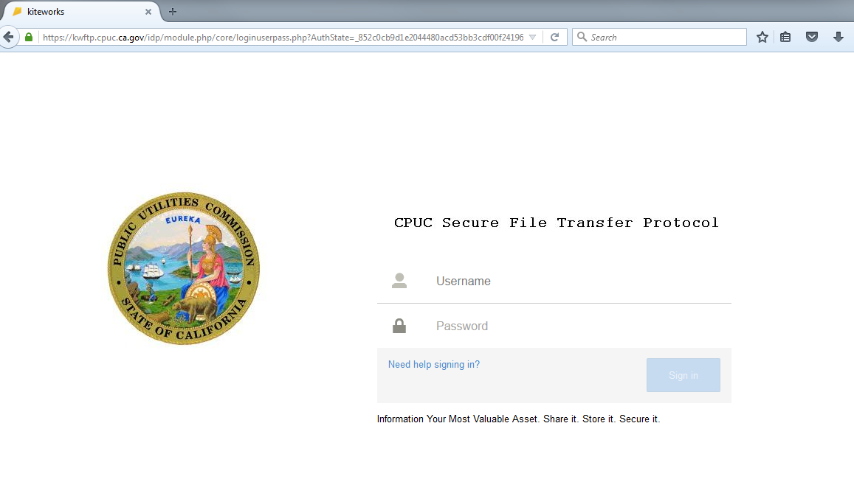

- To complete the registration process, click on “Need help signing in?” and enter your email address in the pop-up. (See Figure 2 )

Figure 2
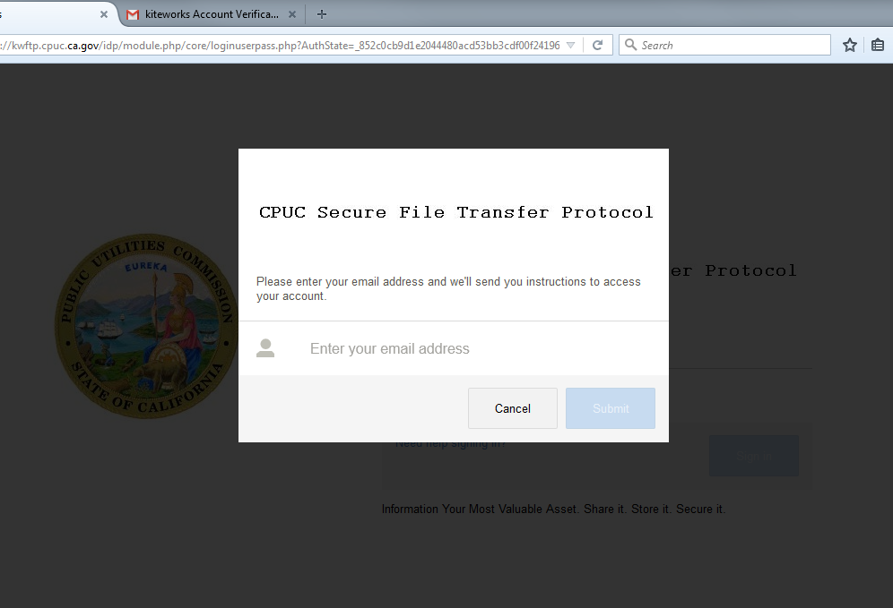

- You will then receive an email from kiteworks Account Verification. Click on the activate button in the email to activate your account. (See Figure 3)

Figure 3
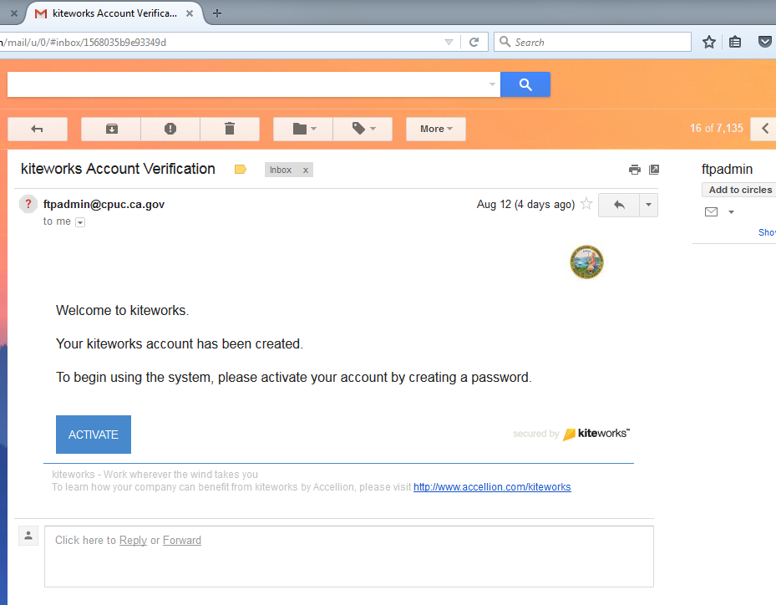

- The setup process will ask you to create a password and to re-type it. Click “Register” upon completion. (See Figure 4)

Figure 4

- Upon successful registration, you will be forwarded to the home page of the application and given the opportunity to view a tutorial. (See Figure 5)

Figure 5
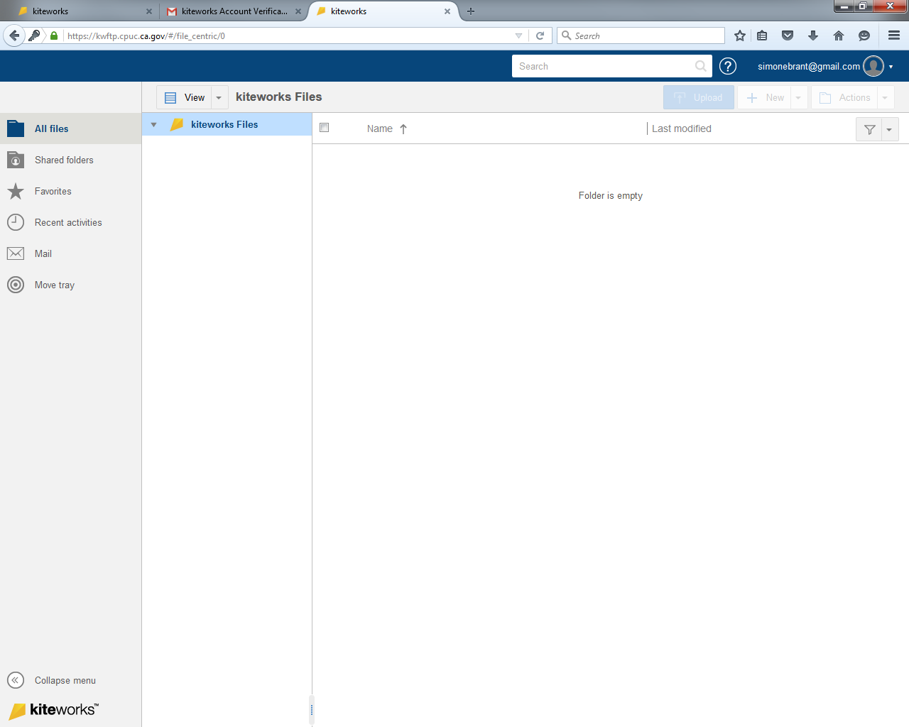

Sending Files

Follow the steps below to send files. This applies to both internal and external users.

- Click on the Mail icon on the left and then click Compose. (See Figure 6)

Figure 6
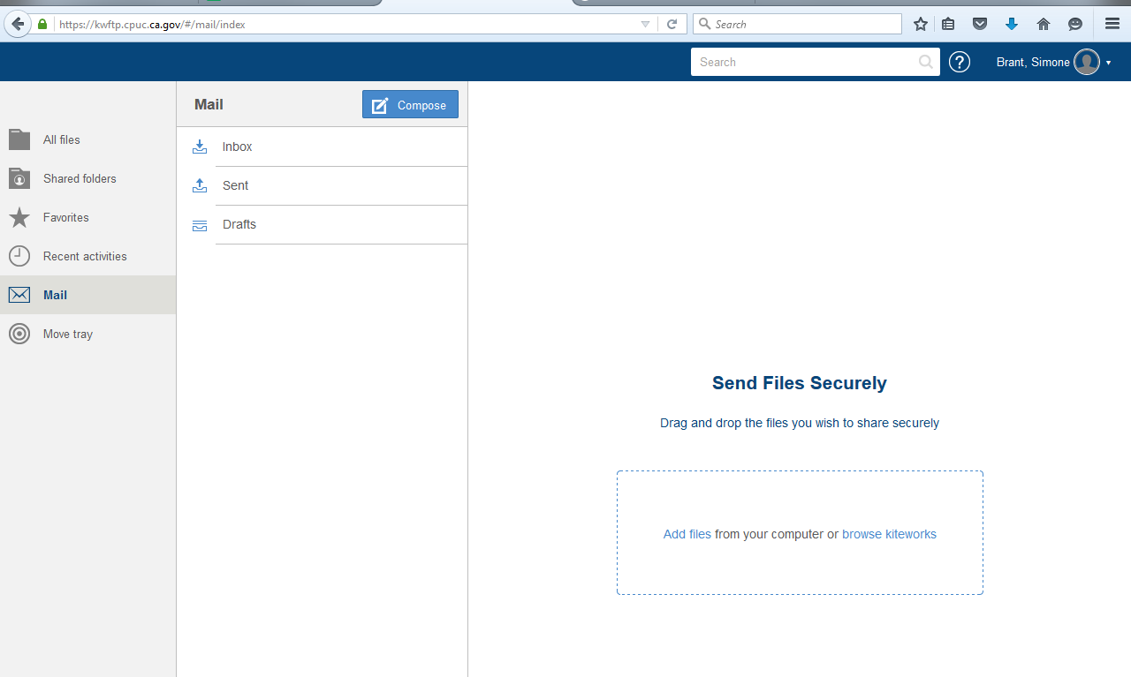

2. Enter the recipient’s email address and a subject. To attach files to the email message, drag and drop the files into the dotted rectangle or click on “Add files.” If you have files already uploaded into kiteworks you can access them by clicking on “Add files.” (See Figure 7)

Figure 7
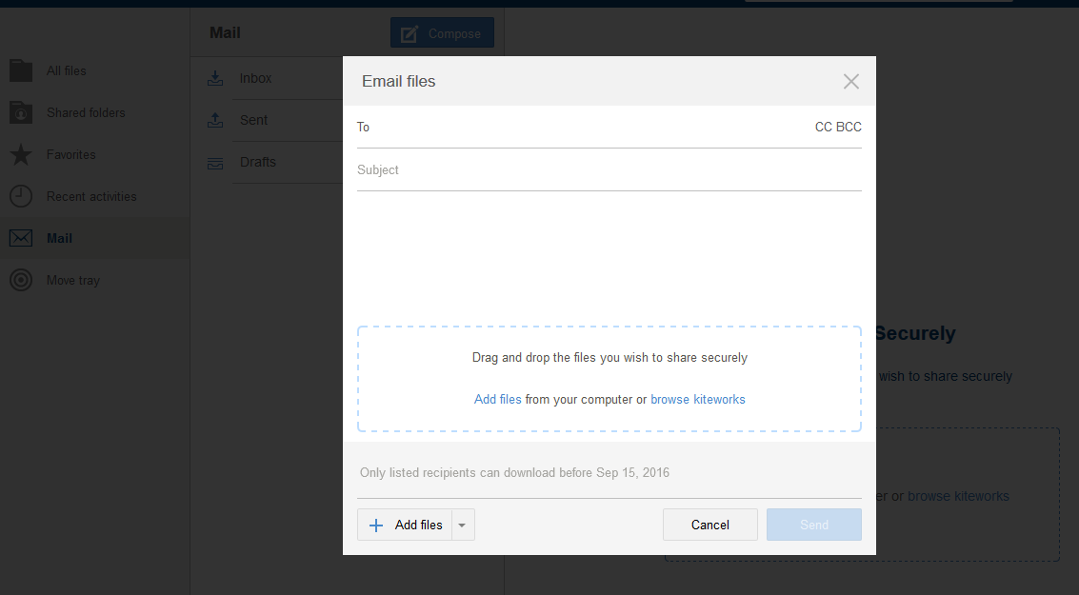

3. The attachments will upload and appear in the dotted rectangle. Click “Send.”

Receiving files

1. You will be notified via email when you have received a file. Click on the “Download” link or the link on the file name to retrieve the file. (See Figure 8)

Figure 18

2. You will be directed to your kitedrive account where you can download the file.

“System” RA as described in this guide may also be referred to as “generic” RA by CAISO.
RA compliance materials site is linked here: http://www.cpuc.ca.gov/General.aspx?id=6311
The Templates treat these negative CAM “allocations” as a positive adder to the IOUs’ relevant RAR, since the IOUs will show the CAM resources on their filings. See Section 8 below for further details.
Section 4.3.5 and OP 6(f), link here: http://docs.cpuc.ca.gov/PUBLISHED/FINAL_DECISION/119856.htm
http://docs.cpuc.ca.gov/SearchRes.aspx?DocFormat=ALL&DocID=97619935
D.05-10-042, section 7.9
D.13-06-024 at 2
3 In the case of demand response resources, the Commission will design future programs to meet CAISO and CPUC RA criteria for flexible, system, and local capacity as they exist in this proposal and as these criteria are modified in the future.
D.08-04-023, Section 4.2.6
Note that Resolution E-4907 and D.18-06-030 (at 17-18) formalized requirements related to the interaction between CCA implementation plans and the RA Program.
The transfer capacity on Path 26 must be de-rated to accommodate ETCs that are used to serve load outside the CAISO control area. “Loop flow” is common to large electric power systems and must be accommodated to prevent overloading of lines.

