2013 Filing Guide for System and Local Resource Adequacy (RA) Compliance Filings
Issued: October 5, 2012

1. Purpose and Overview of RA Guides and Templates 1
2. New for 2013 RA Compliance Year 1
3. Major components of the RA templates 3
4. The Filing Process 3
5. Using the templates – 2013 System and Local RA compliance 5
6. Net Qualifying Capacity 7
7. . Energy Auction and the Capacity Allocation Mechanism 8
8. Local RA Reallocation Process for 2013 Compliance Year 9
9. Confidentiality and RA Filings 10
10. Load Forecast Adjustments 11
11. Maximum Cumulative Capacity and Resource Categories 12
12. Demand Response Resources and the Demand Response Tab 13
13. Export Commitments made with RA Resources 14
14. Outages 14
15. Import Capacity Allocation Process for 2013 15
16. Zonal RA: Constraint on Flows Across Path 26 17
17. Certification of LSE Resource Adequacy Compliance Filing 19
18. Submission of RA Filings – Secure FTP 19
19. Correction of Errors: Minor or Substantial 20
20. RA Penalty Structure 21
Appendix A: Submission of RA Compliance Filings 22
Appendix B: CAISO Import Allocation Process for 2013 24
Appendix C: Frequently asked questions and clarifications to the filing instructions 25
Appendix D: Directions for use of Secure FTP 27

Purpose and Overview of RA Guides and Templates
This 2013 Resource Adequacy (RA) Compliance Guide (Guide) is meant to inform Load Serving Entities (LSEs) in demonstrating compliance with the CPUC’s RA program. Along with the RA System and Local Reporting Templates (Templates) LSEs are to use this Guide as reference material. To the extent that this Guide is incomplete or does not address a particular issue that the LSE may discover, the LSE is strongly requested to contact Energy Division (ED) staff immediately and request direction. Although this Guide is organized for quick reference, the LSE is strongly encouraged to read the entire Guide and become familiar with its contents. In addition to more specific line item instructions provided in the Templates this Guide presents three basic elements: a summary and explanation of what is new for 2013 Compliance Year and notifications the LSE receives, instructions for filling in the individual template pages, and instructions for submitting the Templates to ED.

New for 2013 RA Compliance Year
For the 2013 RA Compliance Year, the CPUC is issuing this Guide to specify how to fill out the Templates. Webinar workshops were held on August 6th and September 17th to cover the 2013 templates and guide. The System Month Ahead and Year Ahead Templates have been combined, but the Local RA Template is still separate. There are a number of changes made to the Templates discussed below. LSEs are encouraged to read this Guide and the instructions included in the Templates carefully and to contact Energy Division with any questions at RAFiling@cpuc.ca.gov .
Changes to the Guide and Templates for 2013 include the following:
- Dates were revised to reflect 2012-2013 dates, and some other minor rewordings to clarify directions. The schedule of filing deadlines included in section 2 of this guide are based on current rules regarding when RA filings are due; in the event alternate due dates are made please visit our online RA Filing calendar for an updated version - http://www.cpuc.ca.gov/PUC/energy/Procurement/RA/RA+Calendar.htm
- Energy Division proposes to shorten the time in between monthly CAM and RMR allocations and the RA filing due dates. In the past Energy Division has sent allocations 45 days before the compliance filing is due, but that has sometimes resulted in the need to send revisions closer to the filing due date. Energy Division proposes to shorten the time frame to 25 days in advance of the RA compliance deadline, and enable more current information to be used. This will have the effect of notifying LSEs later and closer to the filing due date of allocations, possibly affecting their procurement, but the benefits of more current information might outweigh the costs. In the event that the RA compliance due date is moved back to 45 days before the start of the month, the CAM and RMR allocations will likewise move back, to maintain coordination.
- DR resources are all listed on the DR tab now, although the allocations amounts are still included on the LSE allocations tab. This is to measure DR resources against the new DR bucket restrictions.
- The DWR tab was removed due to the expiration of the final non-unit specific DWR contract. Other unit specific DWR contracts are to be entered onto the physical Resource tab and validated against supply plans identically to other capacity. The DWR section was removed from this guide.
- The process for RMR contracts has been obviated due to reduction in DWR capacity. D.11-06-022 no longer requires a Preliminary Local RA Filing. As of 2012 RA compliance year, there is now only one existing RMR contract. RMR capacity will be included in the CAM/RMR allocation process that Energy Division performs. It is not expected that additional RMR contracts will be added in the near future, but if there is, Energy Division may return to the previous process. The RMR section was removed from this guide.
- A formula was changed in the Year Ahead Summary and the Month ahead Summary page cells E11 and F11 to reflect rule changes for 2013. DR resources no longer come off the LSE allocations page, and instead are now drawn from the DR tab. The areas on the DR tab colored orange are formulas, and are locked. LSEs are not to enter information into those cells.
- LSEs are now allowed to file updates to their year ahead load forecasts up to August 17, 2012 in order to increase accuracy. This means that the RA obligations LSEs receive in July are preliminary; although they should be close to final, LSEs will receive final obligations on September 17, 2012.
- The NQC list has been updated for 2013 compliance year.
- LSEs are no longer required to derate capacity on scheduled outage in their annual or month ahead RA filings due to the elimination of the Scheduled Outage rules.
- Local and System RA obligations and compliance with those obligations is now verified at a single decimal place or one digit after the decimal point. This supersedes earlier rounding conventions, and has been adopted in D.12-06-025.
Timeline for Year Ahead Load Forecasts for 2013 Compliance Year:

LSEs file Historical load info | Mar 16, 2012
LSEs file 2013 Year-Ahead Load Forecast | Apr 20, 2012
LSEs receive 2013 Year-Ahead RA obligations | Jul 31, 2012
Final date to file revised forecasts for 2013 | Aug 17, 2012
LSEs receive revised 2013 RA obligations | Sep 17, 2012

Load Forecast and Month-Ahead filing dates for 2013 RA Compliance (Includes dates for Local RA True up Filings pursuant to D.10-12-038)
RA filing month | Load Forecast month | Due Date
Final 2013 Year-Ahead | January | Oct 31, 2012
January | February | Nov 30, 2012
February | March | December 31, 2012
March | April (with first Local RA August revised forecast) | Jan 31, 2013
April | May | Feb 28, 2013
May (first cycle) | June(with second Local RA August revised forecast) | Apr 2, 2013
June (first cycle) | July | Apr 30, 2013
July (second cycle) | August | May 31, 2013
August (second cycle) | September | Jul 1, 2013
September (second cycle) | October | Jul 31, 2013
October (second cycle) | November | September 3, 2013
November (second cycle) | December | September 30, 2013
December (second cycle) | January | Oct 31, 2013
This calendar reflects the current RA Filing timelines. In the event a variation is approved via Commission decision that changes the due dates for RA filings, Energy Division will issue a new RA Guide with a revised timeline in it.

Major components of the RA templates
The Templates are comprised of a number of individual tabs including the following:
- ID and Local Areas tab listing resources available for use in the RA Filings. Information is taken from the CAISO NQC list
- LSE Specific Allocations of Demand Response, CAM, RMR, Path 26, and load forecasts are still inserted into the LSE Allocations tab so as to minimize manual error and paperwork
- Year Ahead and Month Ahead Summary Sheets that sum resources and compute LSE compliance are included in one template. The Month Ahead summary sheet also includes a check for Local RA adjustments. Combined Physical Resource and Import worksheet for LSEs to report contracts with unit specific CAISO resources and import RA resources
- DWR worksheet was removed due to the expiration of the final non-unit specific DWR contract
- Resources Under Construction worksheet
- Demand Response Resource worksheet for reporting DR allocations and all other DR programs not part of the DR allocations; DR allocation information is drawn from the LSE allocations page, but LSEs can also enter information for programs that are not allocated. The DR tab draws DR allocations into the DR tab, and the DR tab information flows through to the Summary pages

The Filing Process
Decision (D.) 05-10-042 established a Year-Ahead and Month Ahead System Resource Adequacy Requirement (RAR) for Load Serving Entities (LSEs) under the jurisdiction of the California Public Utilities Commission (CPUC). D. 06-06-064 expanded the RA program to include a Year-Ahead Local RAR, and D.10-12-038 adopted a Local RA Process for compliance year 2012 and onward.
- Due October 31, 2012: LSEs are required to make a 2013 Year-Ahead System and Local RAR compliance filing that demonstrates compliance with the Year Ahead System RA obligation, which is 90% of the total load plus planning reserves for the five summer months of May through September of the applicable compliance year. LSEs are also required to meet 100% of the Local RAR for all 12 months of the applicable compliance year. LSEs must show any unit they have under contract that is a Local RA unit and included in the CAISO NQC list, although units in excess of Local RA obligations may be listed on the Additional Local Resources tab.
- Monthly: LSEs are required to continue making monthly forecasts and monthly system RAR showings that track load migration and demonstrate compliance with 100% of an LSE’s system RAR. LSEs are allowed to update their month ahead load forecasts up to 25 days before the RA compliance filing for that month, pursuant to CEC approval. In addition, LSEs must demonstrate that they have procured sufficient capacity to meet incremental Local RA obligations as adjusted by the Local RA True-up process in the monthly RA compliance filings.
- Local RA Reallocation – Pursuant to D.10-12-038, LSEs are required to provide load forecast adjustments to the CEC two times in 2013. These forecast adjustments should provide a forecast for every month from the current month out to August. The first one will be included with their April Month Ahead load migration forecast filed on January 31st. The second one will be included with their June Month Ahead load migration forecast that is filed on April 1st. LSEs are to demonstrate additional RA procurement to meet the incremental Local RA allocations arising from the first cycle and demonstrate procurement for those values in their May and June Month Ahead RA filings. LSEs shall then demonstrate procurement to meet the reallocated values calculated from the second revised forecast in their July through December Month Ahead RA showings.
Templates
The Guide herein and the accompanying Templates (System RA template and Local RA template) provide the means for LSEs to demonstrate compliance with the System and Local RAR Program:
- For 2013 Year Ahead System RAR Template – LSEs are required to use the 2013 System RA Template for the period of May through September.
- For 2013 Local RAR – LSEs are required to use the Local RA Template to demonstrate compliance with the Local RAR for all 12 months of 2013. Local RA resources procured in excess of Local RA obligations may be listed on the Additional Local Resource tab.
- For 2013 Monthly RAR, the 2013 System RA template contains summary sheets for both Year Ahead and Month Ahead compliance, and LSEs are required to use the 2013 System RA Template to demonstrate compliance with 2013 Month Ahead RAR. The month ahead summary tab of the template is automated to perform the Month Ahead RA requirement checks. For 2013 Local RA Reallocations: LSEs are required to use the California Energy Commission’s (CEC) 2013 MA load forecast template to revise their forecasts through August 2013 twice during 2013. Please consult the schedule in Section 2 of this guide.
- System and Local RA obligations have been rounded off to the nearest tenth of a MW (one decimal place) pursuant to the convention adopted in D.12-06-025.The Local RA allocations and the System RA templates have been adjusted to reflect these rounding conventions.
Notification of LSE RA obligation
Each LSE was notified by the CEC/CPUC Energy Division of their Local and System RAR, as well as their DR and CAM allocations. This notification process consisted of four parts.
- For System RAR – On July 31st, 2012 LSEs were notified via Secure FTP of their monthly peak load forecasts, DR Allocations, and CAM Allocations for use in the Year Ahead System RA Filing. LSEs are to consider these RA obligations preliminary, as LSEs will receive Final 2013 RA obligations on or about September 17th, 2012 after LSEs have filed adjusted forecasts. Barring change to RMR contracting, LSEs are to consider those allocations final. On a separate timeline, each LSE will receive notification of their Import Allocations and Path 26 Allocations for use in their System RAR filing. See Sections 12 and 13 for more details regarding Path 26 and Import Allocation.
- For Local RAR -- LSEs were notified of their Local RA obligations net of CAM and RMR amounts for use in the Year Ahead Local RA Filing on July 31st, 2012. Please note that Local RA obligations are not net of DR this year, as DR is to be included as a resource on the DR tab. LSEs received additional DR credit to decrease their Local RA obligations. LSEs are to consider these RA obligations preliminary, as LSEs will receive Final 2013 RA obligations on or about September 17th, 2012 after LSEs have filed adjusted forecasts. Barring change to RMR contracting, LSEs are to consider those allocations final.
- For Monthly System RAR – LSEs were issued their System RAR for all months of 2013 on July 31st, 2012. LSEs are required to comply with the Monthly Load Forecast Adjustment process throughout 2013 as done in past years. LSEs are to continue using the Import Allocations and Path 26 Allocations they receive in August 2012 for all 2013 Month Ahead RA Filings. CPUC Energy Division will notify LSEs via Secure FTP of any change to Condition 2 RMR allocations and CAM Allocations as they occur throughout compliance year 2013 for use in subsequent Monthly RA Filings.
- For Local RA Reallocation Requirements- LSEs will receive notification of adjustments to their Year Ahead Local RA obligations concurrent with their CAM and RMR allocation letters via Secure FTP. The Local RA adjustments for May and June will be sent with the May CAM/RMR allocations. The Local RA adjustments for July-December will be sent with the July CAM/RMR allocations.

Using the templates – 2013 System and Local RA compliance
For 2013 RA compliance year, several key changes were made, both adopted by decision and implemented by Energy Division staff consistent with adopted CPUC policy, thus LSEs are encouraged to pay close attention during RA workshops and to contact Energy Division staff for more direction.
Preliminary 2013 RA obligations and capacity allocations were sent to LSEs on July 31st, 2012 via SFTP. LSEs will receive Final 2013 RA obligations and allocations on or about September 17th, 2012 after LSEs have had a chance to submit any revisions to their load to incorporate any load migration in between their original forecast submissions in April. LSEs are to meet these obligations on October 31st, 2012 in their 2013 System and Local Year Ahead filing.
LSEs receive their Local RA obligations net of CAM and RMR, while Local RA obligations are not net of Local DR allocations. RMR was deducted from total Local RA obligations as all LSEs within CAISO (both CPUC jurisdictional and non-CPUC jurisdictional) pay a portion of the RMR costs. After this step, load shares were applied to the remaining Local RA obligations to arrive at CPUC jurisdictional Local RA obligations net of RMR. From those totals, CAM amounts were deducted from the CPUC jurisdictional portion of the LCR as only IOU distribution customers (IOUs, Community Choice Aggregators, and ESPs) pay for those resources. Then, remaining CPUC jurisdictional Local RA obligations were allocated to LSEs on the basis of share of CPUC jurisdictional TAC area peak forecast, exclusive of publically owned utility load shares (meaning CPUC jurisdictional load shares sum to 1 for each TAC area).
LSEs use the templates to report contracts they have signed with qualifying generators in order to verify compliance with RA obligations. LSEs notice their RA obligations on the summary page, and begin listing contracts to meet their RA obligations on the appropriate tab. For unit specific RA resources, either internal to CAISO or imported into CAISO, the LSE is to use the Phys_RES_Import_RES tab. LSEs begin by entering a contract identifier in the first column, then selecting a Scheduling ID in the second column. The Local and Zonal Area designation will be automatically propagated. From there, the LSE is to enter the applicable System and Local MW amounts in the appropriate columns, so the LSE can demonstrate compliance with the System and Local true up RA obligations. The LSE is to enter MW capacity amounts into the right column to illustrate which MCC bucket the resource is in, as well as enter the total number of available hours in the month for the contract. These hours of availability must include peak hours of the day. LSEs are to enter similar information into the other tabs of the template to list all available RA capacity for the month.
MW capacity information will be totaled and flow through to the summary pages. LSEs are to use the appropriate summary tabs (year ahead or month ahead) to verify they are in compliance before filing. CPUC staff will then do compliance review on the templates and notify LSEs of any corrections or errors found.
Pursuant to D.10-06-036 LSEs are able to list additional Local RA resources that they have contracted for but are not committed for RA. That way, LSEs can list resources under contract for possible backstop designations but not commit them to availability penalties in the event of forced outage. The Local RA template has a tab for Additional Local Resources controlled by LSEs but not committed as RA resources.
Listing all Local resources that LSEs control is mandatory, meaning that LSEs are not able to avoid informing CPUC and CAISO as to which Local resources are under contact to LSEs, but it is no longer mandatory that all Local resources that LSEs control must be committed for RA and subject to the RA Must Offer Obligation. Once a unit is listed as an Additional local resource on this tab the LSE cannot also claim it as RA in the same filing. Subsequent to the filing of the Additional Local Resource tab (made with the 2013 Year Ahead Local RA Filing) the LSE may choose to later commit the resource as RA in a subsequent 2013 Month Ahead RA Filing, but if the resource is committed to provide RA and satisfy RA obligations, then it is no longer a non-RA unit available for substitution or other non-RA purposes.

Net Qualifying Capacity
D. 05-10-042 requires all LSEs to fulfill their System RAR through purchase of Net Qualifying Capacity (NQC). Decision 10-06-036 adopted a Qualifying Capacity Manual that describes the methodologies used to calculate NQC values for all resources. This manual can be found under 2012 RA compliance materials on the RA compliance materials page. The Final 2013 CAISO NQC List will be available and posted under “Current Net Qualifying Capacity (NQC)” on the CAISO website at: http://www.caiso.com/1796/179688b22c970.html as well as on the CPUC website at http://www.cpuc.ca.gov/PUC/energy/Procurement/RA/ra_compliance_materials.htm
Every resource has a resource name (“RES Name”) and associated resource identification number (“Scheduling Resource ID”). Each unit also has a Path 26 and Local Area designation. Resources not located in Local Areas are labeled as “CAISO system” and can only count toward the System RAR. There are also other import resources not listed on the NQC list that can count for RA, provided the LSE has import allocation on the applicable path allocated by CAISO or obtained from someone who received the allocation from the CAISO. Please check that you have an Import Allocation applicable to these resources and that these resources are listed on the Import Worksheet of the RA template.
A list of Scheduling IDs and their Zonal and Local designations is included in the RA template, for purposes of making the compliance workbook more automated for LSEs. New resources that are added as they come online in 2013 or that change their Scheduling Resource ID can be added to the bottom of the list until the new units are reflected in an update that is posted on the CPUC website. It is the responsibility of the LSE to ensure that information is entered correctly.
Resources under construction are listed on a separate tab of the NQC List, and the resources on this list are available for listing by an LSE in their Year Ahead RA Filing on the “Under Construction” tab provided that the current projected date of commercial operation (COD) for the resource is on or before the first date of the compliance month in which the LSE wishes to count the resource towards their RA obligation. Information on the 2013 NQC List will not be changed except for data maintenance and correction of errors, and addition of new resources that come online during the course of 2013. Any revisions made by the CAISO after it is published will be evaluated by the CPUC before being added to the list posted on the CPUC website. Revisions can raise a given unit’s NQC or add units to the NQC list, but CAISO revisions cannot lower the resource’s NQC or remove units for purposes of RA. In instances where more than one Local Regulatory Authority seeks to determine NQC values for a given Scheduling ID, the CPUC will post NQC values consistent with CPUC adopted QC calculation methodologies and CPUC jurisdictional LSEs are required to use the values posted on the CPUC website for subsequent compliance filings. As the CPUC updates the list throughout the year, the new ID and Local Area information will be included in subsequent templates sent to LSEs with revised allocations or other updates.
NQC and Local RA compliance
D.06-06-064 adopted a program of Local RAR for LSEs that are under the jurisdiction of the CPUC, while D.12-06-025 adopted Local RA totals for 2013 compliance year. These decisions require all LSEs to procure physical resources to meet the Local RAR. These units are to be located in the ten LCR areas identified in the CAISO NQC list. For purposes of RA compliance, the ten LCR areas have been aggregated into five Local Areas (LA Basin, Big Creek/Ventura, San Diego-IV, Other PG&E Local Areas, and the Greater Bay Area). The Other PG&E Local Areas include the Local Areas of Fresno, Humboldt, Kern, North Coast/North Bay, Sierra, and Stockton. The LSE is responsible for verification of the Local Area Designation of the unit, as well as the NQC value and the Scheduling Resource ID.
In the case of DR resources, the template will utilize the August DR values for each Local Area for each of the 12 months of the year.
To report a contract with a unit located within a Local Area on the Local Template, LSEs select the correct Scheduling ID from a drop down list in Column C of the Reporting Template, and upon selection, the Local Area designation is filled in for the LSE.
During 2013 compliance year, LSEs are to make RA compliance filings demonstrating compliance with the Local RA obligations as adjusted by the Local RA True-up filings. Thus there is a column entered into the Physical Resource worksheet to allow LSEs to demonstrate monthly Local RA compliance on the same template as System RA compliance. Since only unit specific Physical Resources count towards meeting the LSE’s Local RA obligation, there are no corresponding columns created on other resource tabs.
The Physical Resource tab has a column called “Local RA MW” (Column G) where the LSE is to enter the amount in MW that is meant to satisfy Local RA obligations from that unit. This amount is to be the same MW amount the LSE has listed in their Year Ahead Local RA filing for the appropriate month, which means that this value will be different from the System RA MW for that month for two reasons. First, the values will be different in the event that the resource is affected by scheduled outage for that month, and thus listed at lower MW that the Local RA MW amounts unaffected by outages. Second, this value will be different from the System RA MW for the appropriate month in the event that the resource has a monthly NQC, which differs by month. In that event, the LSE would list the correct applicable month’s NQC in as a System MW but list the August NQC value in the Local RA MW column.

. Energy Auction and the Capacity Allocation Mechanism
Pursuant to the Energy Auction and the Capacity Allocation Mechanism outlined in D.06-07-029, IOUs may enter into contracts for the construction of facilities to meet system demands. The costs will be allocated to all benefitting customers. Due to the cost allocation, LSEs will receive an allocation of capacity for resources that are paid for via the Energy Auction Mechanism. In addition, other types of capacity are also allocated via the CAM. The recent CHP settlement (adopted in D.10.12.035) as well as CAISO backstop procurement under CPM are allocated to LSEs as their customers pay a portion of the costs. In addition, any procurement ordered by the Commission and ordered to be paid for by all benefitting customers in general will be allocated to all LSEs. Energy Division will send the credit to LSEs monthly, and LSEs are to enter the information into their LSE allocation tab which will allow the capacity to be counted towards the LSE’s RA obligation. In the past allocations were sent to LSEs 45 days before the due date of the applicable compliance filings, but for 2013 year and onwards, Energy Division will send the information 25 days before the due date of the compliance filing. This is done as to make use of more updated information and to utilize a more current load share ratio. In the event that the RA compliance due date is moved back to 45 days before the start of the month, the CAM and RMR allocations will likewise move back, to maintain coordination.

Local RA Reallocation Process for 2013 Compliance Year
D.10-12-038 adopted a local RA reallocation process for the 2012 compliance year and onwards.
The Local RA reallocation process requires the use of the two existing templates, the load migration forecast template and the System RA compliance template.
The Local RA reallocation process includes two adjustment cycles, one occurring during the first quarter of the year to apply for filings in the second quarter in the year, and one occurring in the second quarter of the year to apply for filings in the third and fourth quarters of the year. LSEs file adjusted load migration forecasts, receive incremental Local RA adjustments, and have 25 days to procure incremental Local RA in order to meet adjusted Local RA obligations.
The first Local RA reallocation cycle requires LSEs to file load forecast adjustments through August compliance month and submit those forecasts with the April load forecast adjustments. LSEs will have approximately five days to make any corrections to their load forecasts. California Energy Commission (CEC) and Energy Division staff will notify LSEs of incremental adjustments to Local RA obligations for May and June and send these to LSEs 25 days before the May MA filing compliance due date. The adjusted Local RA obligations will then be used for May and June Month Ahead RA filings. The incremental Local RA adjustments must be inserted into the LSE Allocations tab of the RA Compliance Template in Table 5. Table 8 in the month-ahead summary tab will calculate any needed or extra local capacity for the month-ahead RAR.
The second Local RA reallocation cycle requires LSEs to submit another load forecast to the CEC along with the June load forecast adjustments. This will again include forecasts through August compliance month. LSEs will have approximately five days to make any corrections to their load forecasts. Staff will use those forecasts to notify LSEs of adjustments to Local RA obligations for July through December compliance month. The second incremental local RA obligations will be sent to LSEs 25 days before the July MA filing compliance due date. That same Local RA obligation shall apply through the remaining months of the compliance year. There is no third reallocation cycle.
LSEs will receive adjustments to their Local RA obligations through the Secure FTP. LSEs may request allocations inserted into the template, or LSEs can insert the allocations themselves.
Pursuant to the Local RA Reallocation process adopted in D.10-12-038, Energy Division will provide adjustments twice in 2013 per the schedule in section 2 of this guide. LSEs will receive incremental Local RA adjustments, which will adjust the Year Ahead Local RA Allocations in Table 3 of the LSE Allocations tab. LSEs must enter the incremental Local RA adjustments received from Energy Division into Table 5 of the LSE Allocations tab. To implement the provision that allows for aggregation of incremental Local RA procurement after the Year Ahead RA Filing, LSEs will receive incremental adjustments to their Local RA obligations (either a positive or a negative number) for each Local Area. LSEs may enter the allocation in any Local Area in the same Transmission Access Charge (TAC) Area. For example, if an LSE receives a two MW incremental Local RA adjustment in LA Basin, the LSE could enter 2 MW in Big Creek/Ventura and procure a two MW resource in Big Creek-Ventura instead. The LSE could also enter one MW in each LA Basin and Big Creek-Ventura. The template will draw the allocations entered by LSEs into the Summary Tab and calculate any needed or extra local capacity for the Month Ahead-RA showing.

Confidentiality and RA Filings
We start with a presumption that information should be publicly disclosed and that any party seeking confidentiality bears a strong burden of proof. However, in some instances (such as "market sensitive" information relating to electric procurement that passes a materiality standard), confidential treatment of data may not only be allowed, but may be required in order to carry out our statutory and constitutional duties.
Parties or persons submitting RA Filings for which they claim a right to confidential treatment shall attach a declaration under penalty of perjury certifying that they are only claiming confidentiality for data included in the D.06-06-066 Matrices. Pursuant to D.08-04-023, an LSE need not seek confidential treatment every time it makes a compliance filing of a repetitive nature. Instead, on making subsequent compliance filings, the LSE may cite the earlier declaration for confidentiality. Thus the LSE is instructed to file a declaration accompanying the 2013 Year Ahead System and Local RA Filing and refer to that declaration by date and subject in the cover letter submitted alongside subsequent Month Ahead RA Filings.
The LSE is required to send a signed electronic version of the declaration in pdf format via the Secure FTP application accompanying the 2013 Year Ahead Filing templates and cover letter, and to include a reference to this declaration by date and summary of content in the cover letter accompanying each future Month Ahead RA Filing. LSEs also may use the initial declaration submitted with the 2013 Year Ahead Filing to request protection for the annual and month ahead load forecast information submitted to the CEC; the LSE is to refer to the initial declaration filed with the 2013 year ahead filings in the cover letter to the Load Forecast submittals.
RA Filing or data requests related to RA Filings
Situation: An LSE files a RA Filing and seeks confidential treatment for data of the type addressed in the Matrices to D.06-06-066. In this situation, the following procedure applies:
A declaration under penalty of perjury will accompany the filing, establishing the five factors required by D.06-06-066, Ordering Paragraph 2, listed below but no motion is initially required.
- That the material constitutes a particular type of data listed in the Matrix;
- The category or categories in the Matrix to which the data correspond;
- That the submitting party is complying with the limitations on confidentiality specified in the Matrix for that type of data;
- That the information is not already public; and
- That the data cannot be aggregated, redacted, summarized, masked or otherwise protected in a way that allows partial disclosure.
If another person asks to see the confidential data, the filer and the requesting person shall meet and confer to resolve the dispute informally, consistent with the intent of new Rule 11.3 of Commission Decision D.06-06-066. If they cannot resolve the dispute, the filer and the requesting person shall present the dispute to the assigned ALJ. The confidentiality claim and dispute will be resolved consistent with the Commission’s procedures for addressing confidentiality claims and requests for information in the context of Public Record Act requests.

Load Forecast Adjustments
D.05-10-042 stated “[w]e require that month-ahead compliance filings include adjustments for positive and negative load growth due to migration. Apart from load changes due to load migration, load forecasts should not be updated from LSE’s Year-Ahead filing.” LSEs submit historical load data and year ahead load forecasts in March and April of the year before the RA compliance year. CEC staff complete analysis on the LSE submitted information and together with overall statewide forecasts that CEC staff produce annually, LSEs are sent updated year ahead RA obligations based on load forecast information. LSEs receive this information in July of each year. Before 2012 compliance year, LSEs were unable to revise or change their forecasts between April and the October RA filing deadline. This proved to be a significant period of time, and some LSEs requested the ability to revise their year ahead information closer to the RA Filing. D.11-06-022 created a process for LSEs who wish to adjust their year ahead forecasts to do so up until August 17. This will ensure that RA obligations LSEs procure to meet are as accurate as possible. The decision adopted a schedule for doing that, and it is integrated into the schedule in section 2.
On July 31st, 2012 the CPUC sent each LSE the preliminary month specific RA obligation for January-December 2013. Because the Year-Ahead forecasts will make assumptions about direct access load, the Year-Ahead forecasts are revised to account for actual direct access customer migration to date, and expected additional load migration prior to the obligation period. On August 17, LSEs are able to submit revised forecasts to account for load migration or revised assumptions that occur between April and August. This is to improve accuracy of the RA obligations that LSEs are required to procure towards and that are to be met with the year ahead filing in October. All LSEs will receive Final RA obligations and allocations on or about September 17; all LSEs will receive adjustments even if each LSE does not individually file adjustments to their year ahead load forecasts. IOUs should adjust their forecast to account both for customers who are known to have returned to bundled service and for those that have notified the IOU that they intend to return to bundled service prior to the Filing Month. ESPs should account for contracted load and a reasonable expectation for the rate of contract renewals of non-firm load or load with expiring contracts. If the CEC determines that the assumptions made are not plausible, the CEC may make a plausibility adjustment to account for a more plausible rate of customer retention. The CPUC requires LSEs to procure to meet RAR based on the load forecasts that are submitted to the CEC and adjusted by the CEC.
After the Year Ahead RA compliance filings, an LSE with migrating direct access customers is responsible for adjusting its monthly load forecast and monthly RA obligation and reflect those changes on the monthly RA Template, which is currently due along the same schedule as the Month Ahead RA Filings. IOUs should adjust their forecast to account both for customers who are known to have returned to bundled service and for those that have notified the IOU that they intend to return to bundled service prior to the Filing Month. ESPs should account for contracted load and a reasonable expectation for the rate of contract renewals of non-firm load or load with expiring contracts. If the CEC determines that the assumptions made are not plausible, the CEC may make a plausibility adjustment to account for a more plausible rate of customer retention. The CPUC requires LSEs to procure to meet RAR based on the load forecasts that are submitted to the CEC and adjusted by the CEC. The CEC will communicate these monthly adjusted forecasts to the CPUC for compliance validation purposes.
D.10-06-036 (OP 6e) ordered that Load Serving entities may, at the discretion of California Energy Commission staff, file changes to their load forecasts up to 25 days before the due date of any 2013 month-ahead compliance filings. LSEs are not to submit revisions after the filing due dates laid out in Section 2 of this Guide, unless approved by CEC staff, and any revisions made after the filing date without CEC approval or any revisions made less than 25 days before the RA compliance filing will be ignored by CEC and CPUC staff for RA compliance purposes.
The CEC has provided a separate template to facilitate the forecast revision process and verify that migrating load is correctly accounted. LSEs which have gained or lost customers since their Year-Ahead forecast will enter the amount of monthly peak load associated with the change in customers, and the template will make the appropriate adjustments, including coincidence. LSEs are to submit complete load forecast adjustments each month to the CEC. This required submission shall include the certification sheet signed by an officer of the company, as well as the electronic template and all supporting data. LSEs are asked not to send this information to the CPUC or the CAISO as they do not need to receive this submission. Guidelines for submission of load information are provided by the CEC.
To implement D.10-12-038 LSEs are required to submit load migration estimates through August with both the April MA load migration filing and the June MA load migration filings to recalculate and reallocate local capacity allocations. LSEs are to continue using the “best estimate” approach, which requires LSEs to make a forecast of anticipated customer retention as well as new customers coming to the LSE. As the “best estimate” approach requires LSEs to forecast load migration in advance of final Direct Access Service Request (DASR)/Community Choice Aggregator Service Request (CCASR) approval, the CEC will expect LSEs to be as accurate and complete as possible and may adjust or correct load migration filings before reallocating Local RA obligations. LSEs are to account for the impacts of Load Migration via the LSE Allocation tab in the Month Ahead RA Filing. LSEs are to enter the Net Change in Load plus Trans. Losses & UFE for each service territory into Table 4 of the LSE Allocations tab for the appropriate month. Summary Table 1 in the Month Ahead Summary Page will sum the Year Ahead forecast for each service territory and the Net Change in Load for each service territory for that month to determine the LSE’s RA obligation. The data for Table 4 is the data from Column 7 (M-O) of the LSE’s most recent Load Forecast adjustments submitted to the CEC.

Maximum Cumulative Capacity and Resource Categories
Maximum Cumulative Capacity categories (the so called “MCC buckets”) were designed in 2005 to limit LSE reliance on resources to meet RA that are contractually limited in their hours of availability. Since 2005, standard energy contracts no longer count towards RA and LSEs are shifting more and more to meeting RA obligations with resources that are not contractually limited. There remain other concerns related to physical availability of the facility due to emissions limits or intermittency of production, which are not dealt with by the MCC buckets structure, forming part of the reason why Energy Division proposed to redesign the buckets in the 2013 RA proceeding. D.12-06-025 revised the percentages applicable to the buckets to reference more updated load shapes, from 2009-2011, and also added a bucket for Demand Response resources. The hour limits for all the existing buckets remain the same, and the hour limit for the DR bucket was chosen in light of the fact that all DR programs are available a minimum of 24 hours in a month. Energy Division intended to allow all current DR programs to continue to count for RA even within the new DR bucket construct. For 2013 RA compliance year, there is no MCC percentage limit on the DR bucket. The chart below outlines the different buckets applicable for 2013 compliance year. As in past years, the MCC restrictions will apply and be based on the total RA obligation not the year ahead 90% RA obligation.
Summary of Resource Categories
Category | Resources may be categorized into one of the five categories shown below, according to their planned availability as expressed in hours available to run or operate per month (hours/month):
DR | Demand Response resources available for “Greater than or equal to” 24 hours per month.
1 | “Greater than or equal to” the ULR [Use Limited Resource] monthly hours as shown in the Phase 1 Workshop Report, Table “Number Hours ISO Load Greater than 90% of the Monthly Peak,” p.24-25, last line of table, titled “RA Obligation,” http://www.cpuc.ca.gov/word_pdf/REPORT/37456.pdf  These ULR hours for May through September are, respectively: 30, 40, 40, 60, and 40, which total 210 hour and have been referred to as “the 210 hours.”
2 | “Greater than or equal to” 160 hours per month.
3 | “Greater than or equal to” 384 hours per month.
4 | All Hours (planned availability is unrestricted)

Demand Response Resources and the Demand Response Tab
In the past LSEs received an allocation of Demand Response (DR) credit for programs that were administered by the utilities. These allocations have been listed on the LSE allocation tab of the compliance spreadsheet and have directly debited from the LSE’s RA obligation. LSEs have not needed to do anything or list any additional information to receive credit for these programs. The DR allocations have been augmented by the 15% planning reserve margin to reflect that DR programs directly reduce the load that the system is required to support, and thus that load does not need planning reserves.
Most LSEs other than the utilities have not themselves developed DR programs. Although the DR tab of the compliance template has been available for this purpose, no LSE has used it.
Pursuant to D.12-06-025, a new MCC bucket has been created for DR resources, and the percentages used for MCC buckets has been updated to reflect a more current load shape.
To implement the new bucket, the summary page has been updated to draw data from the DR tab instead of the LSE allocation tab. This DR tab will be where LSEs list all the DR allocations they receive, for each Local Area, as well as any programs that they themselves run or are not allocated. The DR tab is automated, and DR allocation information is drawn directly into the DR tab and on to the Summary tabs. There would be an indication of which cells to avoid, preserving the automation.
Several other rules have been adopted in recent DR decisions so as to conform DR programs to other RA resources more fully and they are repeated below.
The NQC for DR resources will be grossed up to add back the affects of distribution and transmission line losses. The formula adopted in D.10-06-036 as adjusted by ALJ ruling on July 27 is as follows:
DR RA Value= 1.15*DR Load Impact * (1.00/ (1.00-transmission and distribution (T&D) Line Loss Rate)) where T&D Line Loss Rate= 3% + IOU-specific Distribution Loss Factors.
Pursuant to D.11-06-022, the rules adopted in D.05-01-042 are superseded and no longer effective. All DR resources are required to be available a minimum of four hours per day and three days in a row to be available as RA credit. This is to harmonize rules for DR RA resources with non-DR conventional RA resources.

Export Commitments made with RA Resources
Some LSEs have export commitments that they seek to fulfill with RA Resources. The Reporting template formalizes a method for the LSE to accomplish this end while maintaining the level of proper RA resources to meet the LSE’s RA obligation within CAISO. This is done via the Physical Resource worksheet. LSEs are to list the amount of Export Commitment into which they have entered with a negative value of MW capacity in the proper Maximum Cumulative Capacity resource category. All other information is also entered, such as contract start date and contract end date and contract identifier. The LSE is directed to add the export commitment as if it was a new generator. On the ID and Local Area tab the LSE is to create a Scheduling ID that includes an abbreviation of the name of counterparty. The LSE is to enter a Zonal Designation for the export commitment in the ID and Local Area tab also. For Export Commitments that exit the CAISO via an intertie in SP26, the export commitment has a Zonal Designation of SP26 and for commitments that exit the CAISO via an intertie in NP26, the export commitment would be designated as NP26. Since a negative number is listed, and a zonal designation is given for the resource, the template is able to debit the export commitment from resources in that zone to ensure that the amount of the LSE’s RA obligation is still met with an appropriate amount of resources within that zone.

Outages
D.11-06-022 eliminated the scheduled outage replacement rule, and now LSEs are free to count units towards their RA obligations, even if the unit is impacted by a scheduled or forced generator outage. This rule may be re evaluated in future RA proceedings due to experience in the course of 2013.
Scheduled Outages:
Beginning in 2013 compliance year, the CPUC no longer has a scheduled outage replacement rule. This CPUC’s scheduled outage replacement rule has been replaced by the CAISO’s replacement requirement for scheduled generation outages. http://www.caiso.com/27f1/27f1da3b56ef0.html
Forced Outages:
Forced outage of any RA resource occurring during a month does not change the RA compliance established for that LSE for that month. If the forced outage continues into a succeeding months, the resource may still be counted towards the LSE's RA compliance.

Import Capacity Allocation Process for 2013
Note: Please refer to the CAISO Tariff, Section 40.5.2.2 for the express language on this topic and Appendix B of this Guide for a quick reference guide as to the timelines and tasks that are codified in this section of the CAISO Tariff.
In summary, import capacity will be assigned to entities that serve load in the CAISO Control Area in 2013 per the following steps:
- For 2013, the CAISO will establish for each branch group the total import capacity values into the CAISO Control Area and publish these values on its website by July 1, 2012. The information can be found on the CAISO website at: http://www.caiso.com/1c44/1c44b2dd750.html
- For each branch group, the CAISO will determine the Available Import Capability into the CAISO by taking the Total Import values from Step 1 and deducting the import capacity associated with (i) Existing Transmission Contracts and (ii) Encumbrances and Transmission Ownership Rights.
- The import capability associated with ETCs and TORs in Step 2 will be reserved for the holders of such commitments, and will not be reduced subsequent to the following process.
- The LSEs submitted their existing commitments from resources outside CAISO Control Area entered into before March 10, 2006 and with a term lasting through the year 2012 as part of the 2012 Compliance Year Import Allocation Process. The CAISO will use this information to determine Import Capability reserved for Pre-RA Commitments. Previously, LSEs selected particular branch groups based on the primary branch group that energy or capacity from each particular import resource commitment had historically been scheduled. For resources that did not have deliveries in 2012 or were not included in the Compliance Year 2012 Import Allocation process, the CAISO will assign capacity based on which branch group the energy or capacity was anticipated to be scheduled. This is the Pre-RA Import Capability.
To the extent a particular branch group is over requested due to Pre-RA commitments not included in the Compliance Year 2012 Import Allocation process or changes to system conditions that affect total import capability into the CAISO, the requested Pre-RA Import Capability will be allocated based on the Import Capacity Load Share ratio of each Load Serving Entity that submitted such resource commitments. However, to the extent this initial allocation has not fully assigned the total import capacity of a particular branch group to the requested resource commitments, the remaining capacity will be allocated until fully exhausted based on the Import Capacity Load Share ratio of each Load Serving Entity whose quantity of submitted resource commitment have not been fully satisfied. Import Capacity Load Share is each Load Serving Entity’s proportionate share of the forecasted 2013 coincident peak load for the CAISO Control Area relative to the total coincident peak load of all Load Serving Entities that have not had their request for import capacity for a resource commitment on a particular branch group fully satisfied. The proportionate share of the forecasted 2013 peak load for the CAISO Control Area for each Load Serving Entity is the “Coincident Load Share” as determined by the California Energy Commission.
The CAISO will assign Remaining Import Capability to LSEs that have not received Existing or Pre-RA Import Allocations in excess of their Import Capability Load Share due to the steps above. This is not a branch specific allocation.
- By July 9, 2012 the CAISO will publish on their website the following information:
  - Total Import Capability;
  - Quantity in MW of ETCs and TORs assigned to each branch group, distinguishing between ETCs held by LSEs within the CAISO and those held by LSEs outside the CAISO;
  - The aggregate quantity in MW, the holders, of Pre-RA Import Commitments assigned to each branch group;
  - Remaining aggregate import capacity, the identity of the branch groups with available capacity, and the MW quantity remaining on each such branch group. http://www.caiso.com/1c44/1c44b2dd750.html
- By July 9, 2012 the CAISO will notify the Scheduling Coordinators of each LSE of the following information:
  - LSE’s Import Capability Load Share;
  - LSE’s Load Share Quantity
  - Amount and branch group on which the LSE’s Contract Import and Pre-RA Import Capability has been assigned;
  - LSE’s Remaining Import Capability
- Load Serving Entities will be allowed to trade some or all of their remaining import capability to any other Load Serving Entity or market participant. The CAISO will accept trades among LSEs and market participants only to the extent such trades are reported to the CAISO as outlined in a CAISO Market Notice. LSEs must report to the CAISO the following:
  - Name of counterparty
  - MW quantity
  - Term of transfer
  - Price per MW
LSEs must report their trades to the CAISO by July 19, 2012.
- By July 19, 2012, Scheduling Coordinators for LSEs and other market participants shall report to the CAISO requests to allocate post-trading Remainder Import Capacity on a MW per available branch group basis. The CAISO will honor the requests to the extent a branch group has not been over-requested. If a branch group is over requested, the requests for Remainder Import Capacity on that branch group will be allocated based on the ratio of each Load Serving Entity’s Import Capacity Load Share, as used in Step 4. A market participant without an Import Capacity Load Share will be assigned the Import Capacity Load Share equal to the average Import Capacity Load Share of those Load Serving Entities from which it received Remainder Import Capacity.
- By August 2, the CAISO will notify each Scheduling Coordinator for Load Serving Entities of their accepted allocations and publish on its website remaining aggregate import capacity, the identity of the branch groups with available capacity, and the MW quantity remaining on each branch group.
- To the extent import capacity remains unallocated pursuant to Step 10, all LSEs will notify the CAISO by August 2, 2012 of their request to allocate any Remainder Import Capacity on a MW per available branch group basis. The CAISO will honor the requests to the extent a branch group has not been over requested. If a branch group is over requested, the requests on that branch group will be allocated based on the ratio of each Load Serving Entity or market participant’s Import Capacity Load Share, as used in steps 3 and 6.
- By August 9, 2012 the CAISO will notify each Scheduling Coordinator for a Load Serving Entity of the Load Serving Entity’s accepted allocation under this Step 12 and publish on its website the quantity and branch group identity of Remaining Import Capability that has not been assigned pursuant to the steps above.
- To the extent total Available Import Capability remains unassigned pursuant to Step 12, Scheduling Coordinators for Load Serving Entities shall notify the CAISO pursuant to limitations discussed below, of a request to assign the Remaining Import Capability on a branch group. The CAISO will accept two (2) requests per calendar week from any Scheduling Coordinator on behalf of a single LSE or market participant. The CAISO will honor requests on a first come first served basis and without regards to the LSE’s Load Share Quantity. Requests will be honored and assigned for the balance of the Compliance Year, however requests honored by the CAISO and notified to the LSE after the 20th day of the month cannot be included in the Monthly RA Filing submitted at the end of that month, but may be used for subsequent RA Filings.
This multi-step allocation of import capacity does not guarantee or result in any actual transmission service being allocated and is only used for determining the maximum import capacity that can be credited towards satisfying a Load Serving Entity’s planning reserve margin, or appropriate Resource Adequacy Obligation. Upon the request of the CAISO, Scheduling Coordinators must provide the CAISO with information on existing import contracts and any trades or sales of their load share allocation. The CAISO will inform the CPUC or other Local Regulatory Authority of any Resource Adequacy Plan submitted by a Scheduling Coordinator for a Load Serving Entity under their respective jurisdiction that exceeds its allocation of import capacity.
Please refer to Appendix B of this Guide for a quick reference guide as to the timelines and tasks that are codified in Section 40.5.2.2 of the CAISO’s Tariff.

Zonal RA: Constraint on Flows Across Path 26
The Path 26 Counting Constraint was adopted in D.07-06-029 and will continue into 2013 compliance year. LSEs are still required to balance their loads and resources so as to provide the CAISO with enough resources north of Path 26 (between Midway and Vincent substations) and south of Path 26 to meet load while at the same time observing the transfer limits in both directions.
The reporting and offer requirements of resources listed in the Preliminary Path 26 submittals is the same as with a standard RA resource. There is the binding obligation that a resource listed in the Preliminary Path 26 submittals also be used to satisfy an LSE’s RAR and thus be offered to the CAISO under an RA MOO in the subsequent System RA Filing and in all applicable Monthly RA Filings.
Each LSE is required to forecast load and specify customer count separately by TAC Area (PG&E, SCE, and SDG&E) in a template submitted to the CEC in April 2012. The CEC then verifies the submitted information, benchmarks the information against the CEC forecast and adjusts each LSE’s forecast for plausibility. Energy Division includes this information in the LSE Allocation spreadsheet that is now included in the System RA reporting template. The LSE then verifies that each resource they list to provide RA is listed with the correct Zonal Designation in the appropriate Resource Worksheet and that the total of their commitments both north of Path 26 and south of Path 26 do not require transfers across Path 26 in either direction that exceed their Path 26 Allocation..
The System and Monthly templates implement this Path 26 transfer constraint by splitting the System RA obligation into Zonal RA obligations, and measuring resources procured against the Zonal RA obligations. LSE load for each TAC Area is drawn from the LSE Allocation spreadsheet; physical resources, along with imports, portfolio resources, units under construction, and demand response resources are designated according to zone. The template subtracts the amount of demand response resources located in the zone from the load within the zone, computes a RA obligation with the required Planning Reserve Margin, tallies the resources listed to meet that RA obligation, and computes a necessary flow across Path 26 to meet their zonal RA obligation. The LSE then enters their appropriate Path 26 allocation received at the conclusion of this process to accommodate those necessary flows. Imports delivered across a particular import branch and then traveling across Path 26 must be accommodated by both an import allocation and a Path 26 allocation. Additionally, contracts that do not specify either a particular generating unit or a specific zone of delivery will not be included as resources in the zone to serve load, and are unavailable to offset necessary flows across Path 26. The template assumes that resources delivered to the CAISO are in neither SP26 nor NP26, so in simple terms that capacity is always assumed to be transferred over Path 26 to meet zonal RA obligations.
Schedule for 2013 Path 26 Allocation process
Step 1 – July 19th, 2012. The CAISO will determine the amount of Path 26 transfer capacity available for RA counting purposes after accounting for Existing Transmission Contracts (ETCs) and loop flow. The CAISO will notify the LSEs via their Scheduling Coordinators.
Step 2 – July 19th, 2012. The CAISO will allocate a baseline “Path 26 transfer capability” to each LSE, and notify them via their Scheduling Coordinator. The baseline allocation is the higher of (1) their Load Share Ratio of load in the zone into which capacity is being transferred, or (2) the sum of the LSE’s existing commitments including ETCs, TORs, and RA Commitments executed prior to March 22nd, 2007. Any LSE with a baseline allocation in excess of Load Ratio Share due to existing commitments will receive Path 26 transfer capability to cover those commitments, which will be taken out of other LSE’s baseline allocations.
Step 3 – August 2nd, 2012. Once the baseline quantities are determined, LSEs will have an opportunity, but not an obligation, to submit RA resource contract commitments (Preliminary Path 26 Submittals) that exist as of July 31st, 2007, including Grandfathered RA Commitments, that need to use Path 26 to deliver to the LSE’s loads (Existing RA Commitments). The CAISO will use these Preliminary Path 26 Submittals to “net” the north-to-south and south-to-north Path 26 RA counting impacts associated with the Existing RA Commitments. An LSE’s Preliminary Path 26 Submittal cannot exceed its baseline Path 26 RA counting capacity. Once submitted, the Preliminary Path 26 Submittals will create a binding obligation on the LSE to include the Existing RA Commitments in its Year-Ahead and month-ahead RA compliance filings, and make them subject to the CAISO Tariff regarding RA Resources.
Step 4 – August 9th, 2012. The CAISO will allocate the additional Path 26 RA counting capacity that was made available due to netting of existing commitments. This additional counting capacity will be allocated to LSEs based on load-ratio shares, and will be additive to the LSEs’ baseline allocations. However, LSEs whose baseline Path 26 RA counting capacity exceeds their load-ratio shares because of Grandfathered RA commitments in Step 2 will only receive additional Path 26 RA counting capacity after all other LSEs have been allocated additional Path 26 RA counting capacity in an amount that causes them to exceed their respective load-ratio share by the same percentage that the initial LSE received because its baseline allocation exceeded its load-ratio share.
Step 5 - August 9th, 2012. The CAISO will notify LSEs of the final results of the Path 26 RA counting capacity process. This final notification can add to the baseline allocation in Step 2 but cannot decrease it.

Certification of LSE Resource Adequacy Compliance Filing
As confirmed in D. 06-07-031 all RA Filings shall be filed under the following certification; a certification sheet signed by an officer of the company must accompany each template. Electronic signatures inserted into the appropriate cell of the sheet are acceptable as binding.
Consistent with Rules 1 and 2.4 of the CPUC Rules of Practice and Procedure, this Resource Adequacy compliance filing has been verified by an officer of the corporation who shall expressly certify, under penalty of perjury, the following:
- I have responsibility for the activities reflected in this filing;
- I have reviewed, or have caused to be reviewed, this compliance filing;
- Based on my knowledge, information, or belief, this filing does not contain any untrue statement of a material fact or omit to state a material fact necessary to make the statements true;
- Based on my knowledge, information, or belief, this [filing] contains all of the information required to be provided by Commission orders, rules, and regulations.

Submission of RA Filings – Secure FTP
RA Filings are now all done in Excel 2007 format. Please do not save the templates in 2003 format, as that will disable several formulas and compliance checks built into the templates. Appendices A and D instruct LSEs how to electronically submit RA Filings. LSEs are encouraged to contact Energy Division immediately for any questions or issues relating to the Secure FTP application. LSEs may need to reregister periodically, as the Secure FTP system may purge users after a period of inactivity. Additionally, in the case of unforeseen system failures, Energy Division will notify LSEs with alternate arrangements.
In light of the electronic nature of the submissions, LSEs are required to use the following naming convention when submitting compliance filings to the CPUC, CEC, and CAISO as follows:
[1-10 character name of LSE][first three letters of month or LOC for Year Ahead Local][YA for year ahead, or MA for month ahead][last 2 digits of the year][.xlsx] For example, ACMELSE’s Year Ahead template for August 2013 would be named as follows: ACMELSEAugYA09.xls. Filenames are not case sensitive.
LSEs will use the Secure FTP client available at the url below to transmit the following three files: https://cpucftp.cpuc.ca.gov/courier/1000@/mail_user_login.html?
- Completed workbooks covering the applicable compliance months; Month Ahead System RA Filings cover the next compliance month, while Year Ahead System RA Filings cover the summer months of May through September and the Local RA Filing covers all months of 2013.
- A pdf of the signed certification sheet or an electronic signature in the certification page of the template.
- Confidentiality Declaration covering the filing or reference in the cover letter and Summary Sheet to the date and content of the original confidentiality declaration meant to cover the filing.
The Commission’s SFTP application is undergoing upgrades. Directions for use of this upgraded SFTP application are attached as Appendix D.
LSEs are to submit files directly to the Energy Division via the Secure FTP application, and are requested to submit the filings to the CEC and CAISO at the email addresses below. In the event that an LSE fails to do so or is unwilling to submit the filings via email to the CEC and CAISO, Energy Division will forward all files to the CEC and CAISO at COB on the filing due date.
CPUC Energy Division  email: RAFiling@cpuc.ca.gov | California Energy Commission  email: RAFiling@energy.state.ca.us | CAISO  email: reliabilityrequirements@caiso.com
The RA Filings are due according to the schedule listed in Section 2 of this Guide.
LSEs will receive a letter via electronic mail that confirms approval of the filing from Energy Division. For this reason, the LSE must provide an email address to which the Energy Division will email the approval letter.
CPUC staff has included a set number of rows for each worksheet of the template. If more rows are needed, the LSE is to add rows to the Excel spreadsheet. All formulas are locked to prevent accidental overwriting, but LSEs may unlock the formulas to add rows or if they need to make changes. It is the responsibility of the LSE to ensure that all information is integrated into the formulas correctly. The Summary worksheets of the template are completely automated. Please do not print out and mail any of this information, as paper copies are not useful to Energy Division. Electronic copies of all documents and delivery receipts will be retained by Energy Division for record keeping.

Correction of Errors: Minor or Substantial
There are two classes of corrections, minor or substantial:
- Minor errors are: typos and numerical errors that do not affect compliance or require the LSE to procure additional capacity. Minor errors must be corrected through the filing of accurate replacement sheets.
- Substantive errors require the LSE to procure and demonstrate additional capacity. Substantive errors must be corrected through a complete refiling, including a new certification sheet and cover letter. The LSE must clearly explain the corrections and list extra procurement. The LSE may be subject to enforcement action for substantive errors.
The CPUC has discretion over classifying errors, and ordering corrections. LSEs are to use Secure FTP for all submissions of information and for all error correction. Energy Division will communicate correction notices to the LSE via email.

RA Penalty Structure
D.11-06-022 modified the penalty structure of the RA program, changing both the penalties applicable under Resolution E-4195 as well as the other penalties of the program. D.11-06-022 eliminated the penalty for small procurement deficiencies, and instead created a Specified Violation for any procurement deficiency remedied within five business days. For those deficiencies not cured within five business days, the other penalties adopted in D.10-06-036 continue to apply. The penalty structure follows:

 | Deficiency in either System or Local RA Filing (Modifying Appendix A in Resolution E-4195)
 | System RA penalty | Local RA Penalty
Deficiency cured within five business days from the date of notification by the Energy Division | $5,000 per incident if the deficiency is 10MW or smaller, $10,000 for a deficiency larger than 10 MW. For the second and each subsequent deficiency in any calendar year, penalties will be $10,000 per incident if the deficiency is 10 MW or smaller, $20,000 for a deficiency larger than 10 MW. | $5,000 per incident if the deficiency is 10MW or smaller, $10,000 for a deficiency larger than 10 MW. For the second and each subsequent deficiency in any calendar year, penalties will be $10,000 per incident if the deficiency is 10 MW or smaller, $20,000 for a deficiency larger than 10 MW
Replaced after five-business days from the date of notification or not replaced | $6.66/kW-month | $3.33/kW-month

Appendix A: Submission of RA Compliance Filings
1. Applicability
D.08-06-031 allows Energy Division staff to determine that RA Filings may be submitted via means other than an Advice Letter. These guidelines seek to give direction to LSEs as to how to make RA Filings under the new rules.
1.1 Code of Ethics
Rule 1 (“Code of Ethics”) of the Commission’s Rules of Practice and Procedure (California Code of Regulations, Title 20, Division 1, Chapter 1) shall apply to all RA Filings.
1.2 Computation of Time
As used in these rules, “day” means a calendar day, and “business day” means a calendar day except for Saturdays, Sundays, and weekdays when the Commission’s offices are closed, due either to a State holiday or to an unscheduled closure (e.g., an emergency or natural disaster). The Commission’s Internet site (www.cpuc.ca.gov, under “About CPUC”) will maintain a list of State holidays for the current calendar year and a list for the following calendar year as soon as that list is available.
When these rules set a time limit for performance of an act, the time is computed by excluding the first day (i.e., the day of the act or event from which the designated time begins to run) and including the last day. If the last day does not fall on a business day, the time limit is extended to include the first business day thereafter.
2. RA Filing format
The RA Filings (Cover Letter with Summary Sheet and all RA Templates) shall include a Cover Letter, which shall state the person to contact for questions, and the date when the LSE expects the RA Filing to be received by the CPUC. The Cover Letter shall summarize the contents as follows:
- Note the correct compliance period covered by this Filing
- Show contact person, telephone number, and e-mail address for additional information regarding the RA Filing and the person to whom the approval letter is to be sent.
If an RA Filing does not include a complete submission as described above, the Energy Division may reject the RA Filing and require a new submission by the LSE.
4. Submitting RA Filings and Related Documents
The RA filing (RA Templates and Confidentiality declaration if needed) shall be submitted to the CPUC Energy Division, CEC, and CAISO. The method of filing is summarized in Section 20 of the RA Guide, along with the exact email addresses to be used at the CPUC, CEC, and CAISO.
5. Service to Other Parties
RA filings are compliance filings and not subject to protest. Therefore, service beyond the parties listed in Section 20 of the RA Guide (CPUC, CEC, and CAISO) is not required.
6. Correction of Errors made in RA Filings
Minor typographical or numerical inaccuracies that do not affect compliance and do not require the procurement of additional capacity can be made by submitting a corrected template to replace the original, with the changes described in the cover letter. The LSE must type REVISED at the top of all Resource Worksheets (not Summary Pages) and highlight any changed cells in the Resource Worksheets (not Summary Pages). Since the Summary Pages are protected and unable to be edited, the LSE is not required to highlight any information on them. Errors that do affect compliance and require the LSE to procure additional capacity must be submitted via a complete refiling of the templates with a new cover letter, new Certification Sheet, and must be received by Energy Division within the time frame indicated in the correction notice. The Cover Letter must state the reason for the refiling, and indicate any additional procurement performed. Energy Division Staff reserves the discretion to classify errors as one of the two classes, and to order corrections. Corrections made to RA Filings that affect compliance may also be referred to the Commission’s enforcement staff.
- Minor Typographical and Numerical Errors:
Simple typographical or numerical errors that do not affect compliance or do not invalidate resources sufficient to drop the LSE below RAR can be corrected by the LSE by submitting a corrected template to replace the original in its entirety; specific revisions must be noted in a cover letter. In the case of a supply plan mismatch or a scheduled outage that invalidates a portion of the LSE’s capacity, if the supplier has submitted replacement capacity via a supply plan as of the RA Filing due date, the LSE may submit corrections to list the correct source of capacity via correction sheets. Submission of revised templates and cover letters is done via the same method as the original filing and to the same addresses. LSEs must type REVISED at the top of any page that contains corrections (except for Summary pages) and must highlight cells that have been altered. Corrections must arrive in Energy Division within five business days after notification by the CPUC.
- Substantive Errors that May Affect Compliance
Errors that are substantive and affect compliance, when removal of the capacity in question would leave the LSE without sufficient capacity committed to the CAISO (even in the event that the LSE otherwise controls the capacity but did not make it available to the CAISO via a RA Filing) to meet RAR. Substantive errors must be corrected via a complete refilling of the RA Filing (with cover letter that explains the errors and a new certification sheet). Additional procurement (even if the LSE already controls the capacity but not has made it available to CAISO via an RA filing) must be demonstrated via a corrected template and the LSE is to ensure that a revised supply plan documenting that additional procurement is filed with the CAISO by the supplier.
Procurement deficiencies occur when LSEs do not make sufficient RA capacity available to the CAISO via an RA Filing or supply plan confirmation by the RA Filing due date. If additional RA capacity is made available to the CAISO on behalf of the LSE by suppliers, that amount will be debited against any deficiency even if the LSE does not list it in their RA Filing. Corrections and additional procurement must be clearly explained in the Cover Sheet and noted in the certification sheet. Corrections to an original RA Filing must include the date of submission of the original RA Filing.
Refiled RA Filings are evaluated similarly to original RA Filings, and are subject to the same filing provisions. Examples of errors that may affect compliance include omitting resource availability, filing a resource under an incorrect tab (recording an import as a Physical Resource), and any typographical or numerical error that would change an LSE’s compliance status. Energy Division must receive corrections or refilings within five business days of LSE receipt of the correction notice.

Appendix B: CAISO Import Allocation Process for 2013
California Independent
System Operator Corporation

CAISO Tariff Section 40.5.2.2 – Deliverability of Imports |  | SC/LSE OBLIGATIONS |  | CAISO OBLIGATIONS
Tariff Step | Required Tasks by Step | Due Date | Status | Due Date | Status
1 | CAISO will publish Total Import Capacity on CAISO website |  |  | 1-Jul | Complete
2 | CAISO will determine Available Import Capability by taking Total Import Capability and subtracting ETCs and TORs |  |  | 1-Jul | Complete
3 | CAISO will reserve Import Capability for holders of ETCs and TORs and will not reduce them pursuant to following steps. |  |  | 1-Jul | Complete
4 | CAISO will reserve Import Capability for the holders of Pre-RA Commitments reported as part of the 2012 Import Allocation process pursuant to Branch Group ratings |  |  | 9-Jul | Complete
5 | LSEs receive allocation of Remaining Import Capability reduced by allocations for ETCs, TORs, and Pre-RA Commitments from previous steps |  |  | 9-Jul | Complete
6 | CAISO will post amounts of Total Import Capability, the aggregate amounts and identity of holders of ETCs and TORs, aggregate amounts of Pre-RA Commitments, and the Remaining Import Capability by branch group after previous steps on their website |  |  | 9-Jul | Complete
7 | CAISO will notify the SC for each LSE of the LSE’s import capability Load Share, Load Share Quantity, accepted branch group allocations, and Reminder Import Capability. |  |  | 9-Jul | Complete
8 | LSEs will notify CAISO of any trades of Remainder Import Capability (Incl Path 26) with necessary information | 19-Jul | Pending
9 | SCs for LSEs will report to the CAISO requests to allocate Remainder Import Capability to particular branch groups (Incl Path 26) | 19-Jul | Pending
10 | CAISO will notify LSEs of their accepted allocations of Remainder Import Capability and post the aggregate Remainder Import Capability to their website |  |  | 26-Jul | Pending
11 | LSEs can request allocations of Import Capability remaining after the steps above. CAISO will honor requests pursuant to Branch Capability. Prelim Path 26 showing due | 2-Aug | Pending
12 | CAISO will notify the LSE of the LSE’s accepted allocation based on Step 11 above (Incl Path 26) and publish the amount and identity of any remaining Import Capability on their website |  |  | 9-Aug | Pending
13 | SCs for LSEs may at any time in the year request allocations of Import Capability remaining after Step 12 above, which will be effective for the remainder of the Compliance Year, on a first come - first serve basis. | Continuous

Appendix C: Frequently asked questions and clarifications to the filing instructions
1. Question: What if I have more than one contract with facilities under the same Scheduling Resource ID such as a set of QFs or maybe there is a baseload contract with a generator for part of the capacity, but also peak capacity contract for the rest? How should I file that in the RA template; should I include all that information in one line with one contract ID?
Answer: For multiple QF units under one aggregate ID that are all for as available capacity, please roll them all up under one Scheduling Resource ID and report the total capacity in one line of the template with the same hours of availability. For multiple contracts with the same Scheduling Resource ID that have different hours of availability, please list each separate contract on separate lines consecutively in the RA template. The Scheduling Resource ID (column C) will remain the same, but the Capacity Contract Identifier (column B) will be different. Please list all information for each contract to the extent that functionally they are different contracts.
- Question: What if I have one contract for peak capacity for 15 MW and a second contract for off-peak capacity for 5 MW? How should I report these contracts in the RA template; should I include all that information in one line with one Contract Identifier (Column B)?
Answer: If the peak and off peak contracts combine to cover a 24 x 7 period, split the peak contract into two components; 5 MW to match with the off-peak contract and 10 MW that remain peak. Then, on one line report the 5 MW peak and 5 MW off peak contracts as a single resource in Bucket 4 with unrestricted availability (all hours). On a second line report a 10 MW peak contract. On the line with two contracts, both contract numbers should appear in the contract ID cells.
- Question: What if I have one contract with a facility that includes different components? For example 100 MW 7x24, and 15 MW 7x16? How should I report that in the RA template; should I include all that information in one line with one contract ID?
Answer: If a single resource contract has separate components that qualify in different resource categories, the contract should be entered in the RA Template in multiple lines. Using the example, one line should be completed using the 100 MW 7x24 component and a separate line should be completed using the 15 MW 7x16 component. Each line should include all information.
4. Question: What does it mean in the instructions for Minimum Hours in Month, where the directions refer to “during peak load hours?”
“Minimum Hours in Month - The minimum number of hours in the RA month that the RA resource is contractually or physically available and capable of operating at its Qualifying Capacity during peak load hours to meet the LSE’s RAR.”
Answer: The minimum hours in a month are the minimum hours that a resource is available. For example a 5x4 contract is available for 80 hours a month. To count, those hours must be peak hours. A 5x4 contract that is available between 2 and 6 am would not deliver RA benefits. Different programs have different definitions of peak hours, so for this template peak hours are counted in accordance with program rules. For example, solar and wind resources define peak as noon to 6pm per D 05-10-042.

5. Question: Do firm import LD contracts signed after October 27, 2005 still count towards RA requirements, or are they subject to the same sunset date and phase out percentages as in-area LD contracts are pursuant to page 65 of D. 05-10-042?
Answer: Firm import LD contracts do not fall under the sunset and phase out provisions because they do not present the same deliverability and reliability issues as in-area LD contracts. Thus Firm import LD contracts with specific intertie agreements do not fall under the same phase out schedule.
6. Question: What is the difference between Scheduling Resource ID in Column C and the Contract Identifier in column B in Worksheets I through III in the RA Template?
Answer: Scheduling Resource ID – The CAISO-assigned Scheduling Resource ID that identifies the unit in the CAISO NQC list and by which the unit is scheduled into CAISO markets.
Contract Identifier – LSE specified number that identifies the relevant contract(s) in the LSE’s internal recordkeeping. This information will be used to identify supporting documentation during compliance verification.
If there are two contracts with the same unit, then Contract Identifier (column B) would be different, but the Scheduling Resource ID (Column C) would be the same. Please refer to Question 1 above.
8. Question: What if I have a contract with a unit that lasts for only part of the month?
Answer: Please pair up the resource with another resource that can fill out the month as done for peak/off peak pairings in question 2 above. If that is impossible, a contract for part of a month will not count for RA and should not be listed.

Appendix D: Directions for use of Secure FTP
Summary

This article explains how to set up an account for the CPUC Secure File Transfer Protocol (SFTP) that will enable you to send large files securely throughout the CPUC. The article will also detail steps to exchange large files with an external entity. You can send files up to 2GB in size. Please note that external users can ONLY send files to internal users within CPUC.

NOTE: This user Guide is for External Users. All blacked out parts of images are to protect the confidentiality of user information.

Getting Started: Setting up Account

- Go to: https://cpucftp.cpuc.ca.gov/
- There are two ways to gain access to the CPUC Secure File Transfer Protocol:
  - If you are a non CPUC employee, register as a new user (See Figure 1)
  - You received an invite via Email (See Figure 7)

2. When you are on the login page, click on “I don’t have an account yet.” (See Figure 1)

Accessing CPUC Secure File Transfer as a new user (Non-CPUC employee)

Figure 1
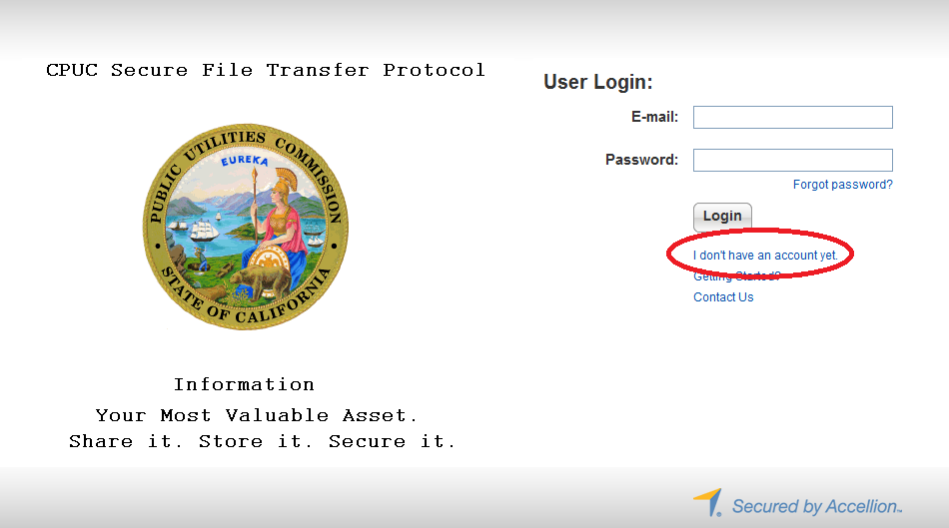

- To complete the registration process, enter your email address. (See Figure 2 )
Figure 2
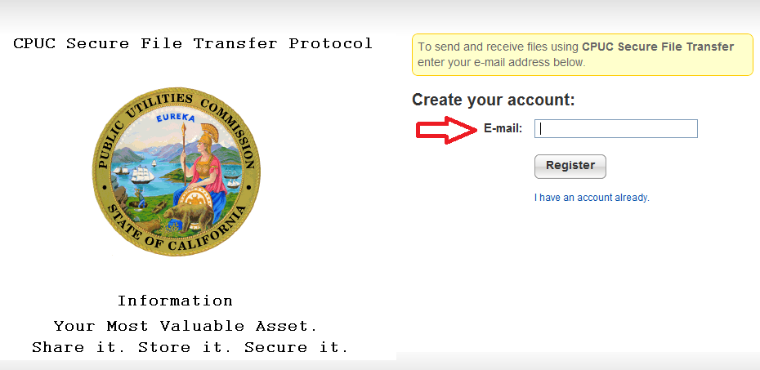

- A verification code will be sent via email. (See Figure 3)

Figure 3
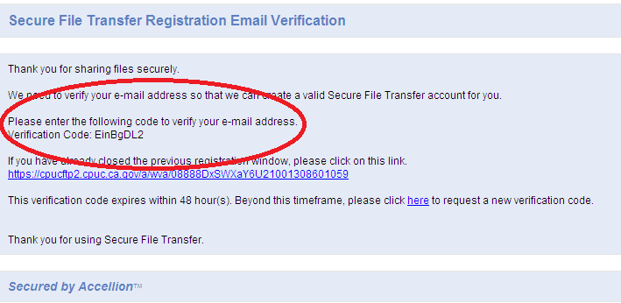

- To verify your account, enter the verification code. Click “Verify.” (See Figure 4)

Figure 4
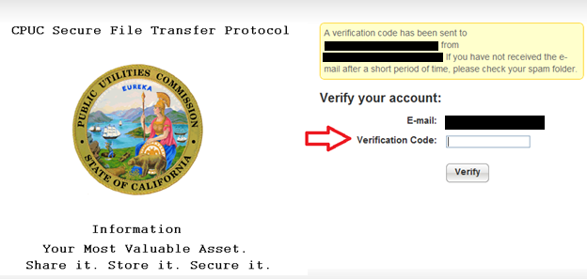

- The setup process will ask you to create a password and to re-type it. Click “Register” upon completion. (See Figure 5)

Figure 5
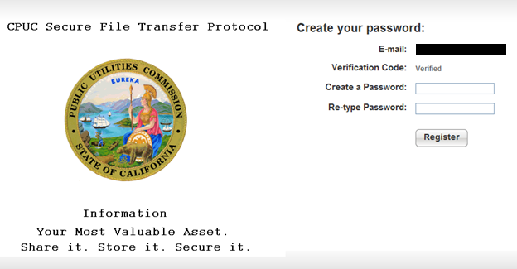

- Upon successful registration, this message should appear, and immediately forward you to the home page of the application (See Figure 6)
Figure 6
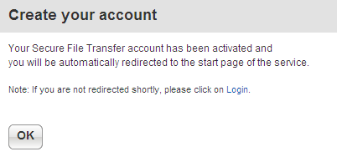

Access CPUC Secure File Transfer via Email invitation

1. If you were invited to use the program, an email was sent to you from the inviter. Click on the link that is provided. (See Figure 7)

Figure 7
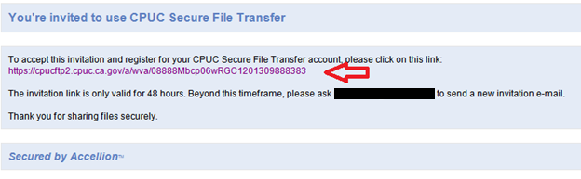

2. After you click the link, create your password. Click “Register” and following successful registration; it will direct you to the main page. Note: it has to contain at least 6 characters with one uppercase and one number. (See Figure 8)

Figure 8
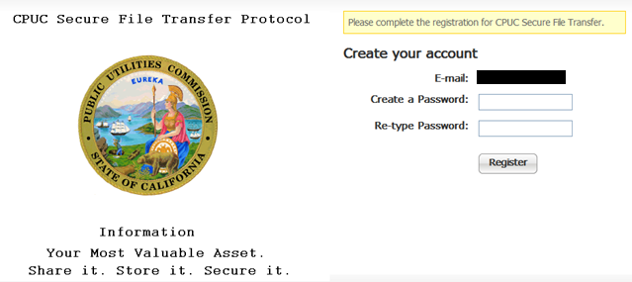

Sending Files

Follow steps below to send files. This applies to both internal and external users:
- Enter recipient’s email address
  - External users may only send files to recipients within CPUC. Please contact Help Desk for special circumstances.
- Enter Subject

1. To attach files to the email message, click on “Choose File/Folder.” If you have files already uploaded into the File Manager, then click on “Choose from File Manager.” (See Figure 9)

Figure 9
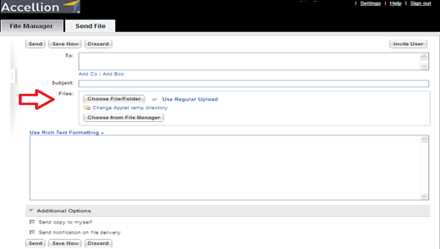

2. Select the folder/file you want to attach and click “Attach.” (See Figure 10)

Figure 10
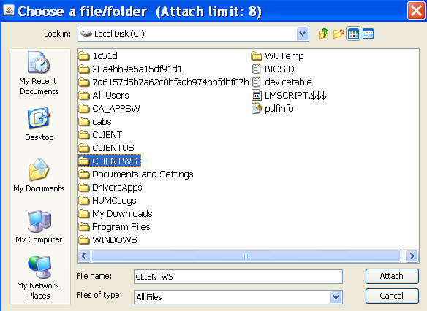

4. The attachments will upload and appear on top of your message. Click “Send.” (See Figure 11)

Figure 11
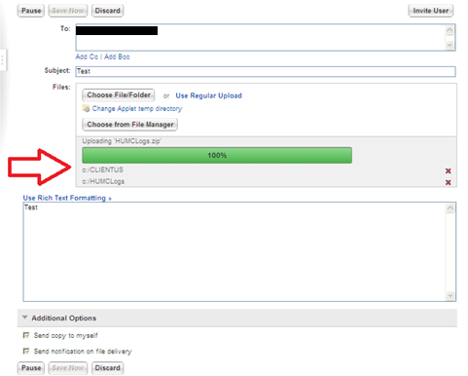

5. Following a successful sent email, a notification page will appear (See Figure 12)
- Note: Folders are converted into zip files.

Figure 12
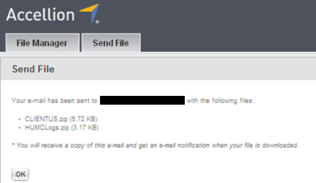
Confirming files that were sent or uploaded to the File Manager
1. Click on “File Manager” on top of the page, and it shows all the files you have sent or uploaded in the File Manager (See Figure 13)

- The file manager is for you to store files, so you can easily select them to send later. You can add files to the cabinet by clicking “Add Files.”

Figure 13
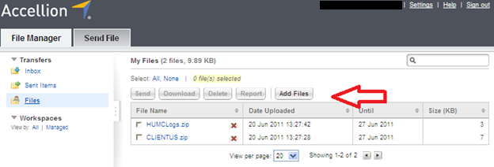

Receiving files

1. You will be notified via email when you have received a file. Click on the “Download File” link (indicated by the red arrow in Figure 14)

Figure 14
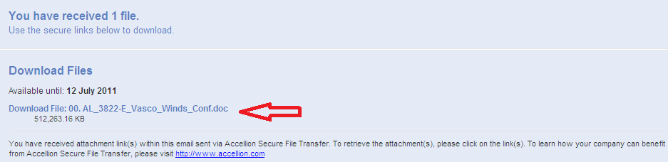

2. You will be directed to a download page. If your browser blocks downloads, click on the blue highlighted bar, and click “Download File.” Otherwise your download will automatically begin. (See Figure 15)

Figure 15
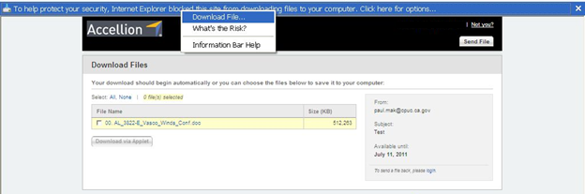

Section 4.3.5 and OP 6(f), link here: http://docs.cpuc.ca.gov/PUBLISHED/FINAL_DECISION/119856.htm
http://www.cpuc.ca.gov/PUC/energy/Procurement/RA/ra_compliance_materials.htm
D.05-10-042, section 7.9
Page 6 of Appendix A, D10-12-038
Section 4.2.6 of D.08-04-023
D.10-06-036 OP 6b
The transfer capacity on Path 26 must be de-rated to accommodate ETCs that are used to serve load outside the CAISO control area. “Loop flow” is common to large electric power systems and must be accommodated to prevent overloading of lines.

