California Solar Initiative
Progress Report
Q1 2010
Data Annex

Contents
1 Program History and Structure ………........ ......................................................................... 3

2 Additional CSI Program Demand Statistics.......................................................................... 5
2.1 PBI Incentive Demand....................................................................................................................... 5

3 Administrative Statistics ……………………........................................................................... 6
3.1 Application and Incentive Processing Times ...…………. ................................................................. 6
3.2 Installation time . ............................................................................................................................... 8
3.3 Interconnection time ......................................................................................................................... 9
3.4 Incentive claim processing ................................................................................................................9

4 CSI Program Trainings ......................................................................................................... 14
4.1 PG&E Training Offerings................................................................................................................. 14
4.2 SCE Training Offerings.................................................................................................................... 15
4.3 CCSE Training Offerings................................................................................................................. 16

5 Program Dropouts ................................................................................................................ 17
6 Net Energy Metering ............................................................................................................. 19
Question 9 ................................................................................................................................ 20
List of Figures
Figure 1. Number of PBI systems by system size and Program Administrator ........................................... 5
Figure 2. Residential reservation processing .............................................................................................. 8
Figure 3. Non‐residential reservation processing ....................................................................................... 8
Figure 4. Residential project completion times ........................................................................................ 13
Figure 5. Non‐Residential project completion times ................................................................................ 13

List of Tables
Table 1. Incentive MW available by step, by program administrator and customer class ......................... 4
Table 2. Time from application to reservation ........................................................ ................................... 7
Table 3. Installation time ............................................................................................................................ 9
Table 4. Interconnection time ..................................................................................................................... 9
Table 5. Incentive claim processing times ................................................................................................. 11
Table 6. Payment time .............................................................................................................................. 12
Table 7. Number of trainings by Program Administrator .......................................................................... 14
Table 8. CSI MW dropouts and dollar differentials ................................................................................... 19
This report was compiled by the California Solar Initiative Program Administrators – Pacific Gas and Electric Company (PG&E), Southern California Edison Company (SCE), and the California Center for Sustainable Energy (CCSE) – pursuant to direction from the CPUC.

1 Program History and Structure

The original step allocations and megawatt (MW) goals were divided among the three investor-owned utilities (IOUs) according to the proportion of their respective electricity sales. Table 1 shows the original MW goals of the program allocated to PG&E, SCE, and CCSE (for SDG&E’s service territory), separated into residential and non-residential segments. The goals and budgets were determined by each utility’s percentage of electricity sales compared to the total of all utility sales. These allocated percentages are:

Program Administrator(PA) Allocated Percent (%)
PG&E 43.7
SCE 46.0
SDG&E 10.3

As each Program Administrator (PA) receives applications for solar incentives, it tracks the total MW reflected in the applications received. Table 1 also shows the actual MW available or used at each step. The “actual” MW amount is different than the “original” MW amount because the actual amount takes into account program dropouts and represents the actual number of MW that will be paid at a given step. Finally, the highlighted sections of Table 1 show the current step for each Program Administrator and each customer segment, based on CSI Program demand as of March 2010.

Table 1. Incentive MW Available by Step, by Program Administrator and Customer Class
Step | MW in Step | PG&E  (MW) |  |  |  | SCE  (MW) |  |  |  | CCSE in SDG&E Territory  (MW) |  |  |  | SoCalGas  (MW)
Step | MW in Step | Residential |  | Non-Residential |  | Residential |  | Non-Residential |  | Residential |  | Non-Residential |  | Residential |  | Non-Res
Step | MW in Step | Original | Actual | Original | Actual | Original | Actual | Original | Actual | Original | Actual | Original | Actual | Original | Actual | Original | Actual
1 | 50 | 0 | 0 | 27.8 | 11.4 | 0.1 | 0 | 12.4 | 5.5 | 0 | 0 | 6.4 | 0.3 | 0 | 0 | 3.3 | 3.3
2 | 70 | 10.1 | 11.9 | 20.5 | 18.0 | 10.6 | 9.4 | 21.6 | 21.4 | 2.4 | 2.2 | 4.8 | 7.5 | SoCalGas was a Program Administrator in 2006 during the transition to CSI, but has no role in CSI projects that started since 1/1/2007.
3 | 100 | 14.4 | 13.0 | 29.3 | 22.2 | 15.2 | 15.1 | 30.8 | 25.0 | 3.4 | 3.3 | 6.9 | 4.9
4 | 130 | 18.7 | 18.3 | 38.1 | 29.3 | 19.7 | 14.5 | 40.1 | 18.4 | 4.4 | 4.4 | 9.0 | 6.0
5 | 160 | 23.1 | 24.6 | 46.8 | 53.7 | 24.3 |  | 49.3 | 51.2 | 5.4 | 5.6 | 11.0 | 17.5
6 | 190 | 27.4 | 20.7 | 55.6 | 35.6 | 28.8 |  | 58.6 |  | 6.5 | 5.0 | 13.1 | 9.5
7 | 215 | 31.0 |  | 62.9 |  | 32.6 |  | 66.3 |  | 7.3 |  | 14.8
8 | 250 | 36.1 |  | 73.2 |  | 38.0 |  | 77.1 |  | 8.5 |  | 17.3
9 | 285 | 41.1 |  | 83.4 |  | 43.3 |  | 87.8 |  | 9.7 |  | 19.7
10 | 350 | 50.5 |  | 102.5 |  | 53.1 |  | 107.9 |  | 11.9 |  | 24.2
Subtotal |  | 252.4 |  | 512.3 |  | 265.6 |  | 539.5 |  | 59.5 |  | 120.8
Totals |  | 764.7 |  |  |  | 805.1 |  |  |  | 180.3
Percent |  | 43.7% |  |  |  | 46.0% |  |  |  | 10.3%
Source: CPUC data request to Program Administrators, dated May 14, 2010, and covering data through March 31, 2010.
Notes: (1) Shading in the table denotes Current Step as of March 31,2010.
(2) The “Actual” MW field in Table 1 denotes the actual amount of MW that are either actively reserved or completed in each step and will be paid out at the given incentive level. The “Actual” MW numbers are equal to the “Original” MW in step less dropouts from that step plus dropouts from previous steps. The “Actual” numbers are current as of March 31, 2010. The “Original” MW amount represents the original number of MW allocated to the step in CPUC decision D.06‐12‐033, Appendix B, Table 13.
(3) In accordance with CPUC policy decisions that provided for a transition between the Self Generation Incentive Program and the California Solar Initiative, Step 1 was fully reserved in 2006 under the Self Generation Incentive Program, which was only open to non‐residential projects. The 50 MW in Step 1 were not allocated across the utilities and were reserved on a first come, first served basis. Although almost all Step 1 MW were reserved by non‐residential entities, Program Administrators later reallocated Step 1 dropouts into both residential and non‐residential customer segments.
(4) Southern California Gas Company (SoCalGas) is an SGIP administrator and had MWs reserved in 2006 for solar projects at the Step 1 incentive level, but since SoCalGas is not a CSI Program Administrator, it has no CSI MWs reserved after January 1, 2007.
2 Additional CSI Program Demand Statistics

All references to capacity are reported as CEC-AC ratings (except Tables 1 and 8, which are reported in CSI rating). Additional CSI program data and information can be found at the following URL: www.GoSolarCalifornia.ca.gov.

2.1 PBI Incentive Demand
The Performance Based Incentive (PBI) path is required of larger projects in the CSI Program. Currently, the CSI Program has 1,415 PBI projects. Figure 1 shows the number of PBI systems by size and Program Administrator as of April 14, 2010.

Figure 1. Number of PBI Systems by System Size and Program Administrator

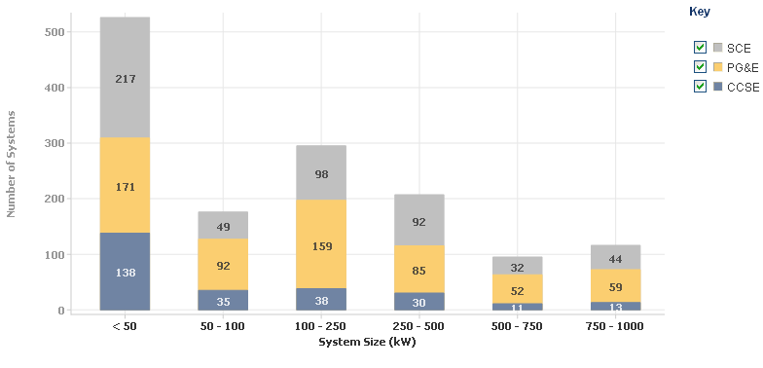

Source: www.californiasolarstatistics.ca.gov

3 Administrative Statistics

The CPUC continues to track a number of administrative metrics in order to monitor potential program administration issues. In particular, the CPUC is interested in application and payment processing times, including the amount of time needed for moving projects from: application to reservation; application to project completion; and incentive claim request to payment. Additionally, CPUC monitors the average number of days for interconnection application to be completed.

The data in this section is responsive to a CPUC data request to the Program Administrators dated May 14, 2010. The data presented is current through March 31, 2010 except as indicated.

3.1 Application and Incentive Processing Times

The Program Administrators strive to process reservation requests in 30 days or less for both residential and non-residential customer applications. Table 2 shows the most recent application processing times, from the date the application paperwork is physically received and time-stamped by the Program Administrator to the date that a reservation is granted (either “first reservation reserved” status or “first pending RFP” for non-residential applications or “first confirmed reservation” status for residential applications). This time period includes both Program Administrator application processing time and time that the host customer takes to respond to requests for more information or application corrections. Table 2 compares processing times from the most recent quarter (Q1, 2010) to average processing times for the same quarter of the last calendar year (Q1, 2009).

Applications for which the Program Administrator takes more than 60 days to grant a reservation typically have a problem. Problems encountered in these applications include, but are not limited to:
- Listed equipment does not match the EPBB printout
- Mailing address is different from the project site address
- Missing signatures
- Missing or incomplete documentation
- Slow customer responsiveness
- Non-Residential 3 step applications have a 60 day period for RFP submittal

Table 2. Time from Application to Reservation

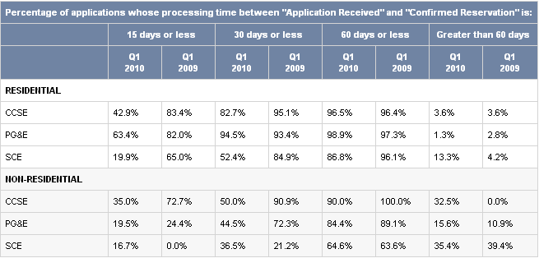

Source: Based on public export from CA Solar Statistics at www.californiasolarstatistics.ca.gov.
Notes: “Q1” includes all applications that were reserved by the Program Administrators between January 1 and March 31 of a specific year.

Figures 2 and 3 offer another look at PA’s progress towards achieving administrative processing goals. These graphs show the percent of applications that were granted a reservation within 30 days, by month since the program began on January 1, 2007. The data is presented separately for each Program Administrator and is divided into residential and non-residential customer sectors. Since March 2008, the
Program Administrators consistently processed the majority of residential reservations in 30 days or less. Analyzing data for non-residential applications is particularly challenging, because the Program Administrators have received far fewer non-residential applications compared to the number of residential applications. As a result, the percentages appear erratic.

Figure 2. Residential Reservation Processing
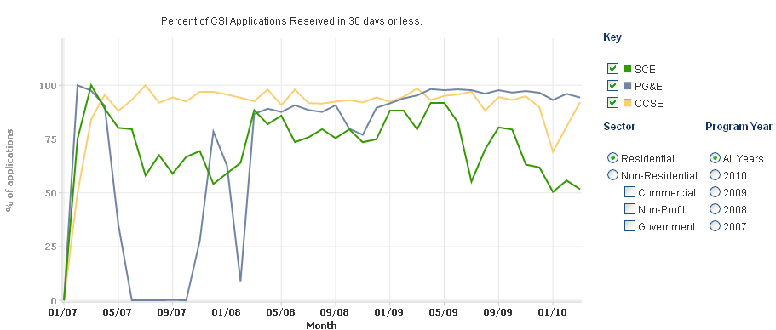

Source: Based on public export from CA Solar Statistics at www.californiasolarstatistics.ca.gov. Data
covers January 1, 2007‐March 31, 2010

Figure 3. Non-Residential Reservation Processing
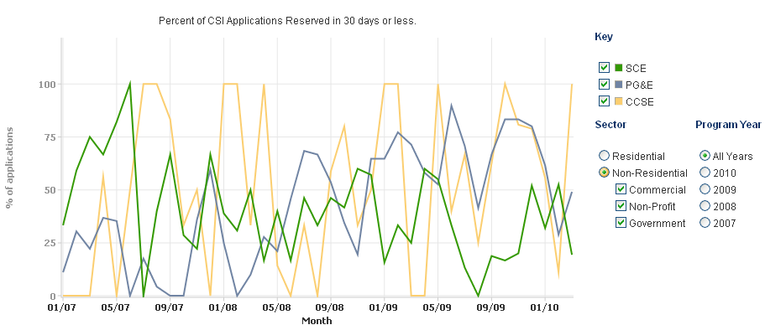
Source: Based on public export from CA Solar Statistics at www.californiasolarstatistics.ca.gov. Data covers January 1, 2007‐
March 31, 2010

3.2 Installation time
The average installation time is determined by the applicant and not the Program Administrator. Residential applicants have 12 months and non-residential applicants have 18 months from the date of the confirmed reservation to submit an Incentive Claim Form (ICF). Installation times also vary according to residential and non-residential projects. Table 3 shows the average number of calendar days between the customer’s confirmed reservation date and the date that the Incentive Claim Form was received by the Program Administrator, for all applications for which the ICF was received in Q1 2010 and Q1 2009.

Table 3. Installation time
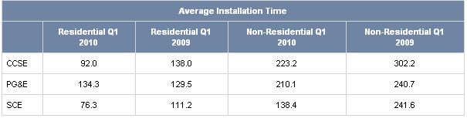
Source: Based on public export from CA Solar Statistics at www.californiasolarstatistics.ca.gov.
Notes: “Q1” includes all projects whereby ICFs were received by the Program Administrators between January 1 and March 31 of a specific year.

3.3 Interconnection Time
The time for interconnection is determined by the date the utility’s interconnection department deems the application to be complete (e.g., final single line, final building permit, etc.) and the date that the utility inspects the interconnection and issues the “permission to operate” letter. This time is generally under the utility’s control and does not depend on additional inputs from other entities, such as cities, counties, etc. However, exogenous factors, such as customer availability or adverse weather conditions, may impact this process. Table 4 shows the average number of calendar days for the interconnection of residential and non-residential customer projects by IOU, for all projects that have been interconnected in the Q1 2009 and Q1 2010.

Table 4. Interconnection Time
 | Residential Q1 2010 | Residential Q1 2009 | Non-Residential Q1 2010 | Non-Residential Q1 2009
PG & E | 7.2 | 4.9 | 12.0 | 6.6
SCE | 8.4 | 4.1 | 15.6 | 18.7
SDG&E | 3.1 | 3.2 | 3.3 | 4.9
Source: Program Administrators and SDG&E

3.4 Incentive Claim Processing
For CSI Program participants, incentive claim processing is an extremely important part of the project timeline. Table 5 shows how quickly incentive claims are processed for different types of projects, from the date that the Incentive Claim Form (ICF) is physically received by the Program Administrator and time-stamped (often different than the date the ICF is electronically submitted in PowerClerk) to the date that the application is changed to “pending payment” status. After the ICF is submitted, the Program Administrator selects a random number of projects for onsite field inspection, during which inspectors verify that the installed system matches the system identified in the paperwork. As scheduling and inspection times often vary, projects identified in Table 5 are sorted into groups that were or were not inspected. Table 5 compares data from those projects that were identified as “pending payment” in Q1 2010 to those in Q1 2009. The majority of residential incentive claims are processed in 60 days or less. Applications for which the Program Administrator takes more than 90 days to process the incentive claim typically have a problem. Problems encountered with applications at the ICF stage include, but are not limited to:

- System not interconnected
- Revised EPBB not submitted to reflect changes in installed equipment
- Missing PMRS documentation
- Missing 10-year warranty for equipment and/or installation
- Incomplete or missing data about Performance Data Provider (PDP)
- Host customer unaware the need for a CSI inspection
- Failed meter or system inspection
- Missing or incomplete documentation

Table 5. Incentive Claim Processing Times
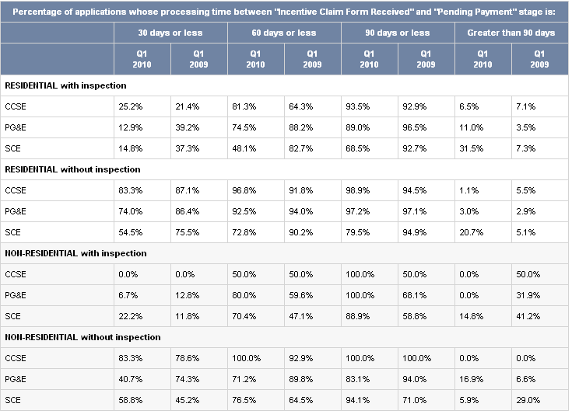
Source: Based on public export from CA Solar Statistics at www.californiasolarstatistics.ca.gov.
Notes: “Q1” includes all applications that were approved for “Pending Payment” by the Program Administrators between January 1 and March 31 of a given year.
Table 6 shows the average number of calendar days for an application in “Pending Payment” status to reach “Completed” status (EPBB payments) or “PBI in Payment” status (PBI payments). The time from “Pending Payment” to “Completed” status reflects the amount of time it takes for payment to be made to the applicant for EPBB payments and the time from “Pending Payment” to “PBI in Payment” status reflects the amount of time it takes for the first payment to be made to the applicant for PBI Payments.
Timeframes vary according to residential and non-residential projects, but also depend upon whether the project is receiving an EPBB or PBI payment.

Table 6. Payment Time
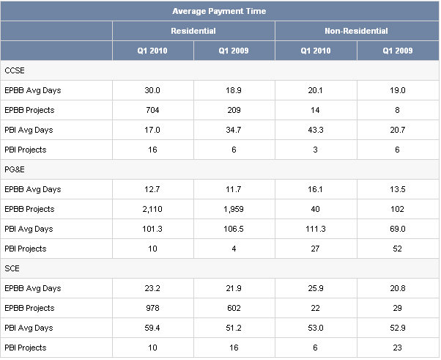

Source: Based on public export from CA Solar Statistics at www.californiasolarstatistics.ca.gov.
Notes: “Q1” includes all ICFs applications that have reached either “PBI-In Payment” or “Completed” status between January 1 and March 31 of a specific year.

Figures 4 and 5 show the end-to-end monthly average project completion times (defined as time between "First Reservation Request Review Date" to either "First Completed Date" or "First PBI - In Payment Date") in calendar days for all projects completed through March 31, 2010. These times reflect both the Program Administrator processing times and host customer responsiveness to inquiries, requests for additional data and inspection scheduling. The data in the figures below are separated by residential and non-residential customer projects completed in each given month, according to Program Administrator.

Figure 4. Residential project completion times
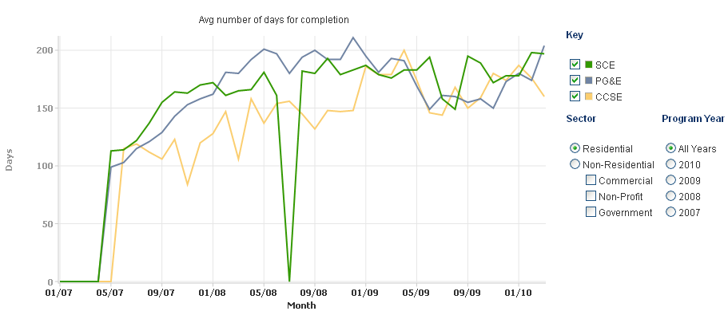
Source: Based on public export from CA Solar Statistics at www.californiasolarstatistics.ca.gov. Data covers January 1, 2007‐
March 31, 2010.

Figure 5. Non‐Residential project completion times
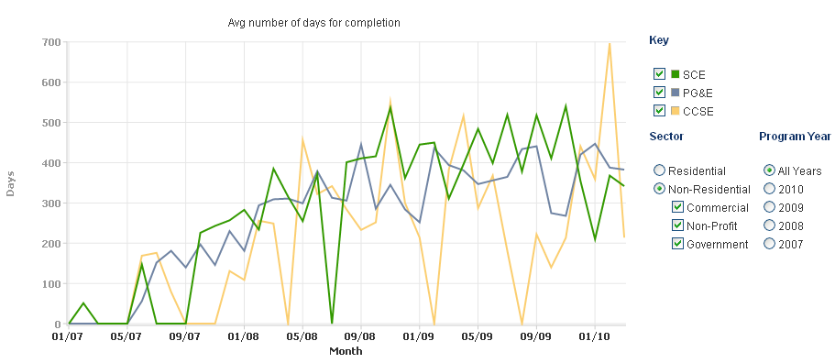
Source: Based on public export from CA Solar Statistics at www.californiasolarstatistics.ca.gov. Data covers January 1, 2007‐
March 31, 2010.

4 CSI Program Trainings
Each of the Program Administrators regularly offer training for both customers and solar installers on the CSI Program and the benefits and technical details of solar generally. In Q1 2010, the CSI Program Administrators held 64 trainings and trained 1843 attendees.

Table 7. Number of Trainings by Program Administrator
 | PGE |  |  | SCE |  |  | CCSE
 | Q1 2008 | Q1 2009 | Q1 2010 | Q1 2008 | Q1 2009 | Q1 2010 | Q1 2008 | Q1 2009 | Q1 2010
Number of attendees at installer trainings | 587 | 945 | 970 | 172 | 743 | 514 | 248 | 427 | 359
Number of CSI Program Trainings held | 14 | 21 | 41 | 4 | 13 | 13 | 7 | 9 | 10
Source: CPUC data request to PAs dated May 14, 2010
Notes: 1) “Q1” refers to the period January 1 through March 31 of a given year.

4.1 PG&E Training Offerings
A general picture of the trainings PG&E offered in the first quarter of this year can be found at PG&E's solar education Web page, www.pge.com/solareducation. As depicted on that page and in the attached supporting curriculum, PG&E approached solar trainings comprehensively, offering classes on a wide breath of issues related to the solar installation and rebate processes. Greater focus was placed on solar water heating classes so as to educate and prepare customers for launch of the CSI Thermal Program. Additionally, PG&E continued to partner with community and industry stakeholders on education and outreach including participating in speaking engagements at varied forums such as libraries and higher education facilities.

4.2 SCE Training Offerings
SCE continues to offer classes geared toward non-residential and residential customers, both of which attract the solar installer community. Since the CSI program’s inception, SCE has reached over 2,600 non-residential customers, through 70 “Intro to CSI” classes, and more than 3,400 residential customers, through 44 Homeowner Solar Information Sessions (HSIS). Since SCE began offering the “Intro to CSI” class via Webinar in 2008, 198 attendees have participated via 15 Webinars.

4.2.1 Intro to CSI Classes
The “Contractor Solar Class” is a course designed for solar contractors, self-installers, managers and PV owners, and features new and updated information on the CSI Program. During the course discussion, information is given to attendees on the following topics: (i) how to participate in the program; (ii) system basics, including the different types of solar systems, metering, monitoring, site and equipment requirements; and (iii) PowerClerk. In addition, SCE enhanced the Interconnection information provided during this course beginning in 2009.

4.2.2 Homeowner Solar Classes
SCE’s HSIS (homeowner) classes are 90-minute, easy-to-understand sessions that provide the basics of how residential customers can “go solar” without the “techy” jargon so often used and confusing to potential solar customers. The subject matter SCE presents in both the “Intro” and “HSIS” classes is updated as required by program needs. SCE also makes adjustments based on feedback received from attendees.
For more information, please visit:

www.sce.com/solarleadership/gosolar/california-solar-initiative/Training/training.htm.

4.3 CCSE Training Offerings
CCSE’s 2010 trainings build on the organization’s prior success in educating consumers about the benefits of solar PV. CCSE believes its efforts to educate homeowners contributed to the two residential step changes experienced by CCSE in 2009. In mid June 2009, the residential step level dropped to Step 5. Between mid June 2009 and October 2009, a period of just over four months, the incentive step dropped again to Step 6. In Q1 2010, CCSE offered six Solar for Homeowners workshops.

CCSE also offers a successful series of workshops for the non-residential sector. The workshop series educates consumers about solar financing options, with an emphasis on commonly used ‘power purchase agreements’ (PPAs). These seminars conclude with a mixer that helps connect prospective customers with solar energy providers.

In Q1 2010, CCSE sustained its efforts to ensure solar contractors understand the CSI Program and complete the application process as efficiently as possible. CCSE offered four trainings in Q1 2010 on how to navigate the CSI application process.

CCSE continues to place heavy emphasis on solar contractor outreach to improve application processing efficiency, but is also helping new solar contractors understand and use ethical business practices. Building on 10 years of solar incentive programs in the State of California, the solar industry is at a crossroads in solar growth and ethics. Partnering with stakeholders such as CALSEIA, CCSE helped educate solar providers about the ethical business practices that are needed to help make the solar market sustainable.

CCSE’s workshops and trainings include:

4.3.1 California Solar Initiative (CSI) Application Process
CCSE holds a quarterly workshop focused on the CSI application process and any recent changes to the program. This training session is designed for contractors, but is open to the public.

4.3.2 Solar Shade Workshops
On a monthly basis, CCSE holds a solar shade workshop that reviews the CSI program’s shade measurement requirements and the CSI inspection protocol. CCSE strongly encourages all installers to attend.

4.3.3 Solar for Homeowners
CCSE conducts a solar for homeowner’s workshop that educates homeowners in the San Diego area about how to read their annual electricity usage and properly size a PV system. The workshop also provides an overview of the California Solar Initiative, and explains the financial and environmental benefits of going solar.

4.3.4 Solar Sales and Marketing Ethics Training
To underscore the importance of business ethics in the growing solar market, CCSE offered a sales and business ethics workshop in November 2009 in partnership with the California Solar Energy Industries Association (CALSEIA) to promote high standards of conduct in the solar marketplace.

In 2010, CCSE is increasing its outreach and education activities. Since January 2010, CCSE is offering the workshop Solar for Homeowners twice a month and has offered the CSI Application Process workshop four times in Q1 2010 due to programmatic changes in processing procedures. Starting in March 2010, CCSE is offering the following additional workshops: Solar for Contractors (in partnership with the Solar Training Institute), What Every Solar Contractor Must Know (in partnership with the California State License Board), California Solar Initiative Overview, and Solar Careers and Opportunities and the Business of Solar (in partnership with Verve Solar Consulting).

For more information, visit: www.energycenter.org and click on “Events & Workshops”.

5 Program Dropouts

The CPUC hosted a workshop on CSI Program Dropouts and their effects on the CSI Budget in July 2008. Since that time, CPUC staff has continued to monitor and report on both the CSI Program dropout rate and the amount of incentive dollars unreserved when projects and their associated MW drop out of a higher incentive level and are added back in to the program after a step change, at a newer, lower incentive level.

The CSI dropout rate is currently about 18.9%. As of March 31, 2010, about 18.9% percent of reserved MW has dropped out of the Program, representing 20.5% of reserved incentive dollars. This average dropout rate was calculated from the Public Data Export, which draws on data from the March 31, 2010, PowerClerk data, and includes only those applications that have ever been granted a CSI reservation (non-blank “Reservation Reserved” or “Confirmed Reservation” or “Pending RFP” date for nonresidential projects, and non-blank “Confirmed Reservation” date for residential projects).

There are about $60 million in unreserved incentives associated with CSI Program dropouts. Additionally, when CSI projects drop out of the program and their associated MW are added in at a lower incentive rate, a small amount of incentive dollars become “unreserved”. For example, if a 1 MW commercial project were to be reserved at incentive Step 4, its associated incentive would be $1.9 million (1 MW x $1.90/watt incentive). If that project were to drop out, and the MW were to be added back in at incentive Step 5, the associated incentive would be $1.55 million (1 MW x $1.55/watt incentive). That represents a difference of $350,000 in unreserved incentive. The CPUC requires Program Administrators to regularly report on the amounts of these unreserved incentives, and publishes the overall sum of these unreserved incentives in the quarterly Staff Progress Reports. Table 8 shows that as of March 31,
2010, the sum of all unreserved incentive dollars was approximately $60 million as reported by the Program Administrators in their responses to the CPUC Data Request dated May 14, 2010.

Table 8. CSI MW Dropouts and Dollar Differentials
Step | PG&E |  |  | SCE |  |  | CCSE |  |  | Total
 | Res MW | NonRes MW | $million un-reserved | Res MW | NonRes MW | $million un-reserved | Res MW | NonRes MW | $million un-reserved | Res MW | NonRes MW | $million un-reserved
1 | 3.3 | 13.4 |  | 0.1 | 6.9 |  | 0.0 | 6.2 |  | 3.4 | 26.5
2a | 0.0 | 3.1 |  | 0.1 | 0.1 |  | 0.0 | 0.8 |  | 0.1 | 4.0
2b | 1.4 | 12.7 | $9,207,365 | 1.3 | 5.2 | $2,976,313 | 0.2 | 1.8 | $1,772,309 | 2.9 | 19.7 | $13,955,987
3 | 2.0 | 12.2 | $7,995,297 | 1.5 | 10.7 | $5,988,736 | 1.6 | 3.1 | $2,110,665 | 5.1 | 26.0 | $16,094,698
4 | 11.8 | 28.9 | $9,686,277 | 0.2 | 29.0 | $8,848,239 | 1.5 | 6.6 | $2,069,936 | 13.5 | 64.5 | $20,604,452
5 | 2.0 | 25.5 | $8,718,973 | 0.0 | 6.1 | - | 0.1 | 0.4 | $30,890 | 2.1 | 32.0 | $8,749,863
6 | 9.3 | 1.8 | - | 0.0 | 0.0 | - | 0.0 | 0.0 | $0 | 9.3 | 1.8 | $0
Totals | 26.5 | 81.1 | $35,607,912 | 3.0 | 51.0 | $17,813,288 | 3.4 | 11.9 | $5,983,800 | 32.9 | 144.0 | $59,405,000
Source: CPUC data request to Program Administrators, dated May 14, 2010 and covering data through March 2010.
Notes: 1) The “$ unreserved” figure is an estimate based on the assumption that all non‐residential dropouts are commercial projects. The actual figures may differ slightly
based on government & non‐profit participation in the steps. The “$ unreserved” figure does not equal the total amount of incentive money associated with the
dropped‐out MW. Varying rate structures have an impact on the calculation for unreserved Incentive dollars.
2) Steps 1 and 2a were fully reserved under the Self Generation Incentive Program in 2006, and these applications were subject to different programmatic rules.
Therefore, Step 1 and 2a dropout rates are not directly comparable to the rates for Step 2 and beyond, and are not included in the totals row at the bottom of Table 8

Question 9. Net Energy Metering

PUC Section 2827 establishes net energy metering (NEM) for solar and small wind customer-generators. The answers to these questions should be combined and included in the Data Annex.

- How many total NEM customer generators, pursuant to PUC Section 2827, are interconnected in your service territory as of March 31st, 2010?

Service Territory | # of Customers
PG&E | 38,722
SCE | 14,009
SDG&E | 9,376

- How many NEM customer generators from subsection a. are solar customer generators?

Service Territory | # of Customers
PG&E | 38,625
SCE | 13,786
SDG&E | 9,354

- What is the “total rated generating capacity” (in MW) of all NEM customer-generators pursuant to PUC Section 2827, as of March 31st, 2010?

Service Territory | MW
PG&E | 318.1
SCE | 161.9
SDG&E | 71.6

- What is the “total rated generating capacity” (in MW) of solar NEM customer-generators only pursuant to PUC Section 2827, as of March 31st, 2010?

Service Territory | MW
PG&E | 316.7
SCE | 157.4
SDG&E | 71.5

- What percentage of your “aggregate customer peak demand,” pursuant to PUC Section 2827(c)(1), is accounted for by all NEM customer-generators, as of March 31st 2010?

Service Territory | Percent
PG&E | 1.52%
SCE | 0.70%
SDG&E | 1.54%

