STATE OF CALIFORNIA Edmund G. Brown Jr., Governor
PUBLIC UTILITIES COMMISSION
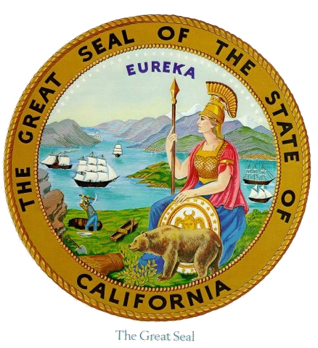
505 VAN NESS AVENUE
SAN FRANCISCO, CA 94102-3298

R.11-10-023 Workshop Agenda
2013 RA Templates and Guides
September 17, 2012, 9:30 am – 12:30 pm
WebEx Information on next page

9:30 am – 9:45 am - Introductions and announcements
  - Goals for the day:
    - To explain the now final versions of the 2013 templates and guides
    - To clarify the Final 2013 RA Reporting Templates and Guide so as to facilitate System and Local RA Compliance Filing
  - Topics for today
    - Overview of big changes that were made for the 2013 templates
    - Walkthrough of the System & Local templates
    - Other issues – potential 45 filing date timeline
    - Questions and Answers

9:45 am – 10:15 am – Big Changes for 2013
  - Overall retention of design from previous RA templates and guides
  - All Demand Response listed on Demand Response tab
  - New DR bucket, with no percentage limit
  - Updates made to Summary pages
  - Additional automation to the template

10:15 am – 12:00 pm – Demonstration of CPUC template and functionality
  - Filling in resource and allocation information for Local and System compliance
    - Listing RA resource – pull down resource ID and date
    - Listing addition Demand Response resources (not allocated in July)
    - System compliance for DR bucket (15% PRM added in summary tables)
    - Local RA adjustments during compliance year
    - Inserting load migration values, CAM-RMR, and Incremental Local allocations
    - Adding resources to NQC list
    - YA Local compliance in the Local template
    - Potential 45 day process if PTM is adopted

12:00 pm – 12:30 pm – Reminders and next steps
  - Questions/answers
  - Reallocation of year ahead RA allocations due to adjustment process – sending allocations today
  - Final NQC list will be posted within this week

The meeting can go long if needed, and LSEs are encouraged to contact Energy Division for more information or more direct demonstration as required.

Thank you for your participation

-------------------------------------------------------
Meeting information
-------------------------------------------------------
Topic: Resource Adequacy 2013 Templates and Guides Workshop
Date: Monday, September 17, 2012
Time: 9:30 am, Pacific Daylight Time (San Francisco, GMT-07:00)
Meeting Number: 742 078 984
Meeting Password: adequacy
-------------------------------------------------------
Go to https://van.webex.com/van/j.php?ED=189970897&UID=491292852&PW=NODllM2Q0M2Ni&RT=MiM0
-------------------------------------------------------
Teleconference information
-------------------------------------------------------
1-866-758-1675, passcode: 3481442
For assistance
-------------------------------------------------------
1. Go to https://van.webex.com/van/mc
2. On the left navigation bar, click "Support".
You can contact me at:
donald.brooks@cpuc.ca.gov
1-4157032626

