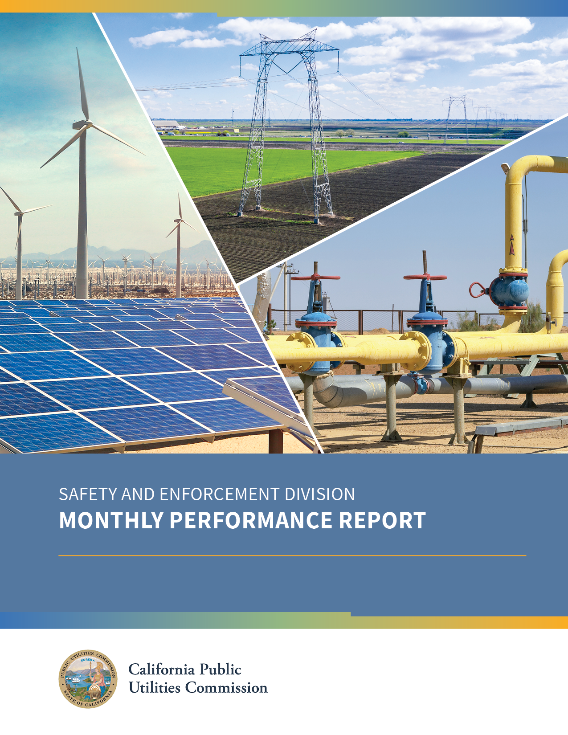

OCTOBER 2020
Contents
INTRODUCTION 3
COMPLIANCE WITH ORDERING PARAGRAPHS (COPS) 4
GAS SAFETY AND RELIABILITY BRANCH (GSRB) 5
Natural Gas Citations 5
Natural Gas Inspections (Year to Date) 6
Natural Gas Incident Reports and Investigations through October 31, 2020 6
Natural Gas Utility Self-Identified Violation (SIV) Investigations 8
Customer Safety Complaints 8
Notice of Probable Violation Letters (NOPV) 8
Natural Gas Safety and Reliability: Proceedings 8
ELECTRIC SAFETY AND RELIABILITY BRANCH (ESRB) 10
Electric Incidents Reported through October 31, 2020 10
Electric Facilities and Power Plant/Generation Incident Investigations 11
Customer Safety Complaints 11
Notice of Probable Violation Letters 11
Electric Safety and Reliability: Proceedings 11
Other Activities 13
Wildfire Safety and Enforcement Branch (WSEB) 15
PSPS Activations, De-energizations & Post Event Reports Reviewed in October 15
Summary of PSPS Events in October 15
PSPS Related Proceedings 16
Monitoring the Whistleblower Website 16
Statistics - 1/01/20 – 10/31/2020 16

Disclaimer
This Report was prepared by California Public Utilities Commission (CPUC) staff. It does not necessarily represent the views of the CPUC, its Commissioners, or the State of California.
The CPUC, the State of California, its employees, contractors, and subcontractors make no warrants, expressed or implied, and assume no legal liability for the information in this Report.
This Report reflects Safety and Enforcement Branch’s monthly work product. It has not been approved by the Commission rather it is information provided by the Division.

INTRODUCTION
The CPUC’s Safety and Enforcement Division (SED) oversees the safety of electric and communication facilities, natural gas infrastructure and propane facilities. SED is comprised of three branches of utility engineers, analysts and investigators that focus on ensuring the safety of utility infrastructure and reducing utility caused wildfires. SED advocates for public safety through performing safety audits, conducting incident investigations, and appearing in CPUC safety proceedings. SED has the authority to issue citations with penalties against utility operators who violate public utility safety codes and requirements.
October experienced many PSPS events. SED’s Wildfire Safety and Enforcement Branch (WSEB) monitored utility Emergency Operations Center (EOC) meetings and utility actions during October PSPS events. There were 7 PSPS events; 3 for PG&E, 2 for SCE, 1 for SDG&E, and 1 for PacifiCorp. Overall, 456,964 customers in 70 counties were impacted including, 28,104 of medical baseline customers, in 70 counties and 17 tribes. SED’s Director, Lee Palmer, provided a report to the CPUC Commissioners on November 5, 2020 about the significant statewide PSPS activity during October 25-27. President Batjer and SED senior staff participated in CalOES state executive calls with each IOU twice daily during a PSPS event. Additionally, SED participated on IOU operational calls and virtually embedded in the IOU EOCs. During the November 5 CPUC meeting, President Batjer shared that the CPUC has a process to review the IOU PSPS event reports and will incorporate lessons learned from this fire season to refine PSPS guidelines to minimize the duration and impact of future PSPS events. More information on these events can be found below in the WSEB section.
On October 13, 2020, SED Director, Lee Palmer, and Gas Safety and Reliability Branch (GSRB) Program Manager, Terence Eng, participated virtually on a panel in Senator Jerry Hill’s Safety Subcommittee Hearing titled, “Gas Safety Retrospective: A Decade Since San Bruno”. SED discussed CPUC improvements and strengthening of regulations based on National Transportation Safety Board (NTSB) recommendations, legislation, and CPUC decisions. For example, AB578 requires the CPUC to act on gas safety recommendations by NTSB recommendation. Also, AB56 requires remote controlled shutoff valves on gas infrastructure in areas of higher population and the comprehensive testing and record keeping of gas transmissions pipelines. SED holds the utilities accountable for safety through audits, investigations, assessments of fines and penalties, and corrective action plans. SED appreciates Senator Hill’s focus on natural Gas Safety oversight and safety improvements enacted over the decade since San Bruno.
Other SED highlights during October, include:
- Electric Safety and Reliability Branch (ESRB):
  - Began its investigation of three (3) utility-related wildfire incidents.
  - Conducted eight (8) audits: two (2) electric distribution audits, one (1) substation audit, three (3) Communication Infrastructure Provider audits, and two (2) electric transmission audits.
- Gas Safety and Reliability Branch (GSRB):
  - Discussed pending safety items with leadership teams of the following utilities:
    - Southwest Gas, SoCalGas/San Diego Gas and Electric, Pacific Gas and Electric.
  - Discussed safety improvements with the Senate Committee on Energy, Utilities and Communications regarding Gas Safety Retrospective: A Decade Since San Bruno.
  - Conducted nine (9) weeks of auditing including: seven (7) large operator, and two (2) municipalities
- Wildfire Safety and Enforcement Branch (WSEB):
  - In addition to the PSPS activities described above, WSEB participated in several CPUC proceedings, including the 2019 PSPS OII and the SCE Petition to Modify the High Fire Threat Districts Map.
  - In conjunction with ESRB, WSEB initiated three (3) investigations into utility-related wildfires.

COMPLIANCE WITH ORDERING PARAGRAPHS (COPS)
The Compliance with Ordering Paragraphs (COPs) database is designed to assist CPUC staff in tracking compliance with Ordering Paragraphs (OPs) of regulated entities with Commission decisions. Each month various agency staff use COPs to identify and enter into the database relevant OPs, verify and document compliance, and produce reports summarizing compliance with OPs.
Between January 2015 and October 31, 2020, SED has 78 total entries in the COPS system with 34 reaching compliance (44%), 38 (49%) not yet due for compliance, and 0 (0%) out of compliance. 78 (100%) of all SED Ordering Paragraphs are assigned to staff. The chart below shows statistics through October 2020. During October, there were no new OPs recorded to the COPs database for SED.

GAS SAFETY AND RELIABILITY BRANCH (GSRB)
The Gas Safety and Reliability Branch (GSRB) ensures that intra-state natural gas and liquid petroleum gas (LPG) pipeline systems are designed, constructed, operated, and maintained according to safety standards set by the CPUC and the federal government. CPUC gas safety engineers are trained and qualified by the federal government. The CPUC enforces natural gas and LPG safety regulations; inspects construction, operation, and maintenance activities; and makes necessary amendments to regulations. Its mission is to protect and promote the safety of the public, the utility employees that work on the gas pipeline systems, and the environment.

Natural Gas Citations
GSRB has the authority to issue citations with penalties for operator violations of public utility safety codes and requirements. The citation process allows the CPUC to act expediently in matters where violations of state and federal rules are clear and unambiguous. Citations may arise out of an ongoing investigation into related matters or when a violation is brought to the CPUC’s attention directly. The table below shows the status of citations issued by GSRB to date in 2020. The citations can be found on the Commission’s website here.
Citation Number | Utility | Amount | Violations | Date Cited | Description | Status
G.20-04-001 | PG&E | $900,000 | 192.13(c), 192.621 | 4/14/20 | PG&E failed to follow its pipe abandonment procedures, leading to incident | Paid
G.20-06-001 | PG&E | $600,000 | 192.605(b)(3) | 6/16/20 | PG&E failed to include a partial copper service line in its replacement program. | Paid
G.20-07-001 | SoCalGas | $300,000 | 192.605(a) – 3 instances | 7/15/20 | SoCalGas failed to follow its emergency / incident procedures | In appeals process
G-20-08-001 | Glenview Mobile Lodge | $50,000 | 192.605(a), 192.605(b)(3), 192.616(j), 192.723(b)(2), 192.747(a), 192.805, 192.1015(a), 192.357(a), 192.479(a), & 192.353(a) | 8/24/20 | The MHP failed to remediate violations discovered during an inspection | Pending

Natural Gas Inspections (Year to Date)
 | 2020 Year-to-Date
Conducted | 51
Final Report Completed | 33
The purpose of GSRB’s inspections is to confirm that operators continue to construct, operate, and maintain their pipeline facilities in a manner that ensures the safety of workers and the public, while providing adequate and reliable service. In addition to routine inspections, GSRB also conducts construction/site inspections as resources permit. Typically, each inspection consists of records review of an operator’s past compliance activities and field verifications, respectively. Results are documented in a final report and sent to the operators after the inspections. The expectation is to have a final report sent to the operator within 60 days of the inspection. All issues should be properly closed out and an Inspection Closure Letter is issued to the operator within 120 days from the day the inspection is completed. Although there are deviations expected from time-to-time for business reasons, late inspections should be the exception and not the norm.

Natural Gas Incident Reports and Investigations through October 31, 2020
As of October 31, 2020, GSRB Staff received 163 incidents year-to-date. All reported incidents are then assigned to GSRB engineers to investigate and prepare a final report. The report indicates if there was any violation of GO 112F committed by the operators. Operators report incidents based on PHMSA guidelines.
6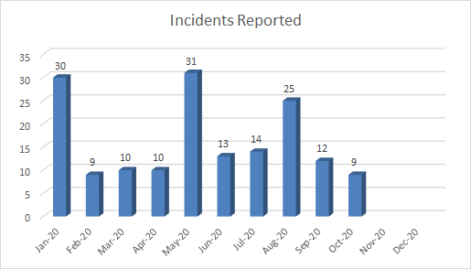
The natural gas incidents reported chart shows a decrease in incidents reported between September and October. There does not appear to be an underling trend for incidents reported throughout the year.
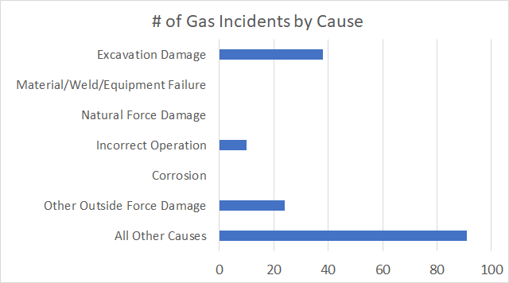
This bar chart above shows the 163 incidents by cause as of October 31, 2020. The table below shows the 163 incidents by level and status.
 | Level 1 | Level 2 | Level 3 | Level 4 | TOTAL
Open | 63 | 69 | 6 | 4 | 142
Closed | 2 | 19 | 0 | 0 | 21
TOTAL | 65 | 88 | 6 | 4 | 163

The table below provides a summary description of the levels and provides the timeframes/guidelines for incident reports to be completed and closed from the date of assignment of an investigation.
Levels | Definition of Incident Levels | Guidelines
1 | Did not result in injury, fatality, fire or explosion; may be due to an unrelated event outside of the Operator’s control. | 60 days
2 | Did not result in injury, fatality, fire or explosion; may or may not have caused a release of gas, have been reported due to Operator judgment. | 120 days
3 | Resulted in a release of gas but did not result in injury, fatality, fire or explosion. | 150 days
4 | Resulted in injury, fatality, fire or explosion caused by release of natural gas from the Operator’s facilities. | ≥ 180 days

Natural Gas Utility Self-Identified Violation (SIV) Investigations
There were no Self-Identified Violations reported in October. To date there have been two SIVs reported by all operators in 2020.

Customer Safety Complaints
GSRB investigated five (5) customer complaints in the month of October. Four (4) of the complaints have been closed with no further action and one is pending.

Notice of Probable Violation Letters (NOPV)
SED may issue an NOPV based on an investigation, customer complaint, or inspection for a violation of an applicable law or regulation. In October, GSRB issued 4 inspection letters (with 0 probable violations) and 0 NOPVs.
- October 5– City of Victorville Municipal Utility Services inspection letter – 0 probable violations found.
- October 20 – SoCalGas San Fernando inspection letter – 0 probable violations found.
- October 29 – San Diego Gas and Electric Company’s (SDG&E) Emergency Response inspection letter – 0 probable violations found.
- October 29 – SoCalGas Emergency Response inspection letter – 0 probable violations found.

Natural Gas Safety and Reliability: Proceedings
Aliso Canyon OII (I.19-06-016) (Commissioner Rechtschaffen /ALJs Hecht/Poirier) (SED Advocacy): In September, SoCalGas and SED filed motions on a variety of issues of practice and confidentiality and discovery privileges with written responses to the motions continuing into October. On October 15, 2020, the ALJs issued a ruling amending the procedural schedule and are requiring parties to begin hearing preparation activities. The deadline for SoCalGas supplemental testimony is October 27, 2020. SED sur-reply testimony response is due November 24, 2020. The ALJ ruling also directs SoCalGas to create and maintain a publicly accessible web site or portal by November 6, 2020 for all public testimony.
Mobile Home Parks (MHP) Utility Conversion Program (D.20-04-004) (Commissioner Rechtschaffen /ALJ Hecht) (SED Advocacy): In April 2020, the Commission adopted a program to convert Master Meter gas and electric distribution systems at MHPs from park-owned to IOU operation, providing MHP residents with the same level of safety and service that directly served utility customers receive. SED/SPD Staff provided an evaluation of the three-year pilot program originating from D.14-03-021. The evaluation noted the high rate of voluntary participation by park owners, the successful completion of the pilot conversion goals by the IOUs, and improved safety and reliability for park residents, many of whom live in Disadvantaged Communities. The program goal is to convert 50% of all mobile home spaces by the end of 2030 according to a risk-based priority ranking system developed by GSRB. SED will be testing the new risk-rank model in January 2021 and will have it finalized before the end of the MHP Utility Conversion Program application period. SED has updated the MHP utility conversion application documents and confirmed the utilities’ new program management contact information for applicants. SED has sent applications (called Forms of Intent) to the listed owners of all jurisdictional master-meter gas operators and has posted the Form of Intent to the MHP Upgrade webpage on the CPUC Website.
PG&E Locate and Mark Practices OII (I.18-12-007) (Commissioner Rechtschaffen/ALJ Allen) (SED Advocacy): On February 20, 2020, the Commission issued Decision (D.20-02-036) which ordered several shareholder-funded gas and electric System Enhancement Initiatives. On August 21, SED selected a consultant for the Compliance and Ethics Corrective Action Program Audit. On October 15, 2020, SED selected a consultant for the Locate and Mark Compliance Audit and Locate and Mark Field Audit.
Line 1600 Pipeline Safety Enhancement Program (PSEP) Application (A. 15-09-013) (Commissioner Randolph/ALJ Kersten) (SED Advisory) In Decision D.20-02-024, the Commission required Applicants (SoCalGas/SDG&E), “Within six months of approving limited modifications to the Decision D.18-06-028, Applicants shall file cost information that includes, but is not limited to the Class Three cost forecast for all the Line 1600 segments, cost estimating methodology, proposed accounting treatment, contingency...” On August 10, 2020, SDG&E and SoCalGas met with SED and Energy Division staff to review this information. They made their compliance filing on August 12, 2020. This concludes the requirements of the D. 18-06-028 Ordering Paragraph.

ELECTRIC SAFETY AND RELIABILITY BRANCH (ESRB)
The mission of ESRB is to enforce state statutes and regulations regarding the safety and reliability of electric facilities, communication facilities, and power plants that are within the jurisdiction of this Commission in California, to ensure that the facilities are operated and maintained in a safe and reliable manner to protect and promote the public health and safety, and to facilitate an environment inside and outside of the Commission that increases the safety and reliability of these facilities. October activities are below:
- Issued 2 electric distribution audit reports and 1 power plant audit report.
- Performed 2 electric distribution audits, 1 substation audit, 3 Communication Infrastructure Provider audits, and 2 electric transmission audits.
- Monitored 14 planned outages and 32 forced outages reported by natural gas and renewable energy power plants.

Electric Incidents Reported through October 31, 2020
ESRB received 6 electric incident reports in October and closed 10 previously reported electric incidents.
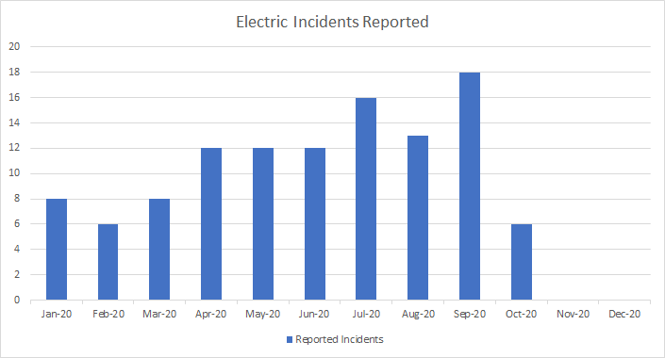

Electric Facilities and Power Plant/Generation Incident Investigations
ESRB |  | Level 1 | Level 2 | Level 3 | Level 4 | Total
Total open incidents in 2020 | Electric Facilities | 7 | 14 | 53 | 71 | 145
 | Generation | 1 | 0 | 3 | 1 | 5
Total incidents reported in 2020 | Electric Facilities | 6 | 15 | 47 | 44 | 112
 | Generation | 1 | 0 | 5 | 0 | 6
Total incidents closed in 2020 | Electric Facilities | 11 | 22 | 55 | 40 | 128
 | Generation | 0 | 0 | 3 | 0 | 3
Total open 2020 incidents in October 2020 | Electric Facilities | 4 | 8 | 37 | 36 | 85
 | Generation | 1 | 0 | 3 | 0 | 4
Incidents reported in October 2020 | Electric Facilities | 0 | 0 | 3 | 3 | 6
 | Generation | 1 | 0 | 2 | 0 | 3
Incidents closed in October 2020 | Electric Facilities | 1 | 1 | 6 | 2 | 10
 | Generation | 0 | 0 | 0 | 0 | 0

The above table shows information about ESRB incident investigations as of October 31, 2020. The level designation indicates increasing severity, with Level 4 as the most severe. Please see footnote 2 for detailed definitions of each level. The guidelines to close incident reports are similar to those GRSB follows (see Guidelines table on page 7).

Customer Safety Complaints
Investigated 15 electric and communication safety and reliability customer complaints.

Notice of Probable Violation Letters
ESRB issued 2 Notice of Probable Violation (NOPV) letters in October. ESRB may issue an NOPV in response to an investigation or customer complaint for a violation of an applicable law or regulation.

Electric Safety and Reliability: Proceedings
PSPS Order Instituting Investigation (I.19-11-013) (Commissioner Batjer/ALJ DeAngelis) (SED Advisory). This OII was initiated by the Commission on November 13, 2019 to determine whether California’s investor-owned electric utilities prioritized safety and complied with the Commission’s regulations and requirements with respect to their Public Safety Power Shutoff (PSPS) events in late 2019. This OII is a companion to R.18-12-005, the Commission’s rulemaking to examine the practice of utility de-energization of powerlines during dangerous conditions. On September 2, 2020, PG&E, SCE and SDG&E filed comments on the issues identified in the Phase 2 Scoping Memo and Ruling. On October 16, 2020, all other parties filed comments regarding the Phase 2 Scoping Memo and Ruling. Pending.
PG&E’s 2017 Wildfires OII (I.19-06-015) (Commissioner Rechtschaffen/ALJ Park) (SED Advocacy): On May 8, 2020, a Final Decision (D.20-05-019) was issued approving a settlement agreement, with modifications, between SED, PG&E, Coalition of California Utility Employees (CUE), and the Office of Safety Advocates (OSA). This decision imposes penalties totaling $2.137 billion consisting of $1.823 billion in disallowances for wildfire-related expenditures, $114 million in shareholder-funded System Enhancement Initiatives, and a $200 million fine payable to the General Fund (the fine shall be permanently suspended). In June and July, SED began implementing OP 1(h) of D.20-05-019, which requires PG&E to consult with SED within thirty days of the effective date of the settlement agreement to discuss the appropriate format, content and treatment of the quarterly electric maintenance reports and “near hit” data required by sections of the settlement agreement. On August 31, 2020, PG&E filed Advice Letter (AL) 5934-E that memorializes the details of the data and reports to be shared by PG&E with SED and SPD regarding the quarterly electric maintenance reports and “near hit” data. Per the Settlement Agreement, SED and SPD are also in the beginning stages of working with PG&E to select a consultant to perform a Root Cause Analysis (RCA) for each of the wildfires. Pending.
PG&E Locate and Mark Practices OII (I.18-12-007) (Commissioner Rechtschaffen/ALJ Allen) (SED Advocacy): D.20-02-036 approved several shareholder-funded gas and electric System Enhancement Initiatives but with a longer compliance audit period of four years and a $110 million total penalty. Following the Commission decision, in September 2020, SED provided comments on selecting candidates for consulting services for this investigation.
Rulemaking to Evaluate the Mobilehome Park Pilot Program and to Adopt Programmatic Modifications (R.18-04-018) (Commissioner Rechtschaffen /ALJ Hecht) (SED Advisory): ESRB’s role in this proceeding is to address the conversion of electric master metered MHPs to direct service by an electric utility. The Commission issued D. 20-04-004 on April 24, 2020, adopting most of the language in the proposed decision. SED, Energy Division, and Housing and Community Development will convene workshops within six months from the effective date to discuss mobile home electrification topics. On September 15, 2020, the Commission held a workshop on the Building Decarbonization Proceeding Phase II Staff Proposal and the Mobilehome Electrification Topics and Tenant Protections. Also, in September 2020, all the parties responded to PG&E’s August submittal of a supplemental advice letter (AL) regarding tariff revisions. The AL reflects changes to the program from a pilot program to a full-scale, ten-year program per D. 20-04-004. Pending.
SCE Appeal of Twentynine Palms Citation (K.18-03-008) (ALJ Kim) (SED Advocacy): ESRB investigated an incident that occurred on August 1, 2015 in Twentynine Palms. On February 12, 2018, SED issued a $300,000 citation to SCE for violations related to the incident. SCE appealed the citation on March 14, 2018. On October 3, 2018, SED issued an $8,000,000 amended citation that replaced the $300,000 citation. The amended citation was the result of new violations of GO 95 that SED discovered. Hearings were held in December 2018, February 2019, and March 2019. Briefs and reply briefs were filed in April 2019. Pending.
Creation of a Shared Database or Statewide Census of Utility Poles and Conduit (I.17-06-027); Communications Provider Access to Poles (R.17-06-028) (Commissioner Batjer/ALJ Mason) (SED Advocacy): On January 22 and 23, 2018, an industry group of pole-owners and pole-tenants hosted an informal workshop to discuss a phased approach and path forward regarding access to pole data, attachment data, and conduit data. ESRB attended and participated in the workshop. The industry group issued a workshop report on February 28, 2019. On June 4, 2019, ALJ Mason issued a ruling approving parties’ recommendation to create working groups to develop requirements for Tracks 1, 2, and 3. SCE and Frontier submitted Track 1 workplans on September 14, 2020. The workplans reflect measures to enable pole database users to access information on 10 pole datapoints. On October 8, 2020 ALJ Mason filed a Track 2 ruling in the Pole OII/OIR requesting party input to a series of questions on additional requirements for pole attachments that would be used to develop a Track 2 decision for the proceeding. ESRB has prepared opening comments and will file on the November 9, 2020 due date. Pending.
Physical Security of the Electric System and Disaster and Emergency Preparedness (R.15-06-009) (Commissioner Rechtschaffen/ALJ Kelly) (SED Advocacy): On May 22, 2015, the Commission issued an Order Instituting Rulemaking regarding policies and regulation of physical security for electric supply facilities and to establish standards for disaster and emergency preparedness plans. This rulemaking was conducted in phases. Phase I addressed physical security for electric supply systems and was resolved by D.19-01-018. Phase II addresses disaster and emergency preparedness plans for electrical corporations and regulated water companies. On July 1, 2020, the Safety Policy Division (SPD) submitted a letter dated June 26, 2020 from the Deputy Executive Director of Safety & Enforcement and Safety Policy enacting the Interim Trial Procedures (ITP) to allow Commission staff to receive and review the major utility deliverables required by D.19-01-018. On July 10, 2020, the six IOUs submitted their Preliminary Assessments under the ITP process to SPD and subsequently presented their briefings regarding their Preliminary Assessment submissions to SPD and SED staff. Three IOUs submitted supplemental filings and met with SED and SPD to discuss their filings. On October 26, 2020, SPD and SED submitted letters to all six IOUs confirming that the submissions meet the requirements of Ordering Paragraph 1 from D.19-01-018. However, some IOUs will submit revised thresholds for assumptions of essential customers. For the next phase of the implementation of the IOUs’ Physical Security plans, the utilities are expected to hire an unaffiliated third-party expert to evaluate their Identification and Assessment evaluations and Mitigation Plans. Pending.

Other Activities
2019 Wildfires: In October 2019, California experienced devastating wildfires. In Northern California, the Kincade Fire burned more than 76,800 acres. The fire destroyed and damaged about 260 structures and caused injuries to two firefighters. In Southern California, the Saddle Ridge Fire, the Easy Fire, and the Maria Fire, burned more than 17,000 acres. The fires destroyed and damaged many structures and caused one fatality and 8 injuries to firefighters. SED is currently working closely with CAL FIRE and other agencies to investigate PG&E, SCE, and the communications companies’ compliance with the Commission’s safety rules.
2020 Wildfires: In 2020, California again experienced devastating wildfires. In Southern California, the Bobcat Fire which started in September 2020 burned about 116,000 acres, damaged 47 structures, destroyed 170 structures, and resulted in 6 injuries. The Silverado Fire which started in October 2020 near Santiago Canyon Road and Silverado Canyon Road in the unincorporated area of Orange County, burned approximately 14,000 acres and injured two firefighters. ESRB and WSEB are working closely with CAL FIRE, the United States Forest Service (USFS) and other agencies to investigate SCE, and communications companies’ compliance with the Commission’s safety rules.
The Slater Fire started on September 9, 2020 in Butte County near the town of Happy Camp. The fire killed two people and injured three. It burned approximately 156,000 acres and damaged 197 residences and 243 structures. In Northern California, the Zogg Fire, which began on September 27, 2020 in Igo, Shasta County resulted in four fatalities, one injury, 27 damaged structures and 204 destroyed structures.
Compliance with D.17-09-024 regarding Long Beach Incident: D.17-09-024 adopted a Settlement Agreement between SCE and SED. Under the settlement, SCE paid a $4 million penalty and will spend $11 million on various system enhancement projects in Long Beach intended to reduce the chance of public injury, reduce the risk of future system failures, and improve the utility’s operational awareness and network maintenance. ESRB is monitoring SCE’s work to ensure compliance with the settlement agreement.
Transmission Maintenance Coordination Committee (TMCC): TMCC is an advisory committee to help the California Independent System Operator (CAISO) develop, review, and revise Transmission Maintenance Standards. TMCC holds quarterly meetings to discuss recent improvements in construction and maintenance processes and techniques, and industry best practices. ESRB is a member of TMCC and attends meetings. On October 15, 2020, ESRB attended the CAISO TMCC WebEx meeting. The meeting addressed and discussed a) Western Area Power Administration Sierra Nevada Region (WAPA SNR) Wildfire Mitigation Plan Implementation presentation, b) COVID 19 and Wildfire impacts on transmission facility maintenance, c) Restricted Maintenance Operations notifications, and d) New business issues and future agenda items.

Wildfire Safety and Enforcement Branch (WSEB)
SED’s WSEB is dedicated to the enforcement of public utility wildfire safety and Public Safety Power Shutoffs (PSPS) violations. WSEB is the lead investigator for utility incidents relating to wildfire, PSPS events and other aspects related to wildfire events. The staff conducts audits, incident investigations, and provides input into policy development. October activities for WSEB, include:
- Observed and monitored 7 separate PSPS events.
- Initiated 3 Wildfire Investigations.
- Participated in various CPUC proceedings.
By way of background, PSPS events are primarily divided into three phases:
- Initial notification and scope by the IOUs to the CPUC, SED, CALOES and the communities,
- An actual PSPS event when De-Energization occurs, and
- Restoration and an after-action review and report.

PSPS Activations, De-energizations & Post Event Reports Reviewed in October
WSEB | PG&E | SCE | SDG&E | Bear Valley | Pacific Corp | Liberty
Total PSPS Activations | 3 | 2 | 1 | 0 | 1 | 0
Total PSPS w/ De-energization | 3 | 2 | 1 | 0 | 0 | 0
Total PSPS Post Event Reports Reviewed | 2 | 1 | 2 | 0 | 1 | 0

Summary of PSPS Events in October
Utility | Dates | Total Customers Impacted | Medical Baseline Customers | Number of Counties Impacted | Number of Tribes Impacted
PacifiCorp | Oct. 25 | 0 | 0 | 0 | 0
PG&E | Oct. 14-17 | 40,574 | 2,431 | 19 | 0
PG&E | Oct. 21-23 | 30,154 | 2,477 | 7 | 0
PG&E | Oct. 25-28 | 345,470 | 22,124 | 35 | 14
SCE | Oct. 16 | 86 | 1 | 2 | 0
SCE | Oct. 23-28 | 36,307 | 860 | 6 | 0
SDG&E | Oct. 26-27 | 4,373 | 211 | 1 | 3

PSPS Related Proceedings
Rulemaking to Examine Electric Utility De-Energization of Power Lines in Dangerous Conditions (R.18-12-005) (President Batjer/ALJ Poirier /ALJ Stevens) (SED Advisory): This Order Instituting Rulemaking (OIR) was opened to further examine policies and guidelines adopted in ESRB-8 regarding communication, notification, mitigation and other logistic and implementation issues of a Public Safety Power Shutoff (PSPS) event. On May 30, 2019, the CPUC adopted Phase I PSPS Guidelines in D.19-05-042 (R.18-12-005) which addressed notice and communication issues. The following year, on May 28, 2020, the CPUC adopted Phase 2 updated and additional guidelines in Decision 20-05-051, which more comprehensively examined de-energization and re-energization practices, notification and other guidelines affecting Medical Baseline and access and functional need (AFN) customers, and which also strengthened the existing Phase 1 PSPS guidelines. On September 14, 2020, ALJ Stevens incorporated into the record SED’s April 30, 2020 report, “Public Report on the Late 2019 Public Safety Power Shutoff Events" (SED Report) which evaluates the 2019 PSPS events. Currently, there are two tracks in this OIR:
- Continued examination of utility de-energization/PSPS practices and guidelines. Comments on the SED Report and how it can inform the PSPS guidelines are due December 2, 2020.
- An Order to Show Cause (OSC) on why PG&E should not be sanctioned for violations of P.U. Code 451, D.19-05-042 (Phase I) and ESRB-8 concerning three PSPS events in October 2019. Opening Briefs were due October 30, 2020 and Reply Briefs are due on November 17, 2020.
PSPS Order Instituting Investigation (I.19-11-013) (Commissioner Batjer/ALJ DeAngelis) (SED Advisory). This Investigation was initiated to determine whether California’s investor-owned electric utilities (IOUs) that experienced PSPS events in late 2019 prioritized safety and complied with the Commission’s regulations and requirements in ESRB-8 and D.19-05-042 (Phase 1 PSPS Guidelines). This OII is a companion to R.18-12-005, the Commission’s rulemaking to examine the practice of utility de-energization of powerlines during dangerous conditions. The assigned Commissioner’s Ruling dated August 3, 2020, narrowed and limited the scope of the OSC track in R.18-12-005 to specific deficiencies in PG&E’s conduct related to three PSPS events in October 2019. In contrast, the scope of I.19-11-013 encompasses the review of all aspects of the PSPS events for all IOUs in late 2019. On April 30, 2020, SED produced a report evaluating the IOUs’ Late Fall 2019 PSPS events. Subsequently the ALJ entered this SED Report into the Record. On September 2, 2020, PG&E, SCE and SDG&E filed comments on the issues identified in the OSC Phase 2 Scoping Memo and Ruling. On October 16, 2020, all other parties filed comments. Reply comments are due November 16, 2020.

Monitoring the Whistleblower Website
The Commission regulates privately owned electric, natural gas, telecommunications, water, railroad, rail transit, and passenger transportation companies. It serves the public interest by protecting consumers and ensuring that utility services and infrastructure are safe, reliable, and available at reasonable rates. The Commission is charged with ensuring that these regulated service providers comply with the regulations. Whistleblower complaints can result in Commission investigations that may involve safety and other issues.

Statistics - 1/01/20 – 10/31/2020
For October 2020, two whistleblower complaints were submitted online to SED. SED is evaluating these complaints.

(Some customer and counties/tribes counts may be duplicative between PSPS events.)
The category of “tracked in financial payment tracker” (FPT) is used to monitor compliance with financial payments to the Commission. The FPT category is verified and deemed “in compliance” and is listed as “in compliance” on this chart.
In December 2011, the CPUC created a citation process authorizing staff to impose fines for natural gas violations.
Level 1: A safety incident that does not meet Level 2, 3, or 4 criteria. Level 2: Incident involved a power interruption not due solely to outside forces (Level 2 for Generation: Incident that occurred during an Electric Alert, Warning or Emergency. Level 3: Incident involved damage estimated to exceed $50,000 and caused, at least in part, by the utility or its facilities (Level 3 for Generation: Incident resulted in a significant outage that was due, at least in part, to plant equipment and/or operations). Level 4: Incident resulted in a fatality or injury requiring hospitalization and that was caused, at least in part, by the utility or its facilities or by equipment and/or operations (for Power Plants).

