Overview of the DER Cost-effectiveness Process

The process currently used in California to determine the cost-effectiveness of distributed energy resources such as energy efficiency, demand response, and customer generation, is shown in Figure 1. This process has 6 steps, although some of the steps are usually done simultaneously rather than sequentially.

The process is sometimes described as a three-part process, where the first part consists of step 1 below (the Avoided Cost Calculator), the second part consists of steps 2 and 3 (determining the benefits of specific DERs, and the third part consists of steps 4 through 6 (determining the costs of specific DERs and comparing them to the benefits).

Figure 1



The first step is determination of the avoided costs of supplying electricity. These are the costs of traditional supply that can be avoided by energy efficiency, demand response, customer generation, and other DERs. These avoided costs are determined by the Avoided Cost Calculator, a spreadsheet tool created by the consulting firm E3. It is important to understand that the six avoided costs determined by the Avoided Cost Calculator are not specific to any DER technology. They are simply the costs associated with the construction, operation, management, and maintenance of the traditional, fossil-fuel based electricity generation, energy markets, and the transmission and distribution grid. The output of the Avoided Cost Calculator consists of hourly avoided costs, in six categories, for a 30 year period.

In the second step, the avoided costs of a particular activity are calculated, based on the characteristics of the particular resource whose benefits and costs are being assessed. The process differs depending on the resource. For example, the hourly avoided cost of each energy efficiency measure is determined by comparing the total avoided costs for each hour of each year with a “load shape” which is specific to each energy efficiency measure. Each measure’s load shape represents the energy savings of that particular measure during each hour of the year. This is depicted graphically in Figure 2.

*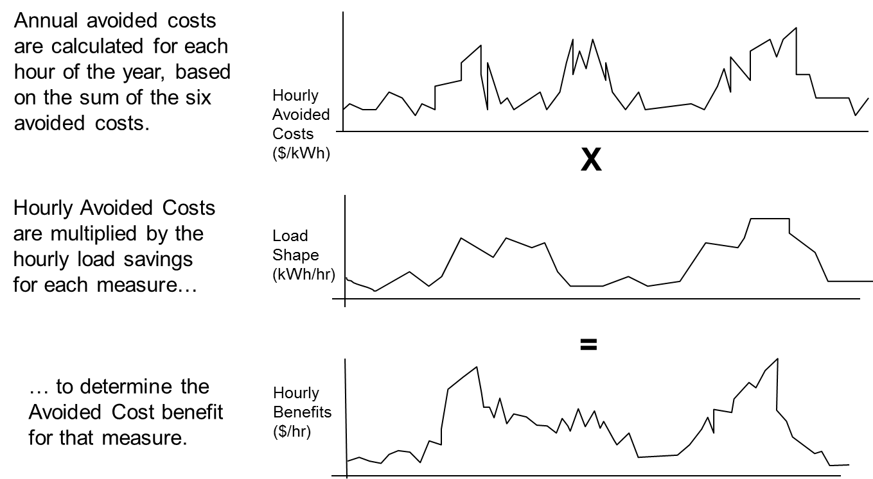Note: above graphs depict representative, rather than actual, data.*

Figure 2 Calculation of Energy Efficiency Measure Avoided Costs

For customer generation programs, a similar process is used, except that in place of the load shape a hourly generation profile of the technology is used.

However, for resources such as demand response, a different process is needed, because these programs are only used a few hours per year when they are “called,” or “dispatched” by the utilities or the system operator. In addition, the value of dispatchable programs includes not only the energy avoided when they are actually dispatched, but also the “insurance” value of having a dispatchable resource available during peak hours in case it is needed.

Hence, the avoided costs of DR programs are determined by applying adjustment factors to the six avoided costs, based on the program’s availability during the particular hours of the year when it is likely to be needed, how quickly the program can respond when it is called, whether the program can alleviate transmission & distribution constraints, and other factors. The Demand Response Cost-effectiveness Protocols describe these adjustment factors in more detail.

The process of determining the specific avoided costs of a particular DER program or other activity can be complicated by the fact that different methods are used for different resources, as described above. Much of this difference is necessitated by the nature of the technologies used, but some of this difference may simply be due to the fact that the cost-effectiveness frameworks for the different resources were developed in different proceedings.

In the third and fourth steps, performed simultaneously, all of the other costs and benefits of DERs are estimated within a cost-effectiveness tool. Some of these costs and benefits are unique to a particular resource or technology, but some are consistently used across resources. However, even the ones that are used by all resources – such as administrative costs –often follow different guidelines or use different methods of calculation.

In step 5, the various reporting tools used to report cost-effectiveness results produce benefit-to-cost ratios, net benefits, and sometimes other metrics, using several different cost-effectiveness tests. Each proceeding currently uses a different reporting tool. Results are generally reported for each program, although the term “program” is somewhat loosely defined. For energy efficiency, results are also reported for the entire “portfolio” of energy efficiency programs. Results are often reported for individual measures (which are generally smaller than programs, usually focusing on a specific technology for a specific region or customer group), and sometimes for particular customer types, geographical regions, technologies, etc.

In the final step, cost-effectiveness results are used to determine budget approval, as part of process evaluations, for program design, and for other purposes that vary by the specific cost-effectiveness test, or by resource, or both.